EMERALD ROYAL INTERNATIONAL SCHOOL, MPAPE ABUJA
LESSON PLAN AND NOTE FOR WEEK 2 ENDING FRIDAY, 19TH JANUARY, 2024
TERM: SECOND TERM
WEEK: WEEK 2
SUBJECT: SOCIAL STUDIES
TOPIC: KEEPING OUR ENVIRONMENT CLEAN
SUB-TOPIC: MATERIALS USED IN KEEPING OUR ENVIRONMENT CLEAN
DATE: TUESDAY, 16TH AND WEDNESDAY, 17TH JANUARY, 2024
TIME: 11:50 – 12:30PM AND 01:20 – 02:00PM
DURATION: 40 MINUTES
PERIOD: 8TH AND 11TH
CLASS: GRADE 1
NUMBER IN CLASS: SIX
AVERAGE AGE: FIVE
SEX: MIXED
LEARNING OBJECTIVES: By the end of the lesson, the pupils should be able to
- Identify the materials used in keeping our environment clean
- State the materials used in keeping our environment clean
- Mention the importance of cleanliness in our environment
RATIONALE: for pupils to know the materials used to keep their environment clean and why you need to keep it clean.
PREVIOUS KNOWLEGDE: pupils learnt about their different environment and how to keep it clean.
INSTRUCTIONAL MATERIALS: pictorial charts of different materials used to keep the environment clean.
REFERENCE MATERIALS:
- Religion and National Values Social Studies for Primary schools Book 2 by Gbenga M. Babalola.

LESSON DEVELOPMENT
STAGES/STEPS | TEACHER’S ACTIVITIES | PUPILS’ ACTIVITIES | LEARNING POINTS
INTRODUCTION | Preview previous knowledge | Respond to the teacher | Arousing the pupils interest
PRESENTATION  STEP 1 | Leads pupils to identify the materials used in keeping the environment clean  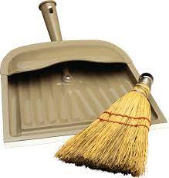  Broom and Dust Pan  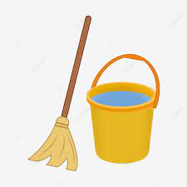  Bucket of water and Mop  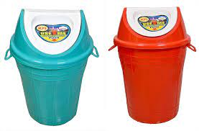  Dust Bin  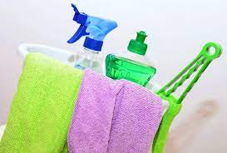  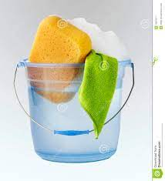  Towel and form  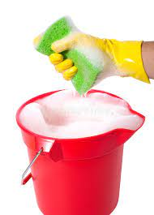  Soapy water  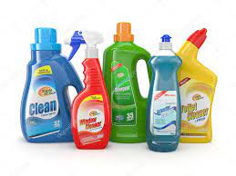  Bottle detergent  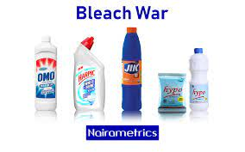  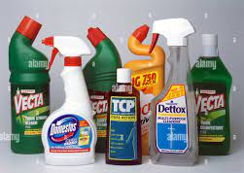  Disinfectanct  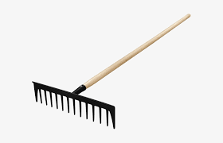  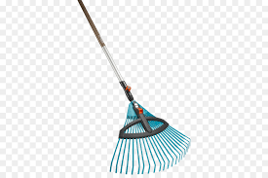  Rake  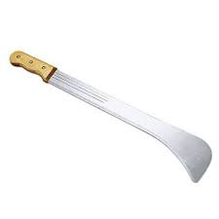  Cutlass  E.T.C | Identify with the teacher | For proper understanding
STEP 2 | Teaches the pupils the materials used in keeping the environment clean.  - Bowl  - Bucket  - Cutlass  - Dust pan  - Dust bin  - Towel  - Broom  - Soap  - Rake  - Water etc. | Mention the materials | For better understanding
STEP 3 | Explain to the pupil’s importance of cleanliness in our environment  are  - Prevent the spread of germs and diseases  - It reduces pollution and other health hazard  - Promotes a safe home and work place. Etc. | Learn and Listen carefully | For further understanding
SUMMARY | Summarises the lesson by emphasising on the main concept and writes note on the board | Listen and copy their notes | For onward study
EVALUATION | Asks pupils to  - Identify the materials used in keeping our environment clean  - State the materials used in keeping our environment clean  - Mention the importance of cleanliness in our environment | Respond to the teachers questions | To test the understanding of the lesson
CONCLUSION | Summarises, reacts and corrects the pupils | Answer to the teachers questions | To consolidate the lesson
HOME WORK | Christian Religious Studies and National Values for Primary Schools Book 2  Revision questions 1 - 4  Page 64 | Returns home with task | Extending the lesson home


Approved as a working document.
Dep. Head Instructor (Academics)
19th January, 2024

