Lesson Plan/Note for Week 4 Ending 3/2/2023.
Term: 2nd.
Week: 4
Class: SS 2
Date: 01/02/2023.
Subject: Civic Education.
Topic: Drug and Drug Abuse.
Sub-Topic: Government agencies to prevent Drug Abuse (NDLEA).
Period: 6th
Time: 11: 50-12:30.
Duration: 40 Minutes.
Number in class: 5 Students.
Sex: Mixed.
Average Age: 14 Years.
Specific objectives: By the end of the lesson, the students should be able to:
(1) Describe National Drug Law Enforcement Agency (NDLEA).
(11) State the functions of NDLEA.
(111) Explain the functions of NDLEA.
Rationale: To enable the students to identify the functions of NDLEA in preventing drug abuse.
Previous knowledge: The students have seen how people that abuse drug are been arrested.
Instructional Material: A chart showing fake drug about to be destroyed.
Reference material: Gbenga Babalola (2017) Essential civic Education for senior Secondary schools.
LESSON DEVELOPMENT
Stages/steps | Teacher's Activities | Students Activities | Learning points.
Introduction | Review the previous lesson | Participate actively in the class discussion | To arouse the students' interest to learn.
Step 1 | Describe NDLEA as: National Drug Law Enforcement Agency is the sole agency for drug law enforcement in Nigeria. It was established by decree 48 to eradicate hard drugs. | Listen carefully to the teacher | For better understanding of the lesson.
Step 11 | Guides the students to state the functions of NDLEA | State the functions of NDLEA as: (1) co-ordination function (2) enforcement agency function (3) eradication function etc. | To enhance their logical reasoning.
Step 111 | Leads the students to explain the functions of NDLEA. | Participate in the class discussion and ask questions when necessary. | To encourage critical thinking.
Summary | Summarizes the lesson as:  National Drug Law Enforcement Agency (NDLEA).  NDLEA is the sole agency for drug law enforcement in Nigeria. It was established by decree 48 to eradicate hard drugs in Nigeria.  Functions of NDLEA  (1) co-ordination function: NDLEA acts as government watchdog over all drug law. (2) Enforcement Agency function: NDLEA enforces punishment and control on any person or authority conferred against all drug laws. (3) Eradication function: NDLEA eradicate illicit cultivation of narcotic plants throughout the federation.  (4) Elimination function: The body eliminate all forms of illicit demand for narcotic drugs and psychotropic substances throughout the federation. (5) Traffic function: The agency makes sure that no illicit product (narcotic drug and psychotropic substance) is smuggled in or out of the country. (6) security function: NDLEA performs policing functions on dealers of narcotic drugs and psychotropic substances. | Copy and submit the Note book for marking | For future reference.
Evaluation | Evaluates the lesson as:  (1) State 5 functions of NDLEA.  (2) Explain 4 functions of NDLEA | Respond to the questions. | Ascertaining the attainment of the stated objectives.
Conclusion | Rounds up the lesson by marking and correcting students work | Check and do their correction | Consolidation of the lesson.
Assignment | Gives home work as:  Explain Drug Law in Nigeria | Respond by doing the home work at home. | To ensure continuity of learning.
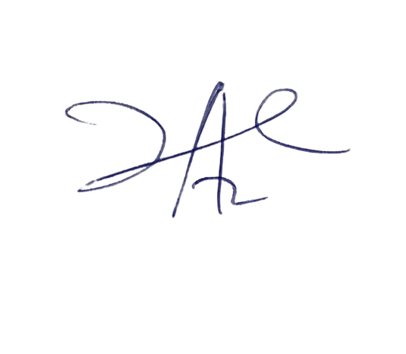
6/3/2023
Principal Head Instructor

