LESSON/NOTE PLAN FOR WEEK 1 ENDING 12th JANUARY 2024.

TERM: 2ND Term
WEEK: One
DATE: 11th January 2024
CLASS: JSS Three
SUBJECT: Basic Technology
TOPIC: Drawing Practice
SUB-TOPIC: Isometric Drawing
PERIOD: 5th
TIME: 11:10-11:50
DURATION: 40 minutes
NO IN CLASS: 13
AVERAGE AGE: 12-13 years
SEX: Mixed
SPECIFIC OBJECTIVE; By the end of the lesson the student should be able to:

- Define technical drawing
- Explain the meaning of isometric drawing
- Drawing various isometric drawing

RATIONALE: To introduce to the student the concept of technical and engineering drawing.

PREVIOUS KNOWLEDGE : The student are familiar with the topic.

INSTRUCTIONAL RESOURSE: Charts , pictures, diagram from the reference material.

REFERENCE MATERIAL[S]: Comprehensive basic technology for junior secondary school by

B A Adelekan.

LESSON DEVELOPMENT

STEPS | TEACHERS ACTIVITY | STUDENTS ACVITITY | LEARNING POINT
INTRODUCTION | The teacher introduces the topic by reviewing the previous lesson | The students participate in the discussion | To arouse the students learning interest
STEP 1 | The teacher guides the students to define technical drawing | The students define technical drawing | To ensure proper understanding
STEP2 | The teacher led the students to explain the meaning of isometric drawing | The students explain the meaning of isometric drawing | To ensure good proper understanding.
STEP 3 | The teacher draw and explain isometric drawing | The students pay attention as the teacher explain isometric | To ensure proper understanding
BOARD SUMMARY | TECHNICAL DRAWING  Is the presentation of technical information through the used of line, symbol,shapes,point from one place to another.  ISOMETRIC DRAWING  The principal distinguishing features of an isometric drawing are the lines on which the drawing is based.  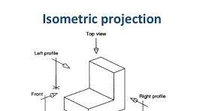  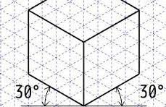 | The students ask question for more clarification | To create room for slow learners
EVALUATION | The teacher asks the students to  - Define technical drawing  - Describe isometric drawing | The students attempt the question | To ascertain the students understanding
CONCLUSION | The teacher end the lesson by marking the students note | The students submit the their note for marking | For future use


Approved as a working document.
Dep. Head Instructor (Academics)
12th January, 2024

