EMERALD ROYAL INTERNATIONAL SCHOOL, MPAPE ABUJA
LESSON PLAN AND NOTE 1 FOR WEEK 4 ENDING FRIDAY, 4TH OCTOBER, 2024
TERM: FIRST TERM
WEEK: WEEK 4
SUBJECT: MATHEMATICS
TOPIC: FRACTION
SUB-TOPIC: HALF FRACTION
DATE: MONDAY, 31ST SEPTEMBER AND TUESDAY, 1ST OCTOBER, 2024
TIME: 08:10 – 08:45AM AND 09:25 – 09:55AM
DURATION: 40 MINUTES
PERIOD: 1ST AND 3RD
CLASS: GRADE 1
NUMBER IN CLASS: TWELVE
AVERAGE AGE: FIVE
SEX: MIXED
LEARNING OBJECTIVES: By the end of the lesson, the pupils should be able to:
- Identify half as a fraction.
- Shade half as a fraction.
- Find the (½) half as a fraction of a group.
RATIONALE: for pupils to know how to divide and shade objects as a fraction of half.
PREVIOUS KNOWLEGDE: pupils have learnt how to place value of 2 digits and 3 digits numbers.
INSTRUCTIONAL MATERIALS:
- Card board paper.
- Oranges
- Pictorials charts of fractions.
REFERENCE MATERIALS:
- New general mathematics for primary schools Book 2 by J Aderohunmu, A Arigbabu etal 2014
- Smart Mathematics primary Pupils Book 2 Cambridge University Press Contributors Are D.A Afariogun, F.C Ona
- Lantern steps to Quantitative reasoning book 2 by Ore Olunloyo

LESSON DEVELOPMENT
STAGES/STEPS | TEACHER’S ACTIVITIES | PUPILS’ ACTIVITIES | LEARNING POINTS
INTRODUCTION | Display an orange on a flat surface and divide it into two equal halves. | Participate in the activity. | Arouse pupils’ interest.
PRESENTATION  STEP 1 | Leads pupils to identify half as a fraction.  A circle divided into two halves.  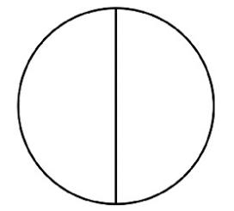  ½  A heart divided into two equal halves.    ½  Half which is written as a fraction of ½ is one part of a whole divided into two equal parts. | Learn attentively. | For proper understanding.
STEP 2 | Teaches and leads pupils to shade half ½ as a fraction.  Shade ½ of the circle  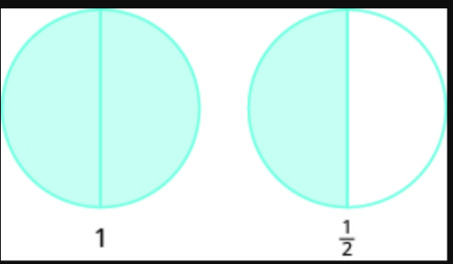  Shade ½ of the heart.   | Shade a fraction of half ½ | For better understanding.
STEP 3 | Teaches pupils to find half ½ of a group of objects.  1.Half ½ of 4 sweets  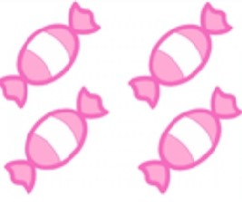  ½ of a group of 4 sweet is 2 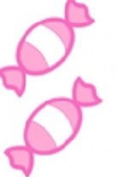  2. Half ½ of 6 tomatoes.  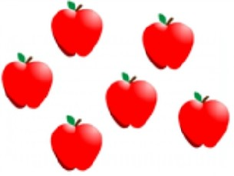  ½ of a group of 6 tomatoes is 3  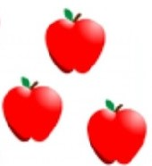  3.Half ½ of 2 toy cars  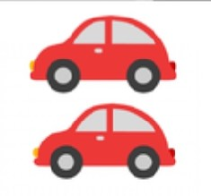  ½ of a group of 2 toy cars is 1   | Finds the fraction of ½ half of each group of objects. | For further understanding.
SUMMARY | Summarises the lesson by emphasising on the main concept and writes note on the board | Listen and copy their notes | For onward study
EVALUATION | Asks pupils to:  1. Identify half ½ as a fraction.  2. Shade ½ as a fraction of the circle.  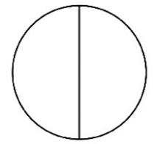  4.Find the fraction of ½ in a group of objects eight (8) square. | Respond to the teacher’s questions. | To test pupils understanding of the lesson.
CONCLUSION | Summarizes, reacts, corrects and mark pupils’ notebooks. | Submits notebook for marking. | To consolidate the lesson.
HOME WORK | New general mathematics for primary school book 2, page 22 worksheet 11. | Return home with task. | Extending the lesson home.

LESSON PLAN AND NOTE 2 FOR WEEK 4 ENDING FRIDAY, 4TH OCTOBER, 2024
TERM: FIRST TERM
WEEK: WEEK 4
SUBJECT: M ATHEMATICS
TOPIC: FRACTION
SUB-TOPIC: QUARTER AS A FRACTION
DATE: WEDNESDAY, 2TH AND THURSDAY, 3RD OCTOBER, 2024
TIME: 10:30 – 11:10AM
DURATION: 40 MINUTES
PERIOD: 5TH
CLASS: GRADE 1
NUMBER IN CLASS: TWELVE
AVERAGE AGE: FIVE
SEX: MIXED
LEARNING OBJECTIVES: By the end of the lesson, the pupils should be able to:
- Identify quarter as a fraction.
- Shade quarter as a fraction.
- Find the fraction of ¼ quarter of a group of objects.
RATIONALE: for pupils to know how to divide and share objects quarterly.
PREVIOUS KNOWLEGDE: pupils have learnt about half ½ as a fraction of a whole object.
INSTRUCTIONAL MATERIALS:
- Card board paper.
- Orange.
REFERENCE MATERIALS:
- New general mathematics for primary schools Book 2 by J Aderohunmu, A Arigbabu etal 2014
- Smart Mathematics primary Pupils Book 2 Cambridge University Press Contributors Are D.A Afariogun, F.C Ona
- Lantern steps to Quantitative reasoning book 2 by Ore Olunloyo

LESSON DEVELOPMENT
STAGES/STEPS | TEACHER’S ACTIVITIES | PUPILS’ ACTIVITIES | LEARNING POINTS
INTRODUCTION | Review previous knowledge on half ½ as a fraction of a whole. | Respond to the teacher. | Arouse pupils’ interest.
PRESENTATION  STEP 1 | Teaches and leads pupils to identify quarter ¼ as a fraction.  Quarter is one part of a whole divided into four equal parts. And it is written as ¼.  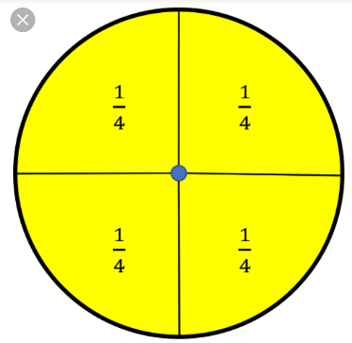  A circle divided into four (4) equal parts  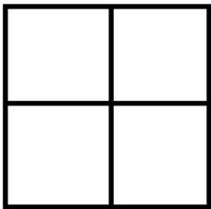  A square divided into four (4) equal parts. | Learn attentively | For proper understanding
STEP 2 | Teaches and leads pupils to shade quarter ¼ as a fraction of the square and the circle.  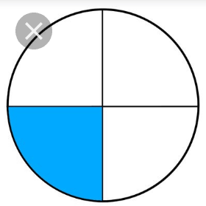  Shaded one part out of 4 (¼)  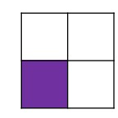  Shaded one part of 4 (¼)
STEP 3 | Teaches pupils how to find the fraction of (¼) quarter in a group of objects.  1.  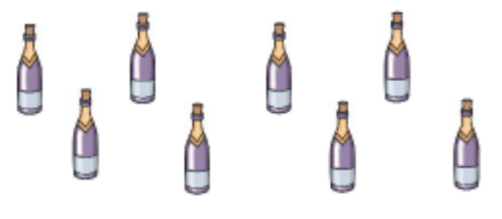  ¼ of group of 8 bottles is 2  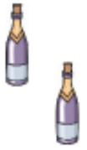  2.  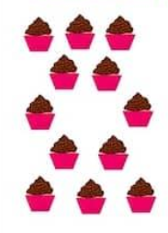  ¼ of group of 12 cakes is 3  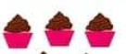  3.  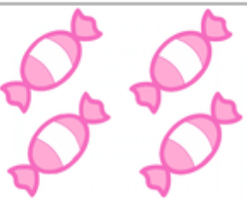  ¼ of group of 4 sweets is 1  
SUMMARY | Summarises the lesson by emphasising on the main concept and writes note on the board. | Listen and copy their notes. | For onward study.
EVALUATION | Asks pupils to:  1.Identify quarter ¼ as a fraction.  2.Shade ¼ as a fraction of the circle.  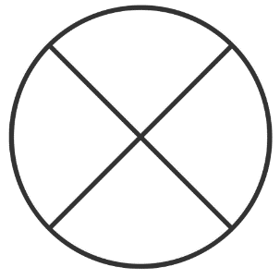  3.Find ¼ quarter as a fraction of the group of 12 flowers.  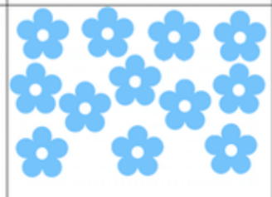 | Respond to teacher’s questions. | To test the pupils understanding of the lesson.
CONCLUSION | Summarizes, reacts, corrects and mark pupils’ notebooks. | Submits notebook for marking. | To consolidate the lesson.
HOME WORK | New general mathematics for primary school. Book 2, page 23  Worksheet 11 | Return home with task. | Extending the lesson home.

LESSON PLAN AND NOTE 3 FOR WEEK 4 ENDING FRIDAY, 4TH OCTOBER, 2024
TERM: FIRST TERM
WEEK: WEEK 4
SUBJECT: MATHEMATICS
TOPIC: FRACTION
SUB-TOPIC: THREE-QUARTER AS A FRACTION
DATE: FRIDAY, 4TH OCTOBER, 2024
TIME: 09:20 – 09:55AM
DURATION: 40 MINUTES
PERIOD: 3RD
CLASS: GRADE 1
NUMBER IN CLASS: TWELVE
AVERAGE AGE: FIVE
SEX: MIXED
LEARNING OBJECTIVES: By the end of the lesson, the pupils should be able to:
- Identify three-quarter ¾ as a fraction.
- Shade three-quarter ¾ as a fraction
- Find the fraction of three-quarter ¾ in a group of objects.
RATIONALE: for pupils to know how to divide and share objects of three-quarter ¾ as a fraction.
PREVIOUS KNOWLEGDE: pupils have learnt how to identify and divide objects into quarter ¼ as a fraction.
INSTRUCTIONAL MATERIALS:
- Card board paper.
- Orange

REFERENCE MATERIALS:
- New general mathematics for primary schools Book 2 by J Aderohunmu, A Arigbabu etal 2014
- Smart Mathematics primary Pupils Book 2 Cambridge University Press Contributors Are D.A Afariogun, F.C Ona
- Lantern steps to Quantitative reasoning book 2 by Ore Olunloyo

LESSON DEVELOPMENT
STAGES/STEPS | TEACHER’S ACTIVITIES | PUPILS’ ACTIVITIES | LEARNING POINTS
INTRODUCTION | Review previous knowledge. | Respond to the teacher. | Arouse pupils’ interest
PRESENTATION  STEP 1 | Teaches and leads pupils to identify three-quarter ¾ as a fraction.  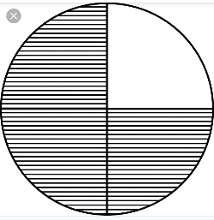  Circle of three-quarter ¾  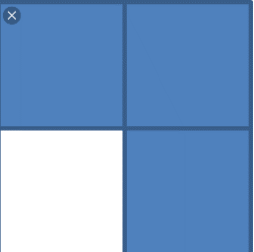  Square of three-quarter ¾. | Identify three-quarter as a fraction. | For proper understanding
STEP 2 | Teaches and leads pupils to shade three-quarter ¾ of the shapes.  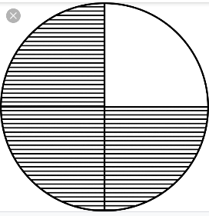  Shaded ¾ of the circle.  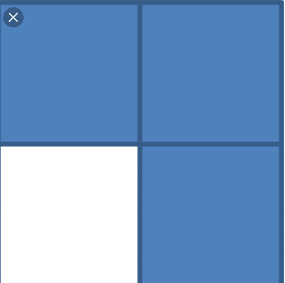  Shaded ¾ of the square.
STEP 3 | Teaches and leads pupils to find three-quarter ¾ as a fraction of a group of objects.  1.  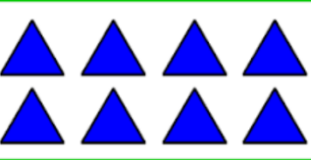  ¾ of group of 8 triangles is 6  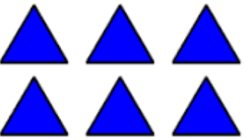  2.  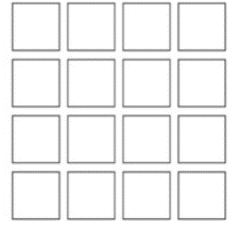  ¾ of group of 16 squares is 12  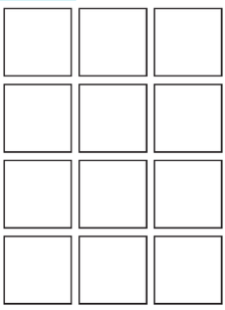  3.  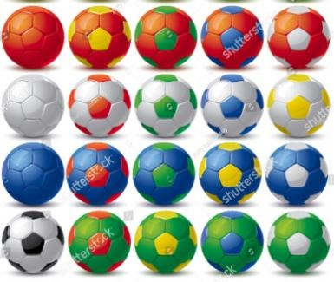  ¾ of group of 20 balls is 15  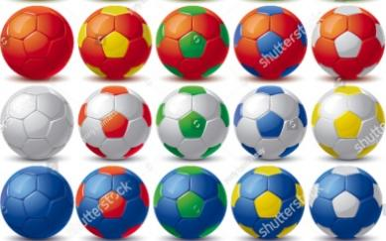
SUMMARY | Summarises the lesson by emphasising on the main concept and writes note on the board. | Listen and copy their notes. | For onward study.
EVALUATION | Asks pupils to:  1. Identify the three-quarter ¾ as a fraction.  2. Shade three-quarter ¾ as fraction of the circle.  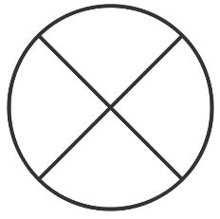  3.Find three-quarter ¾ of the group of twenty (20) balls.  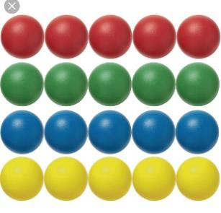
CONCLUSION | Summarizes, reacts, corrects and mark pupils’ notebooks. | Submits notebook for marking. | To consolidate the lesson.
HOME WORK | New general mathematics for primary school. Book 2, page 26, worksheet page 12. | Return home with task. | Extending the lesson home.


Approved as a working document.
Dep. Head Instructor (Academics)
4th October, 2024

