EMERALD ROYAL INTERNATIONAL SCHOOL, MPAPE ABUJA
LESSON PLAN AND NOTE 1 FOR WEEK 5 ENDING 9th FEBRUARY,2024.

SUBJECT: Letter work.
TOPIC: Identification of letter I and it's sound
SUB-TOPIC: Tracing Ietter I.
DATE: /2/2023
TIME: 11:20--12:00
DURATION: 40 minutes
PERIOD: 5th
CLASS: Pre-nursery
NUMBER IN CLASS: 11
AVERAGE AGE: 2 years
SEX: mixed
LEARNING OBJECTIVES: By the end of the lesson, the pupils should be able to:-
- Identify letter I.
- Trace letter I.
RATIONALE: For Pupils to know letters and their sounds.
PREVIOUS KNOWLEGDE: Pupils have learnt from the previous period the jolly phonics song for letter I.
INSTRUCTIONAL MATERIALS:
- Flash cards
- Pupils books
REFERENCE MATERIALS:
- Mastering English for nursery Schools book 1 by J.M.Omogbai.

LESSON DEVELOPMENT
STAGES/STEPS | TEACHER’S ACTIVITIES | PUPILS’ ACTIVITIES | LEARNING POINTS
INTRODUCTION | Teacher introduces the lesson by singing the jolly phonics for letter ' I '. | Pupils sing along with the teacher. | To around the Pupils interest for the lesson.
PRESENTATION  STEP 1 | Teacher writes letter I boldly on the white board and asks the Pupils to point at it and say letter I. | Pupils point at letter I on the board that is  Letter i | For better understanding.
STEP 2 | Teacher prepares the pupils books for them to trace letter I. | Pupils trace letter i in their exercise books .  That's:-  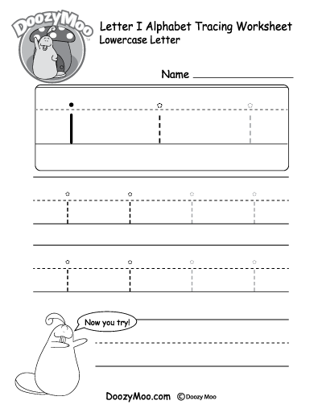 | To ensure Pupils can write letter I .
SUMMARY | Teacher summarizes the lesson by asking the Pupils to point at letter I again on the board. | Pupils point at letter I on the board. | To enhance Pupils knowledge of the lesson.
EVALUATION | Teacher asks the Pupils to:-  - Point at letter I on the board.  - Say the sound for letter I. | Pupils answer the teacher's questions. | To know if Pupils where able to comprehend what has been taught.
CONCLUSION | Teacher ends the lesson by marking the pupils books and sing Nursery rhymes for the Pupils. | Pupils submit their books for marking and Pupils sing the rhyme along with the Pupils. | To consolidate study.
HOME WORK | Teacher asks the Pupils to trace letter I. | Pupils trace letter I at home. | To encourage learning at home.

LESSON PLAN AND NOTE 2 FOR WEEK 5 ENDING 9th FEBRUARY,2024.

SUBJECT: Letter work.
TOPIC: Identification of letter I and it’s sound.
SUB-TOPIC: Recognition of letter I.
DATE: 7/02/2024.
TIME: 11:20 -12:00
DURATION: 40mins
PERIOD: 5th
CLASS: Pre-nursery
NUMBER IN CLASS: 17
AVERAGE AGE: 2years
SEX: Mixed
LEARNING OBJECTIVES: By the end of the lesson, the pupils should be able to:-
1 . Sing the jolly phonics song for letter I.
2. Identify letter ion the flash cards.
RATIONALE: For pupils to know letters and their sounds.

PREVIOUS KNOWLEGDE: Pupils have been learning to identify and say the sounds forletter a - h.
INSTRUCTIONAL MATERIALS:
- Pupils' books
- Phonics song
- Flash cards.
REFERENCE MATERIALS: Mastering English for nursery Schools book 1 by J.M.Omogbai.
LESSON DEVELOPMENT

STAGES/STEPS | TEACHER’S ACTIVITIES | PUPILS’ ACTIVITIES | LEARNING POINTS
INTRODUCTION | Teacher introduces the lesson by singing a nursery for the pupils. | Pupils sing the rhyme along with the teacher. | To arouse pupils interest for the lesson.
PRESENTATION  STEP 1 | Teacher sing the jolly phonics song for letter i and does the action for the pupils. | Pupils attempt singing and imitate the teacher to do the action of the song.That is-;  Inky the mouse is my pet  She spilled the ink and cot wet  The ink it spread allover the desk  /i/ - /i/ - /i/ - /i/  Inky’s wet. | To ensure proper recognition of letters.
STEP 2 | Teacher shows the pupils letter /i/ on a flash cards and also asks the pupils to point at it and say /i/- /I/ /I/. | Pupils take turns to point at letter i on a flash cards and make the sound for letter “I”. | To ensure pupils know the sound for letter i .
SUMMARY | Teacher summarise the lesson by calling out the pupils one after another to point at letter I on the flash cards again and make it’s sound. | Pupils point at letter i on the flash cards and make it’s sound | To enhance pupils understanding of the lesson.
EVALUATION | Teacher asks the pupils one after another to:-  - Identify letter I  - Identify letter I on the flash cards. | Pupils response to the teacher's question. | To assess pupils understanding of the lesson.
CONCLUSION | Teacher ends the lesson by playing a video clips of alphabets | Pupils sit down and watch the video. | To enhance pupils attention span.

LESSON PLAN/NOTE 3 WEEK 5 ENDING 9TH FEBRUARY, 2024
SUBJECT: Letter work
TOPIC: Identification of letter I and it's sound.
SUB-TOPIC: Identifying letter I
DATE: 9/2/2024
DURATION: 40 minutes
TIME: 08:50--09:30
PERIOD: 2nd
CLASS: Pre-nursery
NUMBER OF PUPILS: 17
AVERAGE AGE: 2 years
SEX: Mixed.
SPECIFIC OBJECTIVES: By the end of my lesson, the pupils should be able to:-
- Point and Identify letter I amongst other letters.
- Sing a phonics song for letter i.
RATIONALE: For Pupils to know letters and their sounds.
PREVIOUS KNOWLEDGE: Pupils have been learning about letter I in the previous period.
INSTRUCTIONAL MATERIAL: Phonics song and flash cards.
REFERENCE: Mastering English for nursery Schools book 1 by J.M.Omogbai.
LESSON DEVELOPMENT
Stages/steps | Teacher's activities | Pupils' activities | Learning points
Introduction | Teacher introduces the lesson by singing the A-B-C-D's song for the Pupils. | Pupils sing the rhyme along with the teacher. | To get Pupils attention for the lesson ahead.
Presentation  Step 1 | Teacher prepares the Pupils exercise books for the to circle letter I amongst other letters. | Pupils circle letter I examples:-  a (I) b c  (I) h j g  e (I) f (I) | For Pupils to be familiar with letter I.
Step 2 | Teacher sing a phonics song for letter I for the Pupils. | Pupils sing the phonics song along with the teacher. That's  The I says /i/  The I says /i/  Every letter makes a sound the i says /I/. | To make Pupils knowledgeable about the sound of letter I.
SUMMARY | Teacher summarizes the lesson by asking the Pupils to point at letter I on the flash card and say it's sound. | Pupils point at letter I on the flash card and say it sound. | To improve the Pupils understanding of the lesson.
EVALUATION | Teacher puts flash cards of different letters on the table including letter I and asks the Pupils to-:  - Identify letter i among other letters.  - Say the sound for letter I. | Pupils answer the questions asked by their teacher. | To assess the level of pupils understanding of the lesson.
Conclusion | Teacher marks the pupils note books and makes correction | Pupils submit their books for marking and correction. | For onwards study.
Assignment | Teacher asks the pupils to circle letter i at home.  h i j k  i k g j i | Pupils circle letter i at home. | To ensure learning takes place at home.

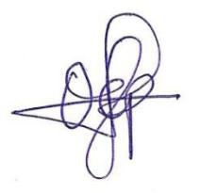

2ND FEBRUARY, 2024
Perpetual Ojoma Ocheja
Stream Head Nursery

