EMERALD ROYAL INTERNATIONAL SCHOOL, MPAPE ABUJA
LESSON PLAN AND NOTE FOR WEEK 6 ENDING FRIDAY, 16TH FEBRUARY, 2024
TERM: SECOND TERM
WEEK: WEEK 6
SUBJECT: BASIC SCIENCE
TOPIC: WATER
SUB-TOPIC: FLOATING OBJECTS
DATE: TUESDAY, 13th AND WEDNESDAY, 14th FEBRUARY, 2024
TIME: 08:10 – 9:25AM AND 09:25 – 09:55AM
DURATION: 40 MINUTES
PERIOD: 1^{ST,} 2ND AND 3RD
CLASS: GRADE 1
NUMBER IN CLASS: SIX
AVERAGE AGE: FIVE
SEX: MIXED
LEARNING OBJECTIVES: By the end of the lesson, the pupils should be able to
- Define the meaning of floating objects
- Identify the objects that can float
- Mention the objects that can float
RATIONALE: for pupils to know floating objects.
PREVIOUS KNOWLEGDE: pupils see see these objects in their daily life.
INSTRUCTIONAL MATERIALS:
- Sample floating objects
- Pictorial charts floating objects.
REFERENCE MATERIALS:
- Lantern Comprehensive Basic Science And Technology For Primary Schools Book 2 by O.J Ehindero, J.B Arubayi etal 2000
- Foundations of Basic Science and Technology Book 2 by Chris Ijiyemi

LESSON DEVELOPMENT
STAGES/STEPS | TEACHER’S ACTIVITIES | PUPILS’ ACTIVITIES | LEARNING POINTS
INTRODUCTION | Displays objects that can float in in water on a flat surface | Identify the objects that float in water | Arousing the pupils interest
PRESENTATION  STEP 1 | Teaches pupils the definition of floating objects  Floating objects are objects that cannot sink in water or go under water and floats on the water surface | Learn attentively | For proper understanding
STEP 2 | Leads pupils to identify floating objects  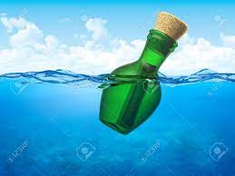  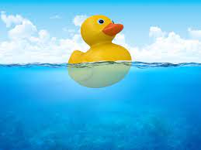  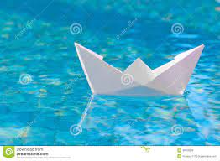  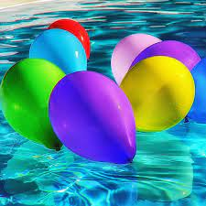  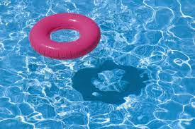  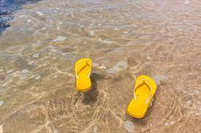  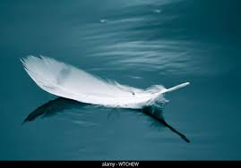  Etc. | Identify floating objects with teacher | For better understanding
STEP 3 | Teaches pupils the objects that can float  1.Bottle  2.Duck  3. Boat  4. Inflated Balloon  5. Floater  6. Rubber Slippers  7. Feather  Etc. | Listen carefully | For further understanding
SUMMARY | Summarises the lesson by emphasising on the main concept and writes note on the board | Listen and copy their notes | For onward study
EVALUATION | Asks pupils to 1.Define the meaning of floating objects  2.Identify the objects that can float in water  3.Mention the objects that can float in water | Respond to the teachers questions | To test the understanding of the lesson
CONCLUSION | Summarises, reacts and corrects the pupils | Answer to the teachers questions | To consolidate the lesson
HOME WORK | State five floating objects you know | Returns home with task | Extending the lesson home


Approved as a working document.
Dep. Head Instructor (Academics)
16th February, 2024

