EMERALD ROYAL INTERNATIONAL SCHOOL, MPAPE ABUJA
LESSON PLAN AND NOTE FOR WEEK 6 ENDING FRIDAY, 16^{h} FEBRUARY, 2024
TERM: SECOND TERM
WEEK: WEEK 6
SUBJECT: SOCIAL STUDIES
TOPIC: ACCIDENTS IN THE SCHOOL/HOME
SUB-TOPIC: PREVENTING ACCIDENT IN THE SCHOOL/HOME
DATE: TUESDAY, 13TH AND WEDNESDAY, 14TH FEBRUARY, 2024
TIME: 11:50 – 12:30PM AND 01:20 – 02:00PM
DURATION: 40 MINUTES
PERIOD: 8TH AND 11TH
CLASS: GRADE 1
NUMBER IN CLASS: SIX
AVERAGE AGE: FIVE
SEX: MIXED
LEARNING OBJECTIVES: By the end of the lesson, the pupils should be able to
- Identify pictures of effect on accident victims
- State effect on accident victims
- Mention ways of preventing accident in the school/home
RATIONALE: for pupils to know about accident and the ways of preventing accident in the school/home.
PREVIOUS KNOWLEGDE: pupils learnt about causes of accidents.
INSTRUCTIONAL MATERIALS: pictorial charts.
REFERENCE MATERIALS:
- Religion and National Values Social Studies for Primary schools Book 2 by Gbenga M. Babalola.

LESSON DEVELOPMENT
STAGES/STEPS | TEACHER’S ACTIVITIES | PUPILS’ ACTIVITIES | LEARNING POINTS
INTRODUCTION | Preview previous knowledge | Respond to the teacher | Arousing the pupils interest
PRESENTATION  STEP 1 | Leads pupils to Identify pictures of effects of accident victims  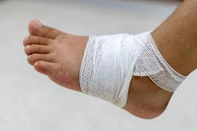  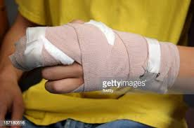  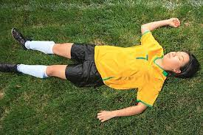  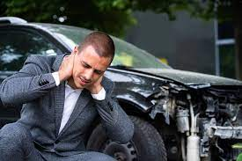  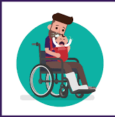  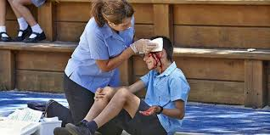  Etc.. | Identify the effects of accident on accident victims | For proper understanding
STEP 2 | Teaches pupils the effect of accident on accident victims  1.Accident can cause severe pains  2.it can lead to deformity  3.Accident in school can cause disrupt in school activities  4. it can cause injuries  5. loss and damage of the bones and body  6. it sometimes leads to death  etc | Learn carefully | For better understanding
STEP 3 | Teaches pupils ways of preventing accident in the school/home  - All dangerous objects that may cause accident should be removed from our surroundings  - Do not play with electrical wires or appliances  - Read all labelled substances before eating or drinking  - Before eating wash all fruits and vegetables very well.  - Avoid climbing trees, chairs, tables. Ladders at school and home. | Learn attentively | For further understanding
SUMMARY | Summarises the lesson by emphasising on the main concept and writes note on the board | Listen and copy their notes | For onward study
EVALUATION | Asks pupils to 1.Identify pictures of effect on accident victims  2.State effect on accident victims  3.Mention ways of preventing accident in the school/home | Respond to the teachers questions | To test the understanding of the lesson
CONCLUSION | Summarises, reacts and corrects the pupils | Answer to the teachers questions | To consolidate the lesson
HOME WORK | State three ways we can prevent accident that occurs in school and at home | Returns home with task | Extending the lesson home


Approved as a working document.
Dep. Head Instructor (Academics)
16th February, 2024

