LESSON PLAN/NOTE FOR WEEK 4 ENDING 06/10/2023
Term: First
Week: 4
Date: 02/10/2023
Class: JSS 2
Subject: PHE
Topic: Family Health
Sub-Topic: Types and transfer of disease.
Period: 6th
Time: 11:50-12:30
Duration: 40 Minutes
Number in class: 12 Students
Average age: 13 Years
Sex: Mixed
Specific objectives: By the end of the lesson, the students should be able to:
(1) State the types of disease in a tabular form.
(11) Explain how diseases are transferred.
(111) Describe Sexually transmitted infection and examples.
Rationale: For the students to be able to identify the various diseases and their consequences to human health.
Previous knowledge: The students have been seeing people infected with different types of diseases and infection.
Instructional material: A Chart showing a Life cycle of mosquitoes and House flies.
Reference material: Olushola etal (2016) New Excellence in Basic Science and Technology for JSS 3.
LESSON DEVELOPMENT
Stages/Steps | Teacher's Activities | Students' Activities | Learning points.
Introduction | Reviews the previous lesson. | Participate actively in the class discussion. | To arouse the students interest to learn.
Step 1 | State the types of disease as: communicable and non-communicable disease. | Listen carefully to the teacher. | For better understanding of the lesson.
Step 11 | Guides the students to explain the transfer of disease. | Explain the transfer of disease as: communicable disease is a disease that can be transferred to humans by pathogens. | To encourage critical thinking.
Step 111 | Leads the students to describe sexually transmitted infections | Describe transmitted infections as: STI are transmitted from one person to another through unprotected sexual contact. | To enable the students reason logically.
Board Summary | Summarizes the lesson as:  Types of Diseases  Transfer of communicable Diseases  Communicable Diseases are diseases that can be transferred to humans by a pathogen. The pathogen can spread from an infected person to an uninfected person. Diseases can be transferred in various ways:  (1) In the air(e.g, pneumonia and TB)  (2) By water (e.g cholera)  (3) By blood (e g HIV/AIDS ).  Some pathogens need another organism, called a vector, to transfer them to an uninfected individual. Examples of vectors include mosquitoes and Houseflies.  Examples of Disease vectors and the disease they transmit.  Vector. Diseases it transmits  Mosquito: malaria, denque fever, yellow fever  Tsetse fly: sleeping sickness  Tick: Diseases caused by rickettsia bacteria for example, typhus, Lyme disease.  Black fly: River blindness  Housefly: Typhoid, cholera, dysentery.  Mosquitoes as vectors of malaria.  The micro- organism that causes malaria is a protozoans called plasmodium. The plasmodium lives inside a mosquito as a parasite. It is carried in the mosquito's saliva and is transmitted to humans when the mosquito bites an infected person and then bites an uninfected person.  Life cycle of the mosquito and the malaria parasite.  The mosquito has four stages in its cycle. Adults lay eggs in stagnant water. The eggs develop into larvae and then pupae. 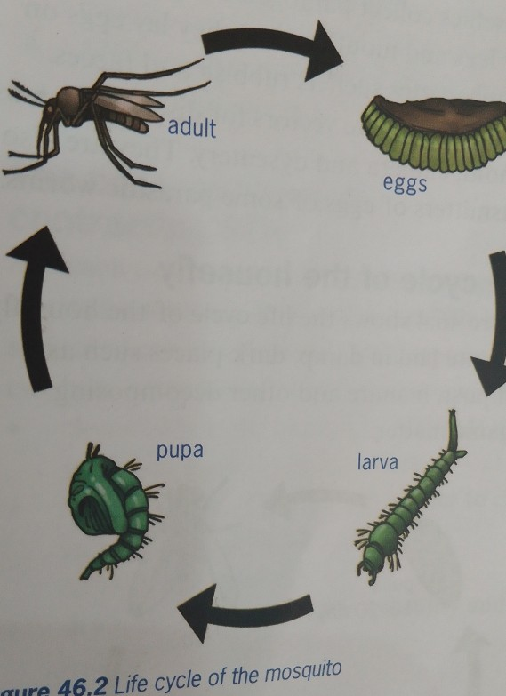  The malaria parasite, plasmodium, lives inside the adult mosquito. The parasite needs both humans and mosquitoes to complete its life cycle. Humans and mosquitoes are hosts for plasmodium. 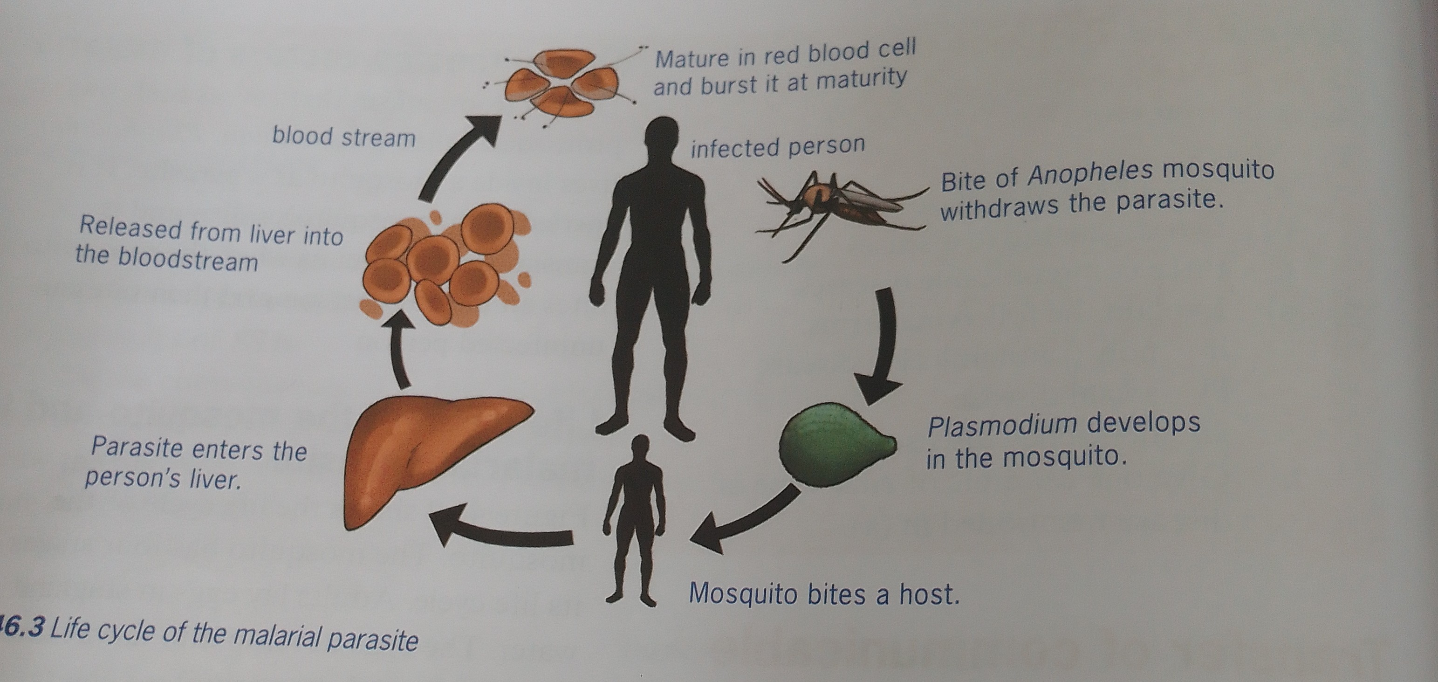  Houseflies as vectors for Diseases  Houseflies collect pathogenic organisms on their legs and mouths when they lay eggs on organic Matter such as rubbish and faeces. Houseflies are vectors for Diseases such as Typhoid, cholera, and dysentery. They are also transmitters of eggs of some parasite worms.  Life cycle of the houseflies.  Eggs are laid in damp, dark places such as compost, manure and other decomposing organic Matter. Housefly larvae are also called maggots. The pupae that develop from the larvae produce legs and wings and, after 10 to 20 days, change into adult flies.  Sexually transmitted infections.  Sexually transmitted infections (STI) are transmitted from one person to another during unprotected sexual contact. This includes vaginal, anal and oral sex. STI are a serious problem, especially among women. The world health organization WHO estimates that there are about 333 million new cases of STI world wide.  Examples of sexually transmitted infections. | Copy and submit the note book for marking. | For future reference.
  Types of disease | Description | Examples
  Communicable Disease | A disease caused by an invading organism and that can be transmitted from one person to another | Cholera, malaria, pneumonia, tuberculosis (TB), sexually transmitted infections such as HIV/AIDS.
  Non-communicable disease | A disease that can not be transmitted from one person to another.
  Inherited disease | A disease caused by genetic fault that can be passed from parents to children. | Sickle cell anaemia, cystic fibrosis.
  Degenerative disease | A gradual decline in function: often associated with ageing. | Arthritis, osteoporosis.
  Social disease | Drug dependence; often caused by social pressure and social behaviour. | Alcoholism, drug addiction.
  Mental illness | A disorder of the mind. | Anorexia, depression, schizophrenia
  Eating disorder | A disease caused by undereating or overeating. | Anorexia, obesity.
  Deficiency disease | A disease caused by a poor diet that lacks one or more essential nutrients. | Scurvy, rickets
  STI | ORGANISM | SYMPTOMS | TREATMENT
  HIV AIDS | Human immuno-deficiency virus | Enlarged lymph glands, fever, headache, weight loss, frequent infections due to lowered immunity. Finally, AIDS, with infections such as TB and pneumonia. | There is no cure to HIV infection, but antiretroviral drugs delay its progress. Can be passed from pregnant mother to unborn baby.
  Chlamydia | Bacterium | No symptoms, so is easily transmitted during sex. There may be pain during urination, and discharge from the genitals | Antibiotics. Can be passed from pregnant mother to unborn baby.
  Genital herpes | Herpes simplex virus | Blister and sores, and pain during urination. Can remain dormant for long periods. | There is no cure, but can be treated with antiviral drugs. Can be passed from pregnant mother to unborn baby.
  Gonorrhea | Bacterium | No symptoms initially. Discharge from the penis or vaginal, and burning sensation during urination. | Antibiotics. Can leads to long term health problem if untreated. Can be passed from pregnant mother to unborn baby.
  Syphilis | Bacterium | Ulcers or sores on the genitals. Later, a rash on the hands, feet or entire body. Highly infectious. | At an early stage, it can be treated with antibiotics. At a later stage , there is no cure. Can be passed from pregnant mother to unborn baby.
Evaluation | Evaluates the lesson as:  (1) State 5 types of Diseases  (2) Explain how diseases are been transferred.  (3) Describe Sexually transmitted infections. | Respond to the questions. | Ascertaining the attainment of the stated objectives.
Conclusion | Rounds up the lesson by marking and correcting students work. | Check and do their correction. | Consolidation of the lesson.
Assignment | Gives home work as:  (1) Mention and explain 4 control measures for mosquitoes and Houseflies.  (2) State 3 consequences of contracting STI.  (3) Describe 3 prevention of STI. | Respond by doing the home work at home | To ensure continuity of learning.

Approved as a working document.
Dep. Head Instructor (Academics)
3rd October, 2023

