LESSON PLAN FOR WEEK 3 ENDING 27th JANUARY, 2023
TERM | 2ND
WEEK | 3
DATE | 16th- 20th January, 2023
CLASS | SS 1
SUBJECT | Government
TOPIC | Types of Constitution.
SUB-TOPIC | Unitary Constitution
PERIOD | 5th
TIME | 11:10-11:50
DURATION | 40 Minutes
NO IN CLASS | 7
AVERAGE AGE | 14 years
SEX | Mixed
SPECIFIC OBJECTIVES | By the end of the lesson, scholars should be able to:  i.Explain the meaning of Unitary Constitution.  ii.Enumerate the features of a Unitary constitution.
RATIONALE | To familiarize scholars with the meaning and features of a unitary constitution.
PREVIOUS KNOWLEDGE | The scholars have been exposed to the meaning and features of unitary constitution.
INSTRUCTIONAL RESOURCES | Charts from textbook explaining the topic.
REFERENCE MATERIAL | Essential Government for Senior Secondary Schools.  Debie Chris (2017)

LESSON DEVELOPMENT
STEPS | TEACHER’S ACTIVITIES | SCHOLARS’ ACTIVITIES | LEARNING POINTS
Introduction | The teacher introduces the lesson by asking the scholars to list two features of federal constitution. | The scholars list two features of a federal constitution as:  i.Division of powers.  ii.Bi-cameral legislature. | To arouse scholars’ interest towards the topic.
Step 1 | The teacher explains the meaning of unitary constitution. | The scholars pay attention. | To ensure proper understanding of the topic.
Step 2 | The teacher enumerates the features of a unitary constitution. | The scholars ask relevant questions on the topic. | To make room for logical reasoning on the topic.
Board Summary | The teacher summerises the lesson thus:  Meaning of Unitary Constitution  In a unitary constitution, all political powers are concentrated in the hands of a single central authority or government. The constitution recognizes the sole authority of the central government. Other component units, for instance, State and Local governments has no powers deposited in them.  Features of a Unitary Constitution  1.Flexibility: The constitution is flexible, making it easy to amend.  2.Political Power: All political powers are concentrated in the hands of a single central government.  3.Component units: The component units are created by the central government.  4.Supremacy of the legislature: There is supremacy of the legislature and not the constitution.  5.Exercise of political powers by other component units is derived from the central government and not from the constitution.  6.Loyalty: Citizens pay loyalty to only one government and that is the central government. | The scholars copy notes into their notebooks. | For reference purposes.
Evaluation | The teacher evaluates the scholars thus:  i.What is a Unitary constitution?  ii.List three features of a Unitary constitution. | The scholars attempt the questions. | To ascertain scholars understanding of the topic.
Conclusion | The teacher check scholars notes and make corrections. | The scholars take corrections made by the teacher. | For consolidation of the topic.
Assignment | The teacher gives the scholars assignment:  -Mention three merits and demerits of a unitary constitution. | The scholars copy their assignment to do it at home. | To encourage continuity of learning.

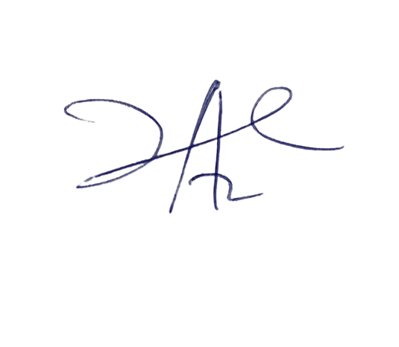
3/3/2023
Head Instructor

