EMERALD ROYAL INTERNATIONAL SCHOOL, MPAPE ABUJA
LESSON PLAN AND NOTE FOR WEEK 10 ENDING FRIDAY, 15TH MARCH, 2024
TERM: SECOND TERM
WEEK: WEEK 10
SUBJECT: SOCIAL STUDIES
TOPIC: DRUGS
SUB-TOPIC: CATEGORY OF DRUGS
DATE: TUESDAY, 12TH AND WEDNESDAY, 13TH MARCH, 2024
TIME: 11:50 – 12:30PM AND 01:20 – 02:00PM
DURATION: 40 MINUTES
PERIOD: 8TH AND 11TH
CLASS: GRADE 1
NUMBER IN CLASS: SIX
AVERAGE AGE: FIVE
SEX: MIXED
LEARNING OBJECTIVES: By the end of the lesson, the pupils should be able to
- Define and state examples of illegal drugs
- Define and state social acceptable drugs
- State the uses of drugs
RATIONALE: for pupils to know about the category of drugs.
PREVIOUS KNOWLEGDE: pupils learnt about category of drugs .
INSTRUCTIONAL MATERIALS:
- pictorial charts of drugs.
- Sample of drugs
REFERENCE MATERIALS:
- Religion and National Values Social Studies for Primary schools Book 2 by Gbenga M. Babalola.

LESSON DEVELOPMENT
STAGES/STEPS | TEACHER’S ACTIVITIES | PUPILS’ ACTIVITIES | LEARNING POINTS
INTRODUCTION | Preview previous knowledge | Respond to the teacher | Arousing the pupils interest
PRESENTATION  STEP 1 | Teaches pupils the definition of illegal drugs.  ilLegal drugs are drugs that cause serious damage to the body. Examples are  1.  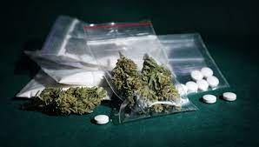  Canabis  2.  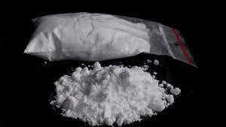  Cocaine  3.  Heroin  4.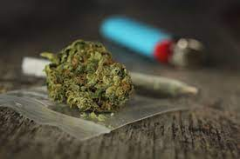  Marijuana  Etc. | Learn attentively | For proper understanding
STEP 2 | Teaches pupils the definition of socially acceptable drugs.  Socially acceptable drugs are drugs accepted by the society for use. Examples are  1.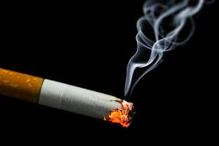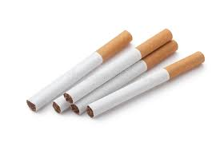  Cigrattes  2.  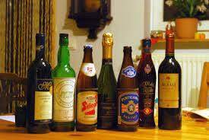  Alcohol | Learn attentively | For better understanding
STEP 3 | Teach pupils the use of drugs.  Drugs are used to treat people who are sick and ill | Learn carefully | For further understanding
SUMMARY | Summarises the lesson by emphasising on the main concept and writes note on the board | Listen and copy their notes | For onward study
EVALUATION | Asks pupils to  1.Define and state examples of illegal drugs  2.Define and state examples social acceptable drugs  3.what is the use of drugs? | Respond to the teachers questions | To test the understanding of the lesson
CONCLUSION | Summarises, reacts and corrects the pupils | Answer to the teachers questions | To consolidate the lesson
HOME WORK | Christian Religious Studies and National Values for Primary Schools Book 2  Revision questions 1 - 5  Page 70 | Returns home with task | Extending the lesson home


Approved as a working document.
Dep. Head Instructor (Academics)
15th March, 2024

