EMERALD ROYAL INTERNATIONAL SCHOOL, MPAPE ABUJA
LESSON PLAN AND NOTE FOR WEEK 3 ENDING FRIDAY, 26TH JANUARY, 2024
TERM: SECOND TERM
WEEK: WEEK
SUBJECT: BASIC SCIENCE
TOPIC: SOIL
SUB-TOPIC: PROPERTIES OF SOIL
DATE: TUESDAY, 23RD AND WEDNESDAY, 24TH JANUARY, 2024
TIME: 08:10 – 9:25AM AND 09:25 – 09:55AM
DURATION: 40 MINUTES
PERIOD: 1^{ST,} 2ND AND 3RD
CLASS: GRADE 1
NUMBER IN CLASS: SIX
AVERAGE AGE: FIVE
SEX: MIXED
LEARNING OBJECTIVES: By the end of the lesson, the pupils should be able to
- State the properties of a clay soil
- Mention the properties of a sandy soil
- List the properties of a loamy soil
RATIONALE: for pupils to know that soil is part of the environment.
PREVIOUS KNOWLEGDE: pupils see sand and play with it around their environment
INSTRUCTIONAL MATERIALS: sample of soil and pictorial charts of soil.
REFERENCE MATERIALS:
- Lantern Comprehensive Basic Science And Technology For Primary Schools Book 2 by O.J Ehindero, J.B Arubayi etal 2000
- Foundations of Basic Science and Technology Book 2 by chris Ijiyemi

STAGES/STEPS | TEACHER’S ACTIVITIES | PUPILS’ ACTIVITIES | LEARNING POINTS
INTRODUCTION | Ask pupils to state the types of soil | Respond to the teachers question | Arousing the pupils interest
PRESENTATION  STEP 1 | Teaches pupils properties of a clay soil  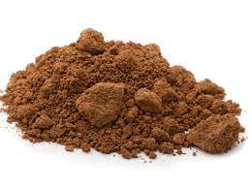  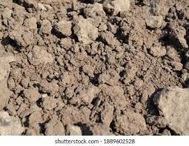  - The texture is smooth, tiny and tightly joined together  - The colour is dark red or grey  - It is sticky when it has water in it  - It can found around marshy or water logged area | Identify the soil | For proper understanding
STEP 2 | Teaches pupils properties of a sandy soil  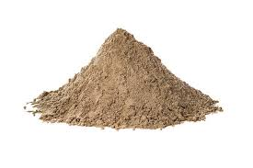  - The texture is rough  - The colour is light grey  - Water goes through it easily  - It can be around road, site ad construction areas | Learn attentively | For better understanding
STEP 3 | Teaches pupils properties of a loamy soil  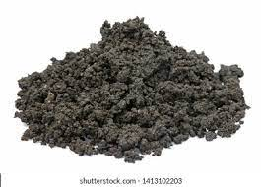  - The texture is rough  - The colour is brown or dark brown  - It can hold some quantity of water  - It can found around garden and farms | Listen carefully | For further understanding
SUMMARY | Summarises the lesson by emphasising on the main concept and writes note on the board | Listen and copy their notes | For onward study
EVALUATION | Asks pupils to 1.State the properties of a clay soil  2.Mention the properties of a sandy soil  3.List the properties of a loamy soil | Respond to the teachers questions | To test the understanding of the lesson
CONCLUSION | Summarises, reacts and corrects the pupils | Answer to the teachers questions | To consolidate the lesson
HOME WORK | State two properties of the following soil  - Clay soil  - Sandy soil  - Loamy soil | Returns home with task | Extending the lesson home


Approved as a working document.
Dep. Head Instructor (Academics)
26th February, 2024

