EMERALD ROYAL INTERNATIONAL SCHOOL, MPAPE ABUJA
LESSON PLAN AND NOTE FOR WEEK 9 ENDING FRIDAY, 8th MARCH, 2024
TERM: SECOND TERM
WEEK: WEEK 9
SUBJECT: BASIC SCIENCE
TOPIC: LIVING AND NON LIVING THINGS
SUB-TOPIC: PLANTS IN THE SCHOOL
DATE: TUESDAY, 5TH AND WEDNESDAY, 6TH MARCH, 2024
TIME: 08:10 – 9:25AM AND 09:25 – 09:55AM
DURATION: 40 MINUTES
PERIOD: 1^{ST,} 2ND AND 3RD
CLASS: GRADE 1
NUMBER IN CLASS: SIX
AVERAGE AGE: FIVE
SEX: MIXED
LEARNING OBJECTIVES: By the end of the lesson, the pupils should be able to
- Identify plants in the school environment
- Write some common plants in the school environment
- State parts of the common plant
RATIONALE: for pupils to know different plants in the environment.
PREVIOUS KNOWLEGDE: pupils see plants in their environment.
INSTRUCTIONAL MATERIALS:
- Sample of specimen of local plants
- Pictorial charts of plants
REFERENCE MATERIALS:
- Lantern Comprehensive Basic Science And Technology For Primary Schools Book 2 by O.J Ehindero, J.B Arubayi etal 2000
- Foundations of Basic Science and Technology Book 2 by Chris Ijiyemi

LESSON DEVELOPMENT
STAGES/STEPS | TEACHER’S ACTIVITIES | PUPILS’ ACTIVITIES | LEARNING POINTS
INTRODUCTION | Displays plants on a flat surface | Identify with teacher | Arousing the pupils interest
PRESENTATION  STEP 1 | Leads pupils to identify the plants in the school environment .  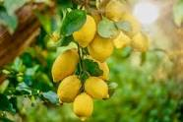  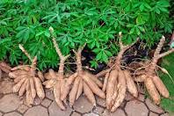  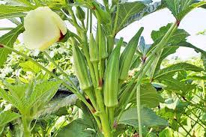  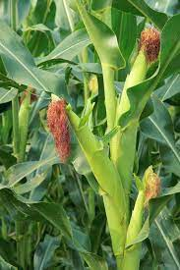  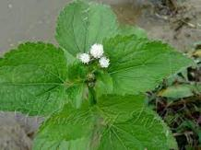  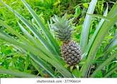  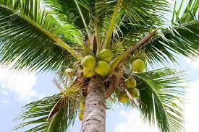  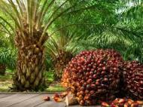  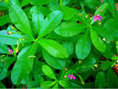  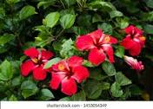  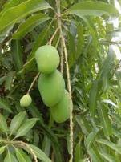  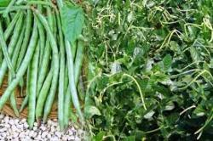  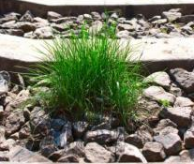  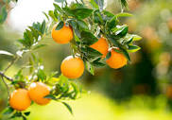  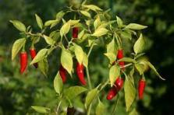 | Identify the plants | For proper understanding
STEP 2 | Leads pupils to write some common plants in the school environment.  1.Cassava plant  2.Cowpea plant  3.Coconut plant  4.Goad weed  5.Hibiscus plant  6.Lemon plant  7.Maize plant  8.Mango plant  9.Oil palm plant  10.Okra plant  11.Orange plant  12.Pepper plant  13.Pineapple Plant  14.Stubborn grass plant  15.Tomato plant  16.water leaf plant  Etc. | Write in their books | For better understanding
STEP 3 | Teaches pupils the common parts of a plant.  Common parts of a plant are  - Flower  - Stem  - Leaf  - Roots  - Branch  - Bud | Listen carefully | For further understanding
SUMMARY | Summarises the lesson by emphasising on the main concept and writes note on the board | Listen and copy their notes | For onward study
EVALUATION | Asks pupils to  1.Identify plants in the school environment  2.Write some common plants in the school environment  3.State parts of the common plant | Respond to the teachers questions | To test the understanding of the lesson
CONCLUSION | Summarises, reacts and corrects the pupils | Answer to the teachers questions | To consolidate the lesson
HOME WORK | 1.Write 5 plants you know  2.state the three parts of a plant | Returns home with task | Extending the lesson home


Approved as a working document.
Dep. Head Instructor (Academics)
8th March, 2024

