EMERALD ROYAL INTERNATIONAL SCHOOL, MPAPE ABUJA
LESSON PLAN AND NOTE FOR WEEK 9 ENDING FRIDAY, 8TH MARCH, 2024
TERM: SECOND TERM
WEEK: WEEK 9
SUBJECT: SOCIAL STUDIES
TOPIC: DRUGS
SUB-TOPIC: CATEGORY OF DRUGS
DATE: TUESDAY, 5TH AND WEDNESDAY, 6TH MARCH, 2024
TIME: 11:50 – 12:30PM AND 01:20 – 02:00PM
DURATION: 40 MINUTES
PERIOD: 8TH AND 11TH
CLASS: GRADE 1
NUMBER IN CLASS: SIX
AVERAGE AGE: FIVE
SEX: MIXED
LEARNING OBJECTIVES: By the end of the lesson, the pupils should be able to
- Identify places where drugs are prescribed
- State the category of drugs
- Define and state examples of legal drugs
RATIONALE: for pupils to know about drugs.
PREVIOUS KNOWLEGDE: pupils learnt about definition of drugs.
INSTRUCTIONAL MATERIALS:
- pictorial charts of drugs.
- Sample of drugs
REFERENCE MATERIALS:
- Religion and National Values Social Studies for Primary schools Book 2 by Gbenga M. Babalola.

LESSON DEVELOPMENT
STAGES/STEPS | TEACHER’S ACTIVITIES | PUPILS’ ACTIVITIES | LEARNING POINTS
INTRODUCTION | Preview previous knowledge | Respond to the teacher | Arousing the pupils interest
PRESENTATION  STEP 1 | Leads pupils to identify places where drugs are prescribe.  1.Hospital  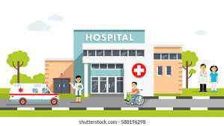  2.Pharmacy  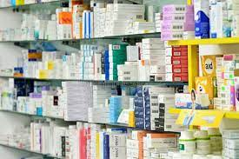 | Identify places where drugs are prescribe. | For proper understanding
STEP 2 | Teaches pupils the category of drugs.  Drugs are categories into three  1.Legal Drugs  2.Illegal Drugs  3.Socially Acceptable Drugs | Learn attentively | For better understanding
STEP 3 | Teaches pupils the definition of legal drugs.  Legal drugs are drugs that are useful to the body. Examples are  1.  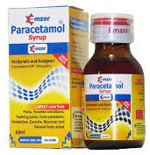  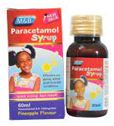  Paracetamol to treat headache, body pains and running of temperature  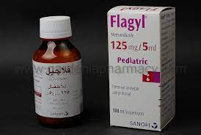  2.  Flagy to treat stomach upset  3.  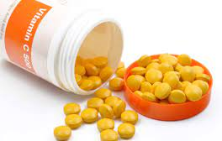  Vitamin c to improve immune system and loss of appetite  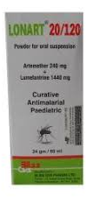  4.  Lonart to treat maleria  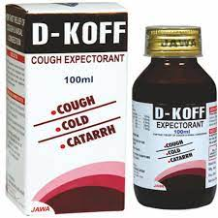  5.  - Koff to treat cough infection and soar throat  Etc. | Learn carefully | For further understanding
SUMMARY | Summarises the lesson by emphasising on the main concept and writes note on the board | Listen and copy their notes | For onward study
EVALUATION | Asks pupils to  1.Identify places where drugs are prescribed  2.State the category of drugs  3.Define and state examples of legal drugs. | Respond to the teachers questions | To test the understanding of the lesson
CONCLUSION | Summarises, reacts and corrects the pupils | Answer to the teachers questions | To consolidate the lesson
HOME WORK | Christian Religious Studies and National Values for Primary Schools Book 2  Revision questions 1 - 5  Page 70 | Returns home with task | Extending the lesson home


Approved as a working document.
Dep. Head Instructor (Academics)
8th March, 2024

