EMERALD ROYAL INTERNATIONAL SCHOOL, MPAPE ABUJA
LESSON PLAN AND NOTE FOR WEEK 1 ENDING FRIDAY, 12TH JANUARY, 2024
TERM: SECOND TERM
WEEK: WEEK 1
SUBJECT: SOCIAL STUDIES
TOPIC: KEEPING OUR ENVIRONMENT CLEAN
SUB-TOPIC: WAYS OF KEEPING OUR ENVIRONMENT CLEAN
DATE: TUESDAY, 9TH AND WEDNESDAY, 10TH JANUARY, 2024
TIME: 11:50 – 12:30PM AND 01:20 – 02:00PM
DURATION: 40 MINUTES
PERIOD: 8TH AND 11TH
CLASS: GRADE 1
NUMBER IN CLASS: SIX
AVERAGE AGE: FIVE
SEX: MIXED
LEARNING OBJECTIVES: By the end of the lesson, the pupils should be able to
- Identify an environment
- Define an environment
- State ways of keeping our environment clean
RATIONALE: for pupils to know their environment and how to keep it clean.
PREVIOUS KNOWLEGDE: pupils reside in different environment but they do not know it is called an environment.
INSTRUCTIONAL MATERIALS: pictorial charts of different environment.
REFERENCE MATERIALS:
- Religion and National Values Social Studies for Primary schools Book 2 by Gbenga M. Babalola.

LESSON DEVELOPMENT
STAGES/STEPS | TEACHER’S ACTIVITIES | PUPILS’ ACTIVITIES | LEARNING POINTS
INTRODUCTION | Leads pupils around the school environment | Participate actively in the exercise | Arousing the pupils interest
PRESENTATION  STEP 1 | Leads pupils to identify environments in the school, home, places of worship etc.  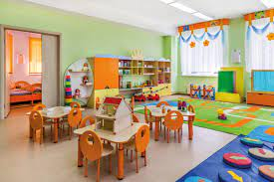  School environment  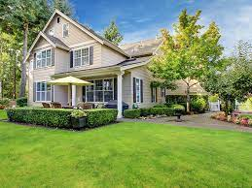  Home environment  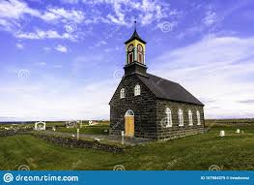  Church environment    Mosque environment  E.t.c | Identify with the teacher | For proper understanding
STEP 2 | Teaches the pupils definition of environment.  Environment is a place where humans as well as plants and animals lives. | Learns attentively | For better understanding
STEP 3 | Teaches pupils ways to keep their environment clean.  Keeping our environment clean and neat is our responsibility. The ways to keep our environment clean are  - By sweeping the floor regularly  - Cut the grasses regularly  - Clean the gutters and drainage  - Dispose waste or garbage properly in a trash bin. Etc. | Listen carefully | For further understanding
SUMMARY | Summarises the lesson by emphasising on the main concept and writes note on the board | Listen and copy their notes | For onward study
EVALUATION | Asks pupils to  - Identify an environment  - Define an environment  - State ways of keeping your environment clean | Respond to the teachers questions | To test the understanding of the lesson
CONCLUSION | Summarises, reacts and corrects the pupils | Answer to the teachers questions | To consolidate the lesson
HOME WORK | State three ways of keeping your home clean | Returns home with task | Extending the lesson home


Approved as a working document.
Dep. Head Instructor (Academics)
12th January, 2024

