EMERALD ROYAL INTERNATIONAL SCHOOL, MPAPE ABUJA
LESSON PLAN AND NOTE FOR WEEK 3 ENDING FRIDAY, 26TH JANUARY, 2024
TERM: SECOND TERM
WEEK: WEEK 3
SUBJECT: MATHEMATICS
TOPIC: MONEY
SUB-TOPIC: RECOGNITION OF CURRENCY (COINS)
DATE: MONDAY, 22ND AND TUESDAY, 23RD JANUARY, 2024
TIME: 08:10 – 08:45AM AND 09:25 – 09:55AM
DURATION: 40 MINUTES
PERIOD: 1ST AND 3RD
CLASS: GRADE 1
NUMBER IN CLASS: SIX
AVERAGE AGE: FIVE
SEX: MIXED
LEARNING OBJECTIVES: By the end of the lesson, the pupils should be able to
- Identify the currency (coins)
- Identify symbol of currency (coins)
- State the examples of currency (coins)
RATIONALE: for pupils to know the examples of currency (coins).
PREVIOUS KNOWLEGDE: pupils learnt about the uses of money.
INSTRUCTIONAL MATERIALS:
- Real samples of money.
- pictorial charts of money.
REFERENCE MATERIALS:
- New general mathematics for primary schools Book 2 by J Aderohunmu, A Arigbabu etal 2014
- Smart Mathematics primary Puiplis Book 2 Cambridge University Press Contributors Are D.A Afariogun, F.C Ona
- Lantern steps to Quantitative reasoning book 2 by Ore Olunloyo

STAGES/STEPS | TEACHER’S ACTIVITIES | PUPILS’ ACTIVITIES | LEARNING POINTS
INTRODUCTION | Display the currencies on a flat surface | Recognises the money | Arousing the pupils interest
PRESENTATION  STEP 1 | leads the pupils to Identify the currency (coins)  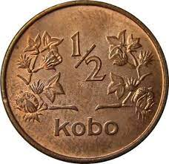  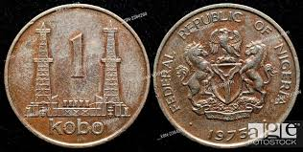  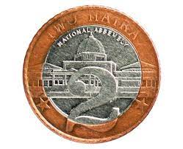  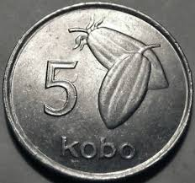  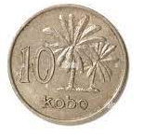  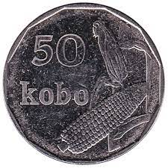  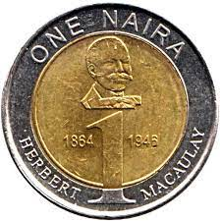  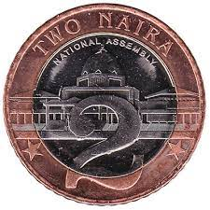 | Identify money (coins) | For proper understanding
STEP 2 | Teaches pupils to  Identify symbol of currency (coins)  In Nigeria we use coins called kobo and the symbol for coins is kobo (k) | Learns attentively | For better understanding
STEP 3 | Teaches pupils the examples of currency (coins).  Coins are in different denomination 50k, 25k, 10k, 5k, 1k, ½k, ₦1, and ₦2 | Learns attentively | For further understanding
SUMMARY | Summarises the lesson by emphasising on the main concept and writes note on the board | Listen and copy their notes | For onward study
EVALUATION | Asks pupils to  - Identify the currency (coins)  - Identify symbol of currency (coins)  - State the examples of currency (coins) | Respond to the teachers questions | To test the understanding of the lesson
CONCLUSION | Summarises, reacts and corrects the pupils | Answer to the teachers questions | To consolidate the lesson
HOME WORK | - Write the symbol for coins  - State 3 examples of coins you know | Returns home with task | Extending the lesson home

LESSON PLAN AND NOTE FOR WEEK 3 ENDING FRIDAY, 26TH JANUARY, 2024
TERM: SECOND TERM
WEEK: WEEK 3
SUBJECT: MATHEMATICS
TOPIC: MONEY
SUB-TOPIC: RECOGNITION OF CURRENCY (BANK NOTE)
DATE: WEDNESDAY, 24TH AND THURSDAY, 25TH JANUARY, 2024
TIME: 10:30 – 11:10AM
DURATION: 40 MINUTES
PERIOD: 5TH
CLASS: GRADE 1
NUMBER IN CLASS: SIX
AVERAGE AGE: FIVE
SEX: MIXED
LEARNING OBJECTIVES: By the end of the lesson, the pupils should be able to
- Identify the currency (bank note)
- Identify symbol of currency (bank note)
- State the examples of currency (bank note)
RATIONALE: for pupils to know the examples of currency (bank note).
PREVIOUS KNOWLEGDE: pupils learnt about the examples of currency (coins).
INSTRUCTIONAL MATERIALS:
- Real samples of money.
- pictorial charts of money.
REFERENCE MATERIALS:
- New general mathematics for primary schools Book 2 by J Aderohunmu, A Arigbabu etal 2014
- Smart Mathematics primary Puiplis Book 2 Cambridge University Press Contributors Are D.A Afariogun, F.C Ona
- Lantern steps to Quantitative reasoning book 2 by Ore Olunloyo

STAGES/STEPS | TEACHER’S ACTIVITIES | PUPILS’ ACTIVITIES | LEARNING POINTS
INTRODUCTION | Display the currencies on a flat surface | Recognises the money | Arousing the pupils interest
PRESENTATION  STEP 1 | leads the pupils to Identify the currency (bank note)  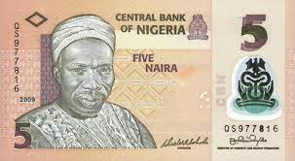  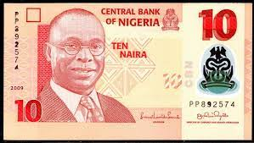  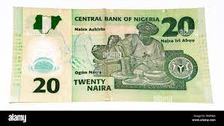  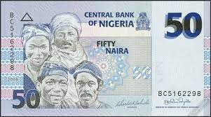  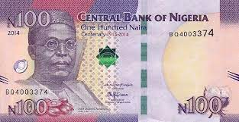  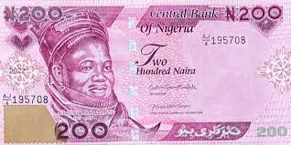  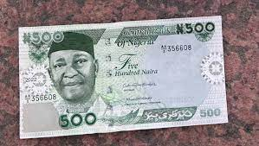  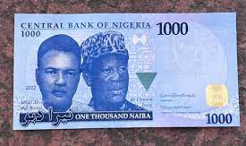 | Identify money (bank note) | For proper understanding
STEP 2 | Teaches pupils to  Identify symbol of currency (bank note)  In Nigeria we use bank note called naira and the symbol for bank note is naira (₦) | Learns attentively | For better understanding
STEP 3 | Teaches pupils the examples of currency (bank note).  Bank notes are in different denomination ₦5, ₦10, ₦20, ₦50, ₦100, ₦200, ₦500 and ₦1000 | Learns attentively | For further understanding
SUMMARY | Summarises the lesson by emphasising on the main concept and writes note on the board | Listen and copy their notes | For onward study
EVALUATION | Asks pupils to  - Identify the currency (bank note)  - Identify symbol of currency (bank note)  - State the examples of currency (bank note) | Respond to the teachers questions | To test the understanding of the lesson
CONCLUSION | Summarises, reacts and corrects the pupils | Answer to the teachers questions | To consolidate the lesson
HOME WORK | - Write the symbol for currency (bank note)  - State 3 examples of bank note you know | Returns home with task | Extending the lesson home

LESSON PLAN AND NOTE FOR WEEK 3 ENDING FRIDAY, 26TH JANUARY, 2024
TERM: SECOND TERM
WEEK: WEEK 3
SUBJECT: MATHEMATICS
TOPIC: MONEY
SUB-TOPIC: RECOGNITION OF CURRENCY (COINS AND BANK NOTE)
DATE: FRIDAY, 26TH JANUARY, 2024
TIME: 09:20 – 09:55AM
DURATION: 40 MINUTES
PERIOD: 3RD
CLASS: GRADE 1
NUMBER IN CLASS: SIX
AVERAGE AGE: FIVE
SEX: MIXED
LEARNING OBJECTIVES: By the end of the lesson, the pupils should be able to
- Identify the currencies (coins and bank note)
- Differentiate the symbol of currencies (coins and bank note)
- Differentiate the examples of currency (coin and bank note)
RATIONALE: for pupils to know the differences in the currencies.
PREVIOUS KNOWLEGDE: pupils learnt about the recognition of currency (bank note).
INSTRUCTIONAL MATERIALS:
- Real samples of money.
- pictorial charts of money.
REFERENCE MATERIALS:
- New general mathematics for primary schools Book 2 by J Aderohunmu, A Arigbabu etal 2014
- Smart Mathematics primary Puiplis Book 2 Cambridge University Press Contributors Are D.A Afariogun, F.C Ona
- Lantern steps to Quantitative reasoning book 2 by Ore Olunloyo

STAGES/STEPS | TEACHER’S ACTIVITIES | PUPILS’ ACTIVITIES | LEARNING POINTS
INTRODUCTION | Display money on a flat surface | Recognises the money | Arousing the pupils interest
PRESENTATION  STEP 1 | Teaches pupils to Identify the currencies (coins and bank note)  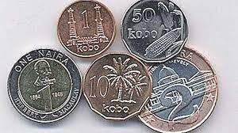  Coins  Naira Bank Notes | Identify the currencies | For proper understanding
STEP 2 | Teaches pupils Differentiate the symbol of currencies (coins and bank note).  coins is kobo (k) and  bank note is naira (₦) | Identify the different symbols of currencies | For better understanding
STEP 3 | Leads pupils to differentiate the examples of currency (coin and bank note)  Coins denomination are 50k, 25k, 10k, 5k, 1k, ½k, ₦1, and ₦2  Bank denomination are ₦5, ₦10, ₦20, ₦50, ₦100, ₦200, ₦500 and ₦1000 | Identify the various currencies | For further understanding
SUMMARY | Summarises the lesson by emphasising on the main concept and writes note on the board | Listen and copy their notes | For onward study
EVALUATION | Asks pupils to  - Identify the currencies (coins and bank note)  - Differentiate the symbol of currencies (coins and bank note)  - Differentiate the examples of currency (coin and bank note) | Respond to the teachers questions | To test the understanding of the lesson
CONCLUSION | Summarises, reacts and corrects the pupils | Answer to the teachers questions | To consolidate the lesson
HOME WORK | State 2 examples of the currencies each  1. coins  2. bank notes | Returns home with task | Extending the lesson home


Approved as a working document.
Dep. Head Instructor (Academics)
26th January, 2024

