EMERALD ROYAL INTERNATIONAL SCHOOL, MPAPE ABUJA
LESSON PLAN AND NOTE FOR WEEK 7 ENDING FRIDAY, 23RD MARCH, 2024
TERM: SECOND TERM
WEEK: WEEK 7
SUBJECT: BASIC SCIENCE
TOPIC: WATER
SUB-TOPIC: SINKING OBJECTS
DATE: TUESDAY, 20TH AND WEDNESDAY, 21ST FEBRUARY, 2024
TIME: 08:10 – 9:25AM AND 09:25 – 09:55AM
DURATION: 40 MINUTES
PERIOD: 1^{ST,} 2ND AND 3RD
CLASS: GRADE 1
NUMBER IN CLASS: SIX
AVERAGE AGE: FIVE
SEX: MIXED
LEARNING OBJECTIVES: By the end of the lesson, the pupils should be able to
- Define the meaning of sinking objects
- Identify the objects that can sink in water
- Mention the objects that can sink in water
RATIONALE: for pupils to know sinking objects.
PREVIOUS KNOWLEGDE: pupils see see these objects in their daily life.
INSTRUCTIONAL MATERIALS:
- sample sinking objects
- pictorial charts sinking objects.
REFERENCE MATERIALS:
- Lantern Comprehensive Basic Science And Technology For Primary Schools Book 2 by O.J Ehindero, J.B Arubayi etal 2000
- Foundations of Basic Science and Technology Book 2 by chris Ijiyemi

LESSON DEVELOPMENT
STAGES/STEPS | TEACHER’S ACTIVITIES | PUPILS’ ACTIVITIES | LEARNING POINTS
INTRODUCTION | Displays objects that can sink in in water in a flat surface | Identify the objects that sink in water | Arousing the pupils interest
PRESENTATION  STEP 1 | Teaches pupils the definition of sinking objects  Sinking objects are objects that can sink in water or go under water to settle there. | Learn attentively | For proper understanding
STEP 2 | Leads pupils to identify sinking objects  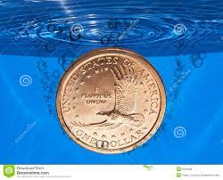  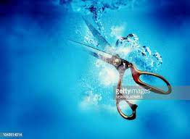  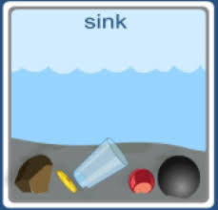  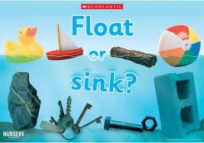  Etc. | Identify the sinking objects | For better understanding
STEP 3 | Teaches pupils the objects that can sink in water  1.stone  2.keys  3. nail  4. glass cup  5. floater  6. scissors  7. coin  8.stainless spoon and fork  Etc. | Listen carefully | For further understanding
SUMMARY | Summarises the lesson by emphasising on the main concept and writes note on the board | Listen and copy their notes | For onward study
EVALUATION | Asks pupils to 1.Define the meaning of sinking objects  2.Identify the objects that can sink in water  3.Mention the objects that can sink in water | Respond to the teachers questions | To test the understanding of the lesson
CONCLUSION | Summarises, reacts and corrects the pupils | Answer to the teachers questions | To consolidate the lesson
HOME WORK | State five sinking objects you know | Returns home with task | Extending the lesson home


Approved as a working document.
Dep. Head Instructor (Academics)
23rd March, 2024

