EMERALD ROYAL INTERNATIONAL SCHOOL, MPAPE ABUJA
LESSON PLAN AND NOTE FOR WEEK 10 ENDING FRIDAY, 17TH NOV, 2023
TERM: FIRST TERM
WEEK: WEEK 10
SUBJECT: SOCIAL STUDIES
TOPIC: GREEETING AND RESPECT TO ELDERS IN OUR CULTURE
SUB-TOPIC: FORMS OF GREETING II
DATE: TUESDAY, 14TH AND WEDNESDAY, 15TH NOVEMBER, 2023
TIME: 11:50 – 12:30PM AND 1:20 – 2:00PM
DURATION: 40 MINUTES
PERIOD: 8TH AND 11TH
CLASS: GRADE 1
NUMBER IN CLASS: NINETEEN
AVERAGE AGE: FIVE
SEX: MIXED
LEARNING OBJECTIVES: By the end of the lesson, the pupils should be able to
- Identify prostrating
- Demonstrate prostrating
- Identify clenching of fist
- Demonstrate clenching of fist
RATIONALE: for pupils to know how to demonstrate various forms of greeting in our locality.
PREVIOUS KNOWLEGDE: pupils learnt about the forms of greeting and demonstrate kneeling.
INSTRUCTIONAL MATERIALS:
- pictorial charts.
- Posters.
REFERENCE MATERIALS:
- Religion and National Values Social Studies for Primary schools Book 2 by Gbenga M. Babalola.

LESSON DEVELOPMENT
STAGES/STEPS | TEACHER’S ACTIVITIES | PUPILS’ ACTIVITIES | LEARNING POINTS
INTRODUCTION | Review previous knowledge | Respond to the teacher and participate actively | Arousing the pupils interest
PRESENTATION  STEP 1 | Leads pupils to identify prostrating as a form of greeting.  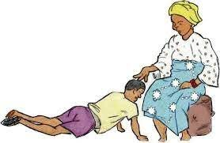  A boy prostrating before an elder to greet | Identify the picture | For proper understanding
STEP 2 | Teach pupils how to prostate when greeting an elder.  Prostrate method of greeting is mostly practised by the Yoruba speaking tribe.  The men and young boys will lay flat on the floor or ground to greet their elders.  It shows that the lad is properly trained. | Learn carefully and demonstrate. | For better understanding
STEP 3 | Leads pupils to identify clenching of fist.      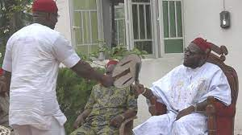  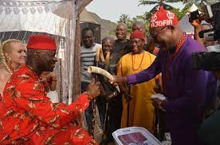  Two elders greeting by clenching their fist. | Identify the pictures | For further understanding
STEP 4 | Teaches pupils how to demonstrate each them how to clench fist when greeting.  The clenching of fist is mostly practised in the eastern part of Nigeria (the igbo speaking community). the elders uses either their hands, hand fans, titles, walking sticks etc. To shake or stroke each other backwards and forwards. | Learn and demonstrate | For furthe explanation
SUMMARY | Summarises the lesson by emphasising on the main concept and writes note on the board | Listen and copy their notes | For onward study
EVALUATION | Asks pupils to  - Identify prostrating  - Demonstrate prostrating  - Identify clenching of fist  - Demonstrate clenching of fist | Respond to the teachers questions | To test the understanding of the lesson
CONCLUSION | Summarises, reacts and corrects the pupils | Answer to the teachers questions | To consolidate the lesson
HOME WORK | - How do you greet in your culture? | Returns home with task | Extending the lesson home


Approved as a working document.
Dep. Head Instructor (Academics)
17th November, 2023

