EMERALD ROYAL INTERNATIONAL SCHOOL, MPAPE ABUJA
LESSON PLAN AND NOTE FOR WEEK 5 ENDING FRIDAY, 9TH FEBRUARY, 2024
TERM: SECOND TERM
WEEK: WEEK 5
SUBJECT: MATHEMATICS
TOPIC: TIME
SUB-TOPIC: INTRODUCTION OF TIME
DATE: MONDAY, 5TH AND TUESDAY, 6TH FEBRUARY, 2024
TIME: 08:10 – 08:45AM AND 09:25 – 09:55AM
DURATION: 40 MINUTES
PERIOD: 1ST AND 3RD
CLASS: GRADE 1
NUMBER IN CLASS: SIX
AVERAGE AGE: FIVE
SEX: MIXED
LEARNING OBJECTIVES: By the end of the lesson, the pupils should be able to
- Identify an analogue clock
- Identify a digital clock
- Identify the hands of clock
RATIONALE: for pupils to know how to tell time.
PREVIOUS KNOWLEGDE: pupils see wall clocks in their homes and places they visit..
INSTRUCTIONAL MATERIALS:
- Real samples of a clock.
- pictorial charts of clock.
REFERENCE MATERIALS:
- New general mathematics for primary schools Book 2 by J Aderohunmu, A Arigbabu etal 2014
- Smart Mathematics primary Pupils Book 2 Cambridge University Press Contributors Are D.A Afariogun, F.C Ona
- Lantern steps to Quantitative reasoning book 2 by Ore Olunloyo
LESSON DEVELOPMENT
STAGES/STEPS | TEACHER’S ACTIVITIES | PUPILS’ ACTIVITIES | LEARNING POINTS
INTRODUCTION | Display the clock on a flat surface | Recognises the clock | Arousing the pupils interest
PRESENTATION  STEP 1 | leads the pupils to Identify an analogue clock.  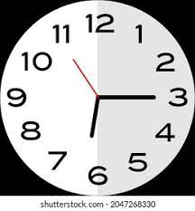  An analogue clock | Identify the analogue clock | For proper understanding
STEP 2 | Teach pupils to  Identify a digital clock  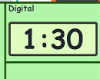  A digital clock | Identify a digital clock | For better understanding
STEP 3 | Teach pupils to Identify the hands of clock.  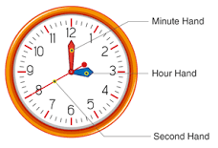 | Learns attentively | For further understanding
SUMMARY | Summarises the lesson by emphasising on the main concept and writes note on the board | Listen and copy their notes | For onward study
EVALUATION | Asks pupils to  1.Identify an analogue clock  2.Identify a digital clock  3.Identify the hands of clock | Respond to the teachers questions | To test the understanding of the lesson
CONCLUSION | Summarises, reacts and corrects the pupils | Answer to the teachers questions | To consolidate the lesson
HOME WORK | Write the hands of the clock  1.The longest hand is _______  2.The shortest hand is the _________________  3.The thinnest hand is the ________________ | Returns home with task | Extending the lesson home

LESSON PLAN AND NOTE FOR WEEK 5 ENDING FRIDAY, 9TH FEBRUARY, 2024

TERM: SECOND TERM
WEEK: WEEK 5
SUBJECT: MATHEMATICS
TOPIC: TIME
SUB-TOPIC: INTRODUCTION OF TIME
DATE: WEDNESDAY, 7TH AND THURSDAY, 8TH FEBRUARY, 2024
TIME: 10:30 – 11:10AM
DURATION: 40 MINUTES
PERIOD: 5TH
CLASS: GRADE 1
NUMBER IN CLASS: SIX
AVERAGE AGE: FIVE
SEX: MIXED
LEARNING OBJECTIVES: By the end of the lesson, the pupils should be able to
- State how many seconds make a minute
- Mention how many minutes makes an hour
- State how many hours makes a day
RATIONALE: for pupils to know how to tell time.
PREVIOUS KNOWLEGDE: pupils identify the analogue and digital clock.
INSTRUCTIONAL MATERIALS:
- Real samples of a clock.
- pictorial charts of clock.
REFERENCE MATERIALS:
- New general mathematics for primary schools Book 2 by J Aderohunmu, A Arigbabu etal 2014
- Smart Mathematics primary Pupils Book 2 Cambridge University Press Contributors Are D.A Afariogun, F.C Ona
- Lantern steps to Quantitative reasoning book 2 by Ore Olunloyo
LESSON DEVELOPMENT
STAGES/STEPS | TEACHER’S ACTIVITIES | PUPILS’ ACTIVITIES | LEARNING POINTS
INTRODUCTION | Review previous knowledge | Respond to the teacher | Arousing the pupils interest
PRESENTATION  STEP 1 | Teach pupils how many seconds makes a minute.  60 seconds makes 1 minute  60 secs - 1 min | Learn attentively | For proper understanding
STEP 2 | Teach pupils how many minutes makes an hour.  60 minutes makes 1 hour  60 mins - 1 hour | Listen carefully | For better understanding
STEP 3 | Teach pupils how many hours makes a day.  24 hours makes a day  24 hours - 1 day | Learns attentively | For further understanding
SUMMARY | Summarises the lesson by emphasising on the main concept and writes note on the board | Listen and copy their notes | For onward study
EVALUATION | Asks pupils to  1.State how many seconds make a minute  2.Mention how many minutes makes an hour  3.State how many hours makes a day | Respond to the teachers questions | To test the understanding of the lesson
CONCLUSION | Summarises, reacts and corrects the pupils | Answer to the teachers questions | To consolidate the lesson
HOME WORK | 1.How many seconds makes 1 minutes?  2.How many minutes makes 1 hour?  3.How many hours makes 1 day? | Returns home with task | Extending the lesson home

LESSON PLAN AND NOTE FOR WEEK 5 ENDING FRIDAY, 9TH FEBRUARY, 2024

TERM: SECOND TERM
WEEK: WEEK 5
SUBJECT: MATHEMATICS
TOPIC: TIME
SUB-TOPIC: READING ON HOUR AND HALF TIME
DATE: FRIDAY, 9TH FEBRUARY, 2024
TIME: 09:20 – 09:55AM
DURATION: 40 MINUTES
PERIOD: 3RD
CLASS: GRADE 1
NUMBER IN CLASS: SIX
AVERAGE AGE: FIVE
SEX: MIXED
LEARNING OBJECTIVES: By the end of the lesson, the pupils should be able to
- Read clock on hour time
- Read clock on half time
- Read clock on quarter time
RATIONALE: for pupils to know how to tell time.
PREVIOUS KNOWLEGDE: pupils learnt about the seconds, minute and hour time.
INSTRUCTIONAL MATERIALS:
- Real samples of a clock.
- pictorial charts of clock.
REFERENCE MATERIALS:
- New general mathematics for primary schools Book 2 by J Aderohunmu, A Arigbabu etal 2014
- Smart Mathematics primary Pupils Book 2 Cambridge University Press Contributors Are D.A Afariogun, F.C Ona
- Lantern steps to Quantitative reasoning book 2 by Ore Olunloyo
LESSON DEVELOPMENT
STAGES/STEPS | TEACHER’S ACTIVITIES | PUPILS’ ACTIVITIES | LEARNING POINTS
INTRODUCTION | Display the clock on a flat surface | Recognises the clock | Arousing the pupils interest
PRESENTATION  STEP 1 | Teach the pupils to read clock on hour time  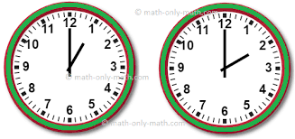  1 o’clock 2 o’clock  When the long hand is on 12 and the short hand is on any number, the time is o’clock | Learn attentively | For proper understanding
STEP 2 | Teach pupils to read clock on half time  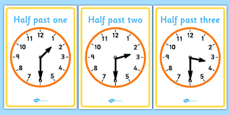  Half past 1, half past, 2 half past 3  When the long hand is on 6 and the short hand is on any number, the time half past | Listen carefully | For better understanding
STEP 3 | Teach pupils to read clock on quarter time  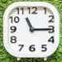  Quarter past 11  When the long hand is on 3 and the short hand is on any number, the time quarter past  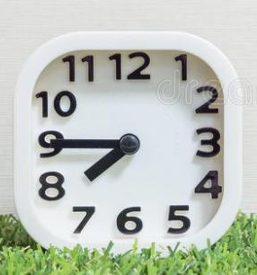  Quarter to 8  When the long hand is on 9 and the short hand is on any number, the time quarter to | Learns attentively | For further understanding
SUMMARY | Summarises the lesson by emphasising on the main concept and writes note on the board | Listen and copy their notes | For onward study
EVALUATION | Asks pupils to  1.Read clock on hour time  2.Read clock on half time  3.Read clock on quarter time | Respond to the teachers questions | To test the understanding of the lesson
CONCLUSION | Summarises, reacts and corrects the pupils | Answer to the teachers questions | To consolidate the lesson
HOME WORK | New general mathematics for primary schools  Workbook book 2  Page 32  Worksheet 22  Exercise 1 | Returns home with task | Extending the lesson home


Approved as a working document.
Dep. Head Instructor (Academics)
9th February, 2024

