EMERALD ROYAL INTERNATIONAL SCHOOL, MPAPE ABUJA
LESSON PLAN AND NOTE 1 FOR WEEK 2 ENDING FRIDAY, 20TH SEPTEMBER, 2024
TERM: FIRST TERM
WEEK: WEEK 2
SUBJECT: BASIC SCIENCE
TOPIC: THE SENSES - SEEING
SUB-TOPIC: SEEING DIFFERENT SHAPES OF OBJECTS
DATE: TUESDAY, 17TH SEPTEMBER, 2024
TIME: 08:10 – 8:45AM AND 08:45 – 9:25AM
DURATION: 40 MINUTES
PERIOD: 1ST AND 2ND
CLASS: GRADE 1
NUMBER IN CLASS: TWELVE
AVERAGE AGE: FIVE
SEX: MIXED
LEARNING OBJECTIVES: By the end of the lesson, the pupils should be able to
- Identify different shapes
- Identify different objects
- State different shapes of objects
RATIONALE: For pupils to see and learn different shapes of objects.
PREVIOUS KNOWLEGDE: Pupils learnt about naming different shapes of objects.
INSTRUCTIONAL MATERIALS:
- Objects
- Shapes
- Pupils textbooks
- Picture charts of shapes and objects
REFERENCE MATERIALS:
- Lantern Comprehensive Basic Science And Technology For Primary Schools Book 2 by O.J Ehindero, J.B Arubayi etal 2000
- Foundations of Basic Science and Technology Book 2 by chris Ijiyemi

LESSON DEVELOPMENT
STAGES/STEPS | TEACHER’S ACTIVITIES | PUPILS’ ACTIVITIES | LEARNING POINTS
INTRODUCTION | Review previous knowledge | Participate in the discussion | Arousing the pupils interest
PRESENTATION  STEP 1 | Teaches pupils to Identify different shapes    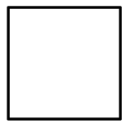  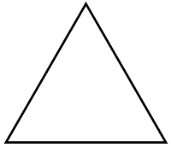  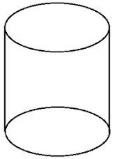  Circle square  Triangle cylinder    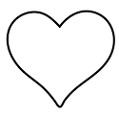  Star Heart  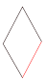  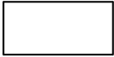  Rhombus Rectangle  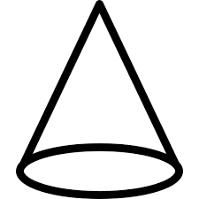  Cone  Etc. | Identify the shapes | For proper understanding
STEP 2 | Leads pupils to Identify different objects.  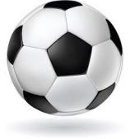  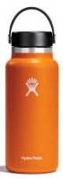  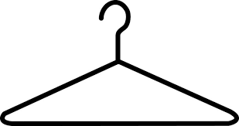  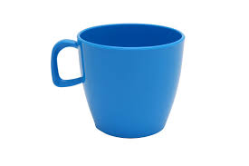    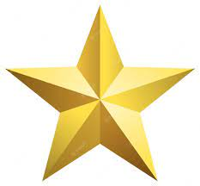    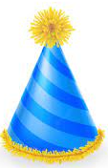  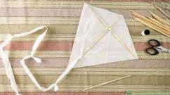  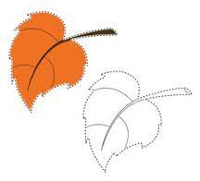  Etc. | Identify the parts of the objects. | For better understanding
STEP 3 | Teaches pupils the different shapes of objects.  Circle - Ball  Rectangle - Nigeria Flag  Triangle - Clothe Hanger  Heart - Love, leaf  Cylinder - Water Bottle  Star - Star  Cone -  Etc. | Learn the different shapes of objects. | For further understanding
SUMMARY | Summarises the lesson by emphasising on the main concept and writes note on the board | Listen and copy their notes | For onward study
EVALUATION | Asks pupils to  - Identify different shapes  - Identify different objects  - State different shapes of objects | Respond to the teachers questions | To test the understanding of the lesson
CONCLUSION | Summarises, reacts and corrects the pupils | Answer to the teachers questions | To consolidate the lesson
HOME WORK | Smart Basic Science and Technology Book 2  Page 8  Exercise 8 | Returns home with task | Extending the lesson home

LESSON PLAN AND NOTE 2 FOR WEEK 2 ENDING FRIDAY, 20TH SEPTEMBER, 2024
TERM: FIRST TERM
WEEK: WEEK 2
SUBJECT: BASIC SCIENCE
TOPIC: THE SENSES - SEEING
SUB-TOPIC: SEEING DIFFERENT SIZES OF OBJECTS
DATE: WEDNESDAY, 18TH SEPTEMBER, 2024
TIME: 09:25 – 09:55AM
DURATION: 40 MINUTES
PERIOD: 3RD
CLASS: GRADE 1
NUMBER IN CLASS: TWELVE
AVERAGE AGE: FIVE
SEX: MIXED
LEARNING OBJECTIVES: By the end of the lesson, the pupils should be able to
- Identify different sizes
- Identify different objects
- State different sizes of objects
RATIONALE: For pupils to see and learn different sizes of objects.
PREVIOUS KNOWLEGDE: Pupils learnt about different shapes of objects.
INSTRUCTIONAL MATERIALS:
- Objects
- Sizes
- Pupils textbooks
- Picture charts of sizes of objects
REFERENCE MATERIALS:
- Lantern Comprehensive Basic Science And Technology For Primary Schools Book 2 by O.J Ehindero, J.B Arubayi etal 2000
- Foundations of Basic Science and Technology Book 2 by chris Ijiyemi

LESSON DEVELOPMENT
STAGES/STEPS | TEACHER’S ACTIVITIES | PUPILS’ ACTIVITIES | LEARNING POINTS
INTRODUCTION | Review previous knowledge | Participate in the discussion | Arousing the pupils interest
PRESENTATION  STEP 1 | Teaches pupils different sizes.  Long Short  Big Small  Thin Thick  Thin Fat  Narrow Wide | Learn attentively | For proper understanding
STEP 2 | leads pupils to Identify different objects.  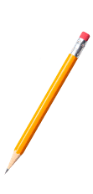  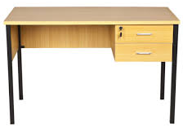  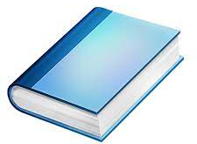  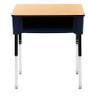  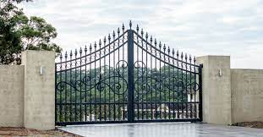  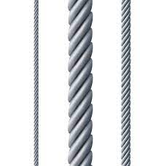 | Identify the objects.  Pencil  Table  Desk  Books  Gate | For better understanding
STEP 3 | Teaches pupils different sizes of objects.  Long pencil Short pencil  Big cup Small cup  Thin wire Thick wire  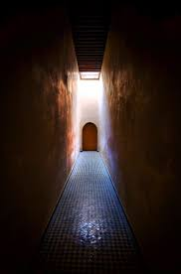  Narrow gate  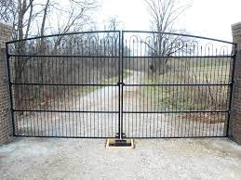  Wide gate  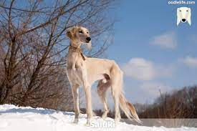  Thin dog  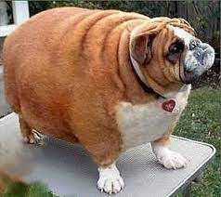  Fat dog  Etc. | Learn different sizes of objects | For further understanding
SUMMARY | Summarises the lesson by emphasising on the main concept and writes note on the board | Listen and copy their notes | For onward study
EVALUATION | Asks pupils to  - Identify different sizes  - Identify different objects  - Observe the objects and identify big or small to describe the sizes of objects  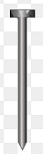 | Respond to the teachers questions | To test the understanding of the lesson
CONCLUSION | Summarises, reacts and corrects the pupils | Answer to the teachers questions | To consolidate the lesson
HOME WORK | Smart Basic Science and Technology Book 2  Page 9  Exercise 9 | Copy and Returns home with task | Extending the lesson home


Approved as a working document.
Dep. Head Instructor (Academics)
20TH September, 2024

