EMERALD ROYAL INTERNATIONAL SCHOOL, MPAPE ABUJA
LESSON PLAN AND NOTE FOR WEEK 5 ENDING 10th FEBRUARY,2023.

SUBJECT: Letter work.
TOPIC: Identification of letter I and it's sound
SUB-TOPIC: Tracing Ietter I.
DATE: 8/2/2023
TIME: 11:20--12:00
DURATION: 40 minutes
PERIOD: 5th
CLASS: Pre-nursery
NUMBER IN CLASS: 11
AVERAGE AGE: 2 years
SEX: mixed
LEARNING OBJECTIVES: By the end of the lesson, the pupils should be able to:-
- Identify letter I.
- Trace letter I.

RATIONALE: For Pupils to know letters and their sounds.
PREVIOUS KNOWLEGDE: Pupils have learnt from the previous period the jolly phonics song for letter I.
INSTRUCTIONAL MATERIALS:
- Flash cards
- Pupils books
REFERENCE MATERIALS:
- Mastering English for nursery Schools book 1 by J.M.Omogbai.

LESSON DEVELOPMENT
STAGES/STEPS | TEACHER’S ACTIVITIES | PUPILS’ ACTIVITIES | LEARNING POINTS
INTRODUCTION | Teacher introduces the lesson by singing the jolly phonics for letter ' I '. | Pupils sing along with the teacher. | To around the Pupils interest for the lesson.
PRESENTATION  STEP 1 | Teacher writes letter I boldly on the white board and asks the Pupils to point at it and say letter I. | Pupils point at letter I on the board that is  Letter i | For better understanding.
STEP 2 | Teacher prepares the pupils books for them to trace letter I. | Pupils trace letter i in their exercise books .  That's:-  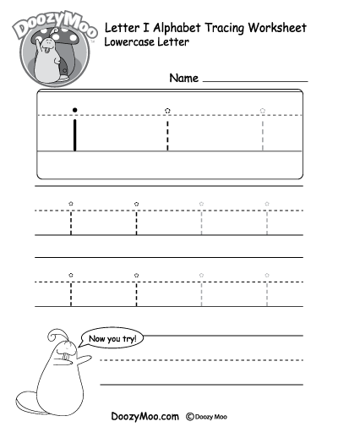 | To ensure Pupils can write letter I .
SUMMARY | Teacher summarizes the lesson by asking the Pupils to point at letter I again on the board. | Pupils point at letter I on the board. | To enhance Pupils knowledge of the lesson.
EVALUATION | Teacher asks the Pupils to:-  - Point at letter I on the board.  - Say the sound for letter I. | Pupils answer the teacher's questions. | To know if Pupils where able to comprehend what has been taught.
CONCLUSION | Teacher ends the lesson by marking the pupils books and sing Nursery rhymes for the Pupils. | Pupils submit their books for marking and Pupils sing the rhyme along with the Pupils. | To consolidate study.
HOME WORK | Teacher asks the Pupils to trace letter I. | Pupils trace letter I at home. | To encourage learning at home.

16th March, 2023
Perpetual Ojoma Ocheja
Stream Head Nursery

