EMERALD ROYAL INTERNATIONAL SCHOOL, MPAPE ABUJA
LESSON PLAN AND NOTE FOR WEEK 8 ENDING FRIDAY, 1ST MARCH, 2024
TERM: SECOND TERM
WEEK: WEEK 8
SUBJECT: BASIC SCIENCE
TOPIC: COLOURS
SUB-TOPIC: FORMS OF COLOURS
DATE: TUESDAY, 27TH FEBRUARY, 2024
TIME: 08:10 – 9:25AM
DURATION: 40 MINUTES
PERIOD: 1ST AND 2ND
CLASS: GRADE 1
NUMBER IN CLASS: SIX
AVERAGE AGE: FIVE
SEX: MIXED
LEARNING OBJECTIVES: By the end of the lesson, the pupils should be able to
- Define colour and list examples of colours
- State the various forms of colour
- Mention the primary and secondary colours
RATIONALE: for pupils to know different forms of object colours.
PREVIOUS KNOWLEGDE: pupils can identify some colours.
INSTRUCTIONAL MATERIALS:
- Sample crayons
- pictorial charts of objects with colours
- Poster colours
- Water colours.
REFERENCE MATERIALS:
- Lantern Comprehensive Basic Science And Technology For Primary Schools Book 2 by O.J Ehindero, J.B Arubayi etal 2000
- Foundations of Basic Science and Technology Book 2 by chris Ijiyemi

LESSON DEVELOPMENT
STAGES/STEPS | TEACHER’S ACTIVITIES | PUPILS’ ACTIVITIES | LEARNING POINTS
INTRODUCTION | Displays objects and different colours on a flat surface | Identify the objects and the colours of the objects | Arousing the pupils interest
PRESENTATION  STEP 1 | Teaches pupils the definition colour and examples of colours.  Colour is the appearance of objects as seen by the eyes.  Examples are  Blue Red  Black White  Yellow Green  Brown Orange  Etc. | Learn attentively | For proper understanding
STEP 2 | Teach pupils the forms of colour.  There are three forms of colours  1.Primary colour  2.Secondary colours  3.complimentary colours | Learn attentively | For better understanding
STEP 3 | Teaches pupils the primary and secondary colours.  PRIMARY COLOURS  These are colours we cannot get by mixing other colours  Blue Red Yellow  SECONDARY COLOURS  These are colours we get when two primary colours are mixing together especially in equal amounts.  Yellow + Blue = Green  Brown + Yellow = Orange  Red + Blue = Purple | Listen carefully | For further understanding
SUMMARY | Summarises the lesson by emphasising on the main concept and writes note on the board | Listen and copy their notes | For onward study
EVALUATION | Asks pupils to  1.Define colour and list examples of colours  2.State the various forms of colour  3.Mention the primary and secondary colours | Respond to the teachers questions | To test the understanding of the lesson
CONCLUSION | Summarises, reacts and corrects the pupils | Answer to the teachers questions | To consolidate the lesson
HOME WORK | 1.Write 10 colours you know  2.state the forms of colours  3. Smart Basic Science and Technology book 2  Page 48  Exercise 2 | Returns home with task | Extending the lesson home

LESSON PLAN AND NOTE FOR WEEK 8 ENDING FRIDAY, 1st MARCH, 2024
TERM: SECOND TERM
WEEK: WEEK 8
SUBJECT: BASIC SCIENCE
TOPIC: COLOURS
SUB-TOPIC: IDENTIFICATION OF OBJECTS THROUGH COLOURS
DATE: WEDNESDAY, 28TH FEBRUARY, 2024
TIME: 09:25 – 09:55AM
DURATION: 40 MINUTES
PERIOD: 3RD
CLASS: GRADE 1
NUMBER IN CLASS: SIX
AVERAGE AGE: FIVE
SEX: MIXED
LEARNING OBJECTIVES: By the end of the lesson, the pupils should be able to
- State the secondary colours
- Mention the uses of colours
- Identify objects through colours
RATIONALE: for pupils to know different forms of object colours.
PREVIOUS KNOWLEGDE: pupils learnt about the definition, examples and forms of colours.
INSTRUCTIONAL MATERIALS:
- Sample crayons
- pictorial charts of objects with colours
- Poster colours
- Water colours.
REFERENCE MATERIALS:
- Lantern Comprehensive Basic Science And Technology For Primary Schools Book 2 by O.J Ehindero, J.B Arubayi etal 2000
- Foundations of Basic Science and Technology Book 2 by chris Ijiyemi
LESSON DEVELOPMENT
STAGES/STEPS | TEACHER’S ACTIVITIES | PUPILS’ ACTIVITIES | LEARNING POINTS
INTRODUCTION | Review previous knowledge | Identify the objects and the colours of the objects | Arousing the pupils interest
PRESENTATION  STEP 1 | Teach pupils the complimentary colours.  COMPLIMENTARY COLOURS  They are colours with clear difference.  They do not look alike at all.  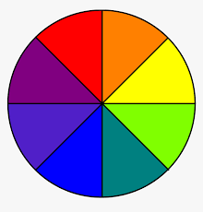  Red, orange, yellow, green, violet, blue, indigo and purple  Green is complimentary to Red  purple is complimentary to yellow  Orange is complimentary to Blue | Learn attentively | For proper understanding
STEP 2 | Teach pupils the uses of colour.  1.to identify different objects and jobs  2.to make surface clearly  3.it helps to guide movement  It makes painted houses and objects beautiful.  E.t.c | Learn carefully | For better understanding
STEP 3 | Lead pupils to identify objects of different colours.  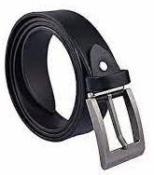  Black belt  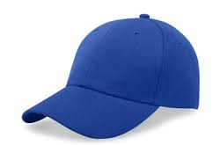  Blue Cap  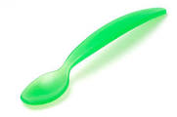  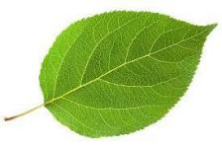  Green spoon and leaf  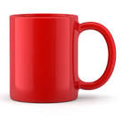    Red Cup and Red Tie  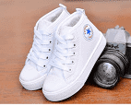  White shoe  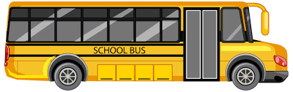  Yellow Bus  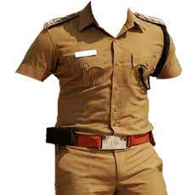  Brown uniform  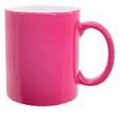  Pink cup  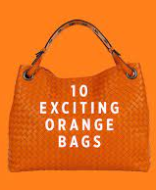  Orange bag  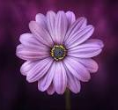  Purple flower  Etc. | Identify the colours of the objects | For further understanding
SUMMARY | Summarises the lesson by emphasising on the main concept and writes note on the board | Listen and copy their notes | For onward study
EVALUATION | Asks pupils to  - State the secondary colours  - Mention the uses of colours  - Identify objects through colours | Respond to the teachers questions | To test the understanding of the lesson
CONCLUSION | Summarises, reacts and corrects the pupils | Answer to the teachers questions | To consolidate the lesson
HOME WORK | Smart Basic Science and Technology book 2  Page 48  Exercise 2 | Returns home with task | Extending the lesson home


Approved as a working document.
Dep. Head Instructor (Academics)
1st March, 2024

