EMERALD ROYAL INTERNATIONAL SCHOOL, MPAPE ABUJA
LESSON PLAN AND NOTE FOR WEEK 2 ENDING FRIDAY, 19TH JANUARY, 2024
TERM: SECOND TERM
WEEK: WEEK 2
SUBJECT: MATHEMATICS
TOPIC: MONEY
SUB-TOPIC: DEFINITION OF MONEY
DATE: MONDAY, 15TH AND TUESDAY, 16TH JANUARY, 2024
TIME: 08:10 – 08:45AM AND 09:25 – 09:55AM
DURATION: 40 MINUTES
PERIOD: 1ST AND 3RD
CLASS: GRADE 1
NUMBER IN CLASS: SIX
AVERAGE AGE: FIVE
SEX: MIXED
LEARNING OBJECTIVES: By the end of the lesson, the pupils should be able to
- Identify money
- Define money
- State the types of money
RATIONALE: for pupils to know the various types of money in Nigeria.
PREVIOUS KNOWLEGDE: pupils see and use money in their homes.
INSTRUCTIONAL MATERIALS:
- Real samples of money.
- pictorial charts of money.
REFERENCE MATERIALS:
- New general mathematics for primary schools Book 2 by J Aderohunmu, A Arigbabu etal 2014
- Smart Mathematics primary Puiplis Book 2 Cambridge University Press Contributors Are D.A Afariogun, F.C Ona
- Lantern steps to Quantitative reasoning book 2 by Ore Olunloyo

STAGES/STEPS | TEACHER’S ACTIVITIES | PUPILS’ ACTIVITIES | LEARNING POINTS
INTRODUCTION | Display money on a flat surface | Recognises the money | Arousing the pupils interest
PRESENTATION  STEP 1 | leads the pupils to Identify money  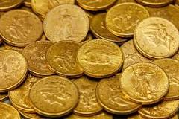  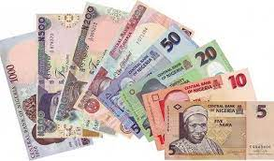 | Identify money | For proper understanding
STEP 2 | Teaches pupils  Definition of money  Money is any object or record generally accepted as payment for goods and services. | Learns attentively | For better understanding
STEP 3 | Teaches pupils the types of money we have in Nigeria.  There are two types of money used in Nigeria  - Coins  - Notes | Learns attentively | For further understanding
SUMMARY | Summarises the lesson by emphasising on the main concept and writes note on the board | Listen and copy their notes | For onward study
EVALUATION | Asks pupils to  - Identify money  - Define money  - State the types of money | Respond to the teachers questions | To test the understanding of the lesson
CONCLUSION | Summarises, reacts and corrects the pupils | Answer to the teachers questions | To consolidate the lesson
HOME WORK | - What is money?  - State the two types of money | Returns home with task | Extending the lesson home

LESSON PLAN AND NOTE FOR WEEK 2 ENDING FRIDAY, 19TH JANUARY, 2024
TERM: SECOND TERM
WEEK: WEEK 2
SUBJECT: MATHEMATICS
TOPIC: MONEY
SUB-TOPIC: TYPES OF MONEY
DATE: WEDNESDAY, 17TH AND THURSDAY, 18TH JANUARY, 2024
TIME: 10:30 – 11:10AM
DURATION: 40 MINUTES
PERIOD: 5TH
CLASS: GRADE 1
NUMBER IN CLASS: EIGHTEEN
AVERAGE AGE: FIVE
SEX: MIXED
LEARNING OBJECTIVES: By the end of the lesson, the pupils should be able to
- Identify money
- Identify a coin
- Identify a note
RATIONALE: for pupils to know the various types of money in Nigeria.
PREVIOUS KNOWLEGDE: pupils learnt about the definition of money.
INSTRUCTIONAL MATERIALS:
- Real samples of money.
- pictorial charts of money.
REFERENCE MATERIALS:
- New general mathematics for primary schools Book 2 by J Aderohunmu, A Arigbabu etal 2014
- Smart Mathematics primary Puiplis Book 2 Cambridge University Press Contributors Are D.A Afariogun, F.C Ona
- Lantern steps to Quantitative reasoning book 2 by Ore Olunloyo
LESSON DEVELOPMENT
STAGES/STEPS | TEACHER’S ACTIVITIES | PUPILS’ ACTIVITIES | LEARNING POINTS
INTRODUCTION | Display money on a flat surface | Recognises the money | Arousing the pupils interest
PRESENTATION  STEP 1 | leads the pupils to Identify money  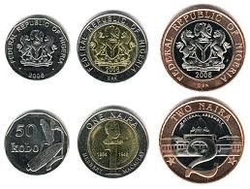  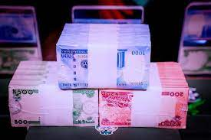 | Identify money | For proper understanding
STEP 2 | leads the pupils to Identify money (coins)  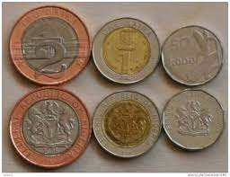 | Identify the coins | For better understanding
STEP 3 | leads the pupils to Identify money  (Notes)  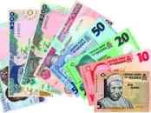 | Identify the notes | For further understanding
SUMMARY | Summarises the lesson by emphasising on the main concept and writes note on the board | Listen and copy their notes | For onward study
EVALUATION | Asks pupils to  - Identify money  - Identify a coin  - Identify a note | Respond to the teachers questions | To test the understanding of the lesson
CONCLUSION | Summarises, reacts and corrects the pupils | Answer to the teachers questions | To consolidate the lesson
HOME WORK | Identify the following money  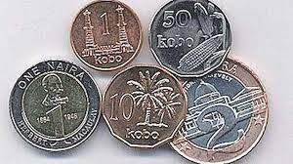 | Returns home with task | Extending the lesson home

LESSON PLAN AND NOTE FOR WEEK 2 ENDING FRIDAY, 19TH JANUARY, 2024
TERM: SECOND TERM
WEEK: WEEK 2
SUBJECT: MATHEMATICS
TOPIC: MONEY
SUB-TOPIC: USES OF MONEY
DATE: FRIDAY, 19TH JANUARY, 2024
TIME: 09:20 – 09:55AM
DURATION: 40 MINUTES
PERIOD: 3RD
CLASS: GRADE 1
NUMBER IN CLASS: SIX
AVERAGE AGE: FIVE
SEX: MIXED
LEARNING OBJECTIVES: By the end of the lesson, the pupils should be able to
- Define currency
- State another name for currency
- Mention the uses of money
RATIONALE: for pupils to know the uses of money in Nigeria.
PREVIOUS KNOWLEGDE: pupils learnt about the types of money.
INSTRUCTIONAL MATERIALS:
- Real samples of money.
- pictorial charts of money.
REFERENCE MATERIALS:
- New general mathematics for primary schools Book 2 by J Aderohunmu, A Arigbabu etal 2014
- Smart Mathematics primary Puiplis Book 2 Cambridge University Press Contributors Are D.A Afariogun, F.C Ona
- Lantern steps to Quantitative reasoning book 2 by Ore Olunloyo
LESSON DEVELOPMENT
STAGES/STEPS | TEACHER’S ACTIVITIES | PUPILS’ ACTIVITIES | LEARNING POINTS
INTRODUCTION | Display money on a flat surface | Recognises the money | Arousing the pupils interest
PRESENTATION  STEP 1 | Teaches pupils the definition of currency.  Currency is the money used in a country to buy and pay for goods. | Learns the definition of currency | For proper understanding
STEP 2 | Teaches pupils  Another name for currency. Currency is also called money. | Learns attentively | For better understanding
STEP 3 | Teaches pupils the uses of money in Nigeria.  Money can be used to  1.Buy goods and other commodities  2. Pay for services rendered by someone else  3.Save until you need it. | Learns carefully | For further understanding
SUMMARY | Summarises the lesson by emphasising on the main concept and writes note on the board | Listen and copy their notes | For onward study
EVALUATION | Asks pupils to  - Define currency  - State another name for currency  - Mention the uses of money | Respond to the teachers questions | To test the understanding of the lesson
CONCLUSION | Summarises, reacts and corrects the pupils | Answer to the teachers questions | To consolidate the lesson
HOME WORK | State 2 uses of money. | Returns home with task | Extending the lesson home


Approved as a working document.
Dep. Head Instructor (Academics)
19th January, 2024

