EMERALD ROYAL INTERNATIONAL SCHOOL.
Lesson plan for week One ending 15th September, 2023
Term: 1ST
Week: One
Date: 14th and 15th September, 2023
Class: JSS1
Subject: Cultural and creative arts
Topic: Introduction to art, history, types and origin.
Sub-topic: Meaning, Early man origin, and types/classes of art
Period: 3rd & 4th
Time: 9:30-10:10 & 10:15-10:50 am
Duration: 40 & 35 Minutes
Number in class: 18
Average age: 11+
Sex: Mixed.
Specific objectives: By the end of the lesson, the students should be able to:
1. Define and explain art.
2. Mention the types of art.
3. State the functions of art.
4. Draw the branches of art.
5. Understand the development of art in Nigeria and the early man.
Rationale: The lesson is aimed at teaching the students the basic knowledge and foundation of art.
Previous knowledge: The students have seen different types of arts before.
Instructional resources: Pictures.
Reference materials: A Proper Approach to Cultural and Creative Arts, 1. By Peter Akinyemi.
LESSON DEVELOPMENT
STEPS | TEACHER’S ACTIVITIES | STUDENTS’ ACTIVITIES | LEARNING POINTS
Introduction | To introduce the lesson, the teacher first introduces himself to the students. He states that “Art is in every facet of life”  He then welcomes the students back from the holiday and introduces them to their new class. | The students listen to the teacher, and also introduces themselves. | To introduce the lesson and create a mental image in the students about art.
Step one | He now introduces the topic of the lesson as “Introduction to art” he then defines art thus “the creative way of expressing ones feeling, ideals, thought etc”  He then explains that “this expression is done in a way that the idea will appeal to the eye of the beholder in such a way that they will appreciate it.” | The students excitedly listen as the teacher explains and also ask questions. | To ensure that the students understand the meaning of art.
Step two | Also, the teacher briefly narrates the history of Nigerian art. He states that Nigerian arts started over 2000 years ago with contemporary art springing from ancient traditional art which started with the NOK culture in central Nigeria. Other arts in Nigeria are;  - Benin.  - Ife  - Igbo-ukwu etc | The students participate and ask questions. | This is to enable the students have a background knowledge of the Nigerian art history.
Step three | The teacher now leads the students to mention the functions of art, while he explains them. | The students mention the functions of art as;  - Beautification  - Entertainment  - Educational  - Communication  - Preservation of culture  - Self-expression etc. | This is to further inform the students about about the importance of art.
Step four | The teacher now mentions the types of art and draws the branches of art.  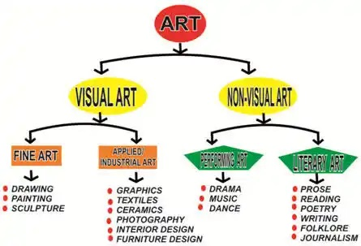 | The students participate in the process in the branches of art. | To better equip the students about the types of art and how they are group.
Step five | The teacher states that ART can be traced to a LATIN WORD “art” which means “TO DO WELL”  Art can be traced to the time of the early man. Art started with the drawing and painting on the wall of the cave, using archaic tools and object which were meant for ritual purposes. | The students listen with keen interest and ask questions | To abreast the students about the origin of art.
Summary | Summarily, the teacher briefly states that “Art is a universal language of expression. Art has been a part of man’s culture for many centuries, from the time of the cave artist to the modern day artist”  The then answers the students question. | The students listen and ask questions. | To help the students understand the lesson on history of art better, especially the slow learners in the class.
Evaluation | To test the students, he asks these questions; 1. define Art. 2. Mention any three types of arts under applied art. 3. Mention the functions of art. 4. List four types of Nigerian arts. | The students answer the questions. | To test the students. On what are you testing the students?
Conclusion | Conclusively, the teacher copies notes on the board | The students copy the notes and submit for marking | To read further.
Home work | - What is art?  - List and explain four types of Nigerian arts. | The students copy the question | To engage the students after school.
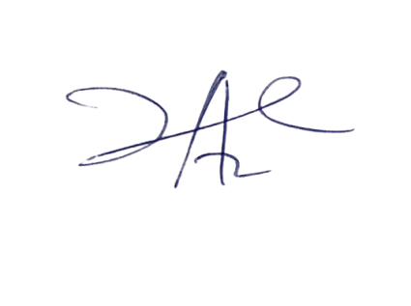
10/10/2023
Principal Head Instuctor

