EMERALD ROYAL INTERNATIONAL SCHOOL, MPAPE ABUJA
LESSON PLAN AND NOTE FOR WEEK 4 ENDING FRIDAY, 2ND FEBRUARY, 2024
TERM: SECOND TERM
WEEK: WEEK 4
SUBJECT: SOCIAL STUDIES
TOPIC: ACCIDENTS IN THE SCHOOL/HOME
SUB-TOPIC: MEANING AND TYPES OF ACCIDENT IN THE SCHOOL/HOME
DATE: TUESDAY, 30TH AND WEDNESDAY, 31ST JANUARY, 2024
TIME: 11:50 – 12:30PM AND 01:20 – 02:00PM
DURATION: 40 MINUTES
PERIOD: 8TH AND 11TH
CLASS: GRADE 1
NUMBER IN CLASS: SIX
AVERAGE AGE: FIVE
SEX: MIXED
LEARNING OBJECTIVES: By the end of the lesson, the pupils should be able to
- Identify pictures of accident victims
- Define accident
- State types of accident
RATIONALE: For pupils to know about accident and the different types of accident.
PREVIOUS KNOWLEGDE: Pupils have heard and seen scene of accidents.
INSTRUCTIONAL MATERIALS: Pictorial charts of victims of accident.
REFERENCE MATERIALS:
- Religion and National Values Social Studies for Primary schools Book 2 by Gbenga M. Babalola.

LESSON DEVELOPMENT
STAGES/STEPS | TEACHER’S ACTIVITIES | PUPILS’ ACTIVITIES | LEARNING POINTS
INTRODUCTION | Preview previous knowledge | Respond to the teacher | Arousing the pupils interest
PRESENTATION  STEP 1 | Leads pupils to Identify pictures of accident victims  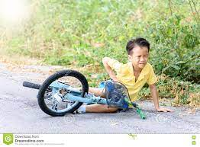  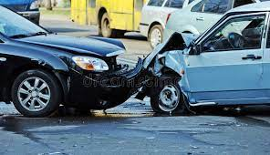      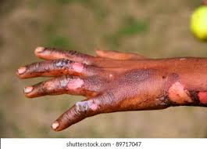        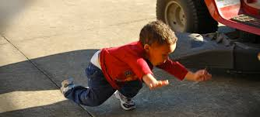  Etc.. | Identify accident victims | For proper understanding
STEP 2 | Teach pupils the definition of accident  Accident are unplanned events that lead to injury, damage or death. | Learn attentively | For better understanding
STEP 3 | Teach pupils the types of accident  1.fall  2.cut  3.burns and scald  4. bleeding  5.fainting  6. poison  Etc.... | Learn attentively | For further understanding
SUMMARY | Summarises the lesson by emphasising on the main concept and writes note on the board | Listen and copy their notes | For onward study
EVALUATION | Asks pupils to 1.Identify pictures of accident victims  2.Define accident  3.State types of accident | Respond to the teachers questions | To test the understanding of the lesson
CONCLUSION | Summarises, reacts and corrects the pupils | Answer to the teachers questions | To consolidate the lesson
HOME WORK | State four types of accident that occurs in school and at home | Returns home with task | Extending the lesson home


Approved as a working document.
Dep. Head Instructor (Academics)
2nd February, 2024

