EMERALD ROYAL INTERNATIONAL SCHOOL, MPAPE ABUJA
LESSON PLAN AND NOTE FOR WEEK 8 ENDING FRIDAY, 1ST MARCH, 2024
TERM: SECOND TERM
WEEK: WEEK 9 AND 10
SUBJECT: MATHEMATICS
TOPIC: WEIGHT
SUB-TOPIC: EXAMPLES OF SCALES
DATE: MONDAY, 26TH AND TUESDAY, 27TH FEBRUARY, 2024
TIME: 08:10 – 08:45AM AND 09:25 – 09:55AM
DURATION: 40 MINUTES
PERIOD: 1ST AND 3RD
CLASS: GRADE 1
NUMBER IN CLASS: SIX
AVERAGE AGE: FIVE
SEX: MIXED
LEARNING OBJECTIVES: By the end of the lesson, the pupils should be able to
- Define weight
- State the object for measuring weight
- List types of scales
RATIONALE: for pupils to know about weight.
PREVIOUS KNOWLEGDE: pupils learnt about measurement using containers.
INSTRUCTIONAL MATERIALS:
- Real samples of object for measuring scales.
- pictorial charts of object for measuring scales.
REFERENCE MATERIALS:
- New general mathematics for primary schools Book 2 by J Aderohunmu, A Arigbabu etal 2014
- Smart Mathematics primary Pupils Book 2 Cambridge University Press Contributors Are D.A Afariogun, F.C Ona
- Lantern steps to Quantitative reasoning book 2 by Ore Olunloyo
LESSON DEVELOPMENT
STAGES/STEPS | TEACHER’S ACTIVITIES | PUPILS’ ACTIVITIES | LEARNING POINTS
INTRODUCTION | Display picture chart on a flat surface. | Respond to the teacher | Arousing the pupils interest
PRESENTATION  STEP 1 | Teach pupils the definition of weight.  Weight determines how heavy something is.  It is measured in Kg or meters | Learn attentively | For proper understanding
STEP 2 | Teach pupils the object for measuring weight.  The object for measuring weight is a scale. | Learn carefully | For better understanding
STEP 3 | Teach pupils the types of scales.  We can use the following to measure weight  1.Hand balancing scale  2.Bathroom scale  3.Seasaw scale  4.Balancing scale | Learn and listen carefully | For further understanding
SUMMARY | Summarises the lesson by emphasising on the main concept and writes note on the board | Listen and copy their notes | For onward study
EVALUATION | Asks pupils to  1.Define weight  2.State the object for measuring weight  3.List types of scales | Respond to the teachers questions | To test the understanding of the lesson
CONCLUSION | Summarises, reacts and corrects the pupils | Answer to the teachers questions | To consolidate the lesson
HOME WORK | New general mathematics for primary schools  Workbook book 2  Page 35 - 36  Worksheet 24  Exercise 1 - 4 | Returns home with task | Extending the lesson home

LESSON PLAN AND NOTE FOR WEEK 8 ENDING FRIDAY, 1ST MARCH, 2024
TERM: SECOND TERM
WEEK: WEEK 9 AND 10
SUBJECT: MATHEMATICS
TOPIC: WEIGHT
SUB-TOPIC: MEASURING WITH SCALES
DATE: WEDNESDAY, 28TH AND THURSDAY, 29TH FEBRUARY, 2024
TIME: 10:30 – 11:10AM
DURATION: 40 MINUTES
PERIOD: 5TH
CLASS: GRADE 1
NUMBER IN CLASS: SIX
AVERAGE AGE: FIVE
SEX: MIXED
LEARNING OBJECTIVES: By the end of the lesson, the pupils should be able to
1.Identify a hand balancing scale
2.Answer questions using hand balancing scale
3. Identify a bathroom scale and answer questions using a bathroom scale
RATIONALE: for pupils to know more about weight.
PREVIOUS KNOWLEGDE: pupils learnt about types of scales.
INSTRUCTIONAL MATERIALS:
- Real samples of object for measuring scales.
- pictorial charts of object for measuring scales.
REFERENCE MATERIALS:
- New general mathematics for primary schools Book 2 by J Aderohunmu, A Arigbabu etal 2014
- Smart Mathematics primary Pupils Book 2 Cambridge University Press Contributors Are D.A Afariogun, F.C Ona
- Lantern steps to Quantitative reasoning book 2 by Ore Olunloyo
LESSON DEVELOPMENT
STAGES/STEPS | TEACHER’S ACTIVITIES | PUPILS’ ACTIVITIES | LEARNING POINTS
INTRODUCTION | Review previous knowledge | Respond to the teacher | Arousing the pupils interest
PRESENTATION  STEP 1 | Teach pupils to Identify a hand balancing scale    A Hand Balancing scale | Learn attentively | For proper understanding
STEP 2 | Teach pupils how to answer questions using hand balancing scale  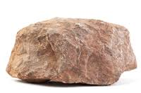  Which one is heavier?  or  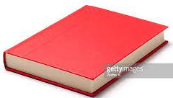  The stone is heavier than the book.  Etc. | Listen carefully | For better understanding
STEP 3 | 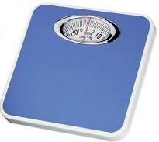  Teach pupils to Identify a bathroom scale and answer questions using a bathroom scale.  A Bathroom scale  Which is lighter?  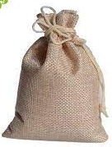  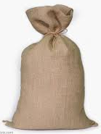  Or  25Kg 50Kg  The 25Kg bag is lighter  Etc. | Learns attentively | For further understanding
SUMMARY | Summarises the lesson by emphasising on the main concept and writes note on the board | Listen and copy their notes | For onward study
EVALUATION | Asks pupils to  1.Identify a hand balancing scale  2.Answer questions using hand balancing scale  3. Identify a bathroom scale and answer questions using a bathroom scale | Respond to the teachers questions | To test the understanding of the lesson
CONCLUSION | Summarises, reacts and corrects the pupils | Answer to the teachers questions | To consolidate the lesson
HOME WORK | New general mathematics for primary schools  Workbook book 2  Page 35 - 36  Worksheet 24  Exercise 1 - 4 | Returns home with task | Extending the lesson home

LESSON PLAN AND NOTE FOR WEEK 8 ENDING FRIDAY, 1ST MARCH, 2024
TERM: SECOND TERM
WEEK: WEEK 9 AND 10
SUBJECT: MATHEMATICS
TOPIC: WEIGHT
SUB-TOPIC: MEASURING WITH SCALES
DATE: FRIDAY, 1ST MARCH, 2024
TIME: 09:20 – 09:55AM
DURATION: 40 MINUTES
PERIOD: 3RD
CLASS: GRADE 1
NUMBER IN CLASS: SIX
AVERAGE AGE: FIVE
SEX: MIXED
LEARNING OBJECTIVES: By the end of the lesson, the pupils should be able to
- Identify a seasaw scale
- Answer questions using seasaw scale
- Identify a balancing scale and answer questions using a balancing scale
RATIONALE: for pupils to know how to measure with measuring scales
PREVIOUS KNOWLEGDE: pupils learnt about types of scales.
INSTRUCTIONAL MATERIALS:
- Real samples of object for measuring scales.
- pictorial charts of object for measuring scales.
REFERENCE MATERIALS:
- New general mathematics for primary schools Book 2 by J Aderohunmu, A Arigbabu etal 2014
- Smart Mathematics primary Pupils Book 2 Cambridge University Press Contributors Are D.A Afariogun, F.C Ona
- Lantern steps to Quantitative reasoning book 2 by Ore Olunloyo
LESSON DEVELOPMENT
STAGES/STEPS | TEACHER’S ACTIVITIES | PUPILS’ ACTIVITIES | LEARNING POINTS
INTRODUCTION | Display the days of the week on a flash card and calendar on a flat surface | Identify the flash cards and calendar | Arousing the pupils interest
PRESENTATION  STEP 1 | Teach the pupils to identify a seasaw scale  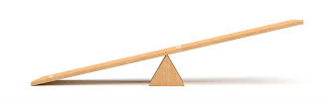  A seasaw scale | Learn attentively | For proper understanding
STEP 2 | Teach pupils how to answer questions using seasaw scale  How many objects are equal in weight to an object?  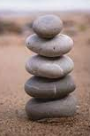  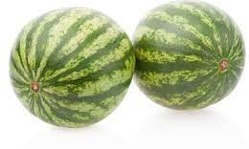  And  5 rocks are equal in weight to 2 watermelon.  Etc. | Learn carefully | For better understanding
STEP 3 | Teach pupils to identify a balancing scale and answer questions using a balancing scale  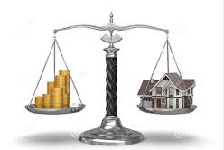  How many objects are equal in weight?  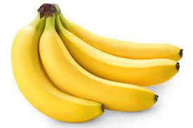  And  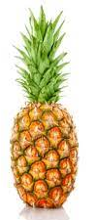  A bunch of banana is equal to a pineapple  Etc. | Learns attentively | For further understanding
SUMMARY | Summarises the lesson by emphasising on the main concept and writes note on the board | Listen and copy their notes | For onward study
EVALUATION | Asks pupils to  1.Identify a seasaw scale  2.Answer questions using seasaw scale  3. Identify a balancing scale and answer questions using a balancing scale | Respond to the teachers questions | To test the understanding of the lesson
CONCLUSION | Summarises, reacts and corrects the pupils | Answer to the teachers questions | To consolidate the lesson
HOME WORK | New general mathematics for primary schools  Workbook book 2  Page 35 - 36  Worksheet 24  Exercise 1 - 4 | Returns home with task | Extending the lesson home


Approved as a working document.
Dep. Head Instructor (Academics)
1st March, 2024

