EMERALD ROYAL INTERNATIONAL SCHOOL, MPAPE ABUJA
LESSON PLAN AND NOTE FOR WEEK 5 ENDING FRIDAY, 9TH FEBRUARY, 2024
TERM: SECOND TERM
WEEK: WEEK 5
SUBJECT: SOCIAL STUDIES
TOPIC: ACCIDENTS IN THE SCHOOL/HOME
SUB-TOPIC: CAUSES OF ACCIDENT IN THE SCHOOL/HOME
DATE: TUESDAY, 6TH AND WEDNESDAY, 7TH FEBRUARY, 2024
TIME: 11:50 – 12:30PM AND 01:20 – 02:00PM
DURATION: 40 MINUTES
PERIOD: 8TH AND 11TH
CLASS: GRADE 1
NUMBER IN CLASS: SIX
AVERAGE AGE: FIVE
SEX: MIXED
LEARNING OBJECTIVES: By the end of the lesson, the pupils should be able to
- Identify causes of accident victims
- State the causes of accident
- Write the causes of accident
RATIONALE: for pupils to know about accident and the causes of accident.
PREVIOUS KNOWLEGDE: pupils learnt about accidents and types of accident.
INSTRUCTIONAL MATERIALS: pictorial charts of causes of accident.
REFERENCE MATERIALS:
- Religion and National Values Social Studies for Primary schools Book 2 by Gbenga M. Babalola.

LESSON DEVELOPMENT
STAGES/STEPS | TEACHER’S ACTIVITIES | PUPILS’ ACTIVITIES | LEARNING POINTS
INTRODUCTION | Preview previous knowledge | Respond to the teacher | Arousing the pupils interest
PRESENTATION  STEP 1 | Leads pupils to Identify causes of accident  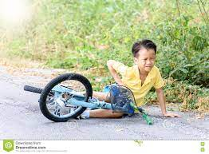  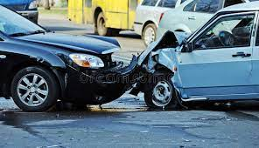      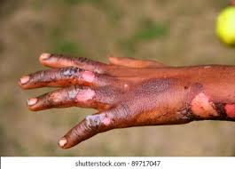  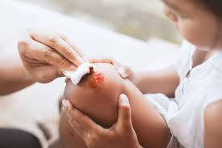      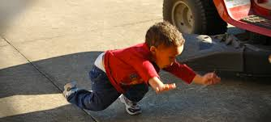  Etc.. | Identify accident victims | For proper understanding
STEP 2 | Teach pupils the the causes of accident  Accident can be caused by the following  - FALL : fall from ladders, stools, chairs. Shower. Stalls, standing on a chair or table, running around the school or home etc.  - CUTS: caused by playing with sharp objects such as razor blade, knife, nails, needles etc.  - BURNS & SCALDS: it occurs as a result of fire or hot objects like pressing iron, gas cooker, hot water, pressure cooker etc.  - BLEEDING: it is a situation whereby blood comes out of the body due to deep cut.  - FAINTING: it is caused when a person stands motionless for too long.  - FRACTURES & DISLOCATIONS: it occurs when we fall or injure ourselves while playing, driving or working etc. | Learn attentively | For better understanding
STEP 3 | Leads pupils to write the causes of accident | Write the causes of accident | For further understanding
SUMMARY | Summarises the lesson by emphasising on the main concept and writes note on the board | Listen and copy their notes | For onward study
EVALUATION | Asks pupils to 1.Identify causes of accident victims  2.State the causes of accident  3.Write the causes of accident | Respond to the teachers questions | To test the understanding of the lesson
CONCLUSION | Summarises, reacts and corrects the pupils | Answer to the teachers questions | To consolidate the lesson
HOME WORK | State two causes of accident that occurs in school and at home | Returns home with task | Extending the lesson home


Approved as a working document.
Dep. Head Instructor (Academics)
9th February, 2024

