EMERALD ROYAL INTERNATIONAL SCHOOL, MPAPE ABUJA
LESSON PLAN AND NOTE FOR WEEK 1 ENDING FRIDAY, 12TH JANUARY, 2024
TERM: SECOND TERM
WEEK: WEEK 1
SUBJECT: BASIC SCIENCE
TOPIC: SOIL
SUB-TOPIC: DEFINITION OF SOIL
DATE: TUESDAY, 9TH AND WEDNESDAY, 10TH JANUARY, 2024
TIME: 08:10 – 9:25AM AND 09:25 – 09:55AM
DURATION: 40 MINUTES
PERIOD: 1^{ST,} 2ND AND 3RD
CLASS: GRADE 1
NUMBER IN CLASS: SIX
AVERAGE AGE: FIVE
SEX: MIXED
LEARNING OBJECTIVES: By the end of the lesson, the pupils should be able to
- Identify soil
- Define soil
- State types of soil
RATIONALE: for pupils to know that soil is part of the environment.
PREVIOUS KNOWLEGDE: pupils see sand and play with it around their environment
INSTRUCTIONAL MATERIALS: sample of soil and pictorial charts of soil.
REFERENCE MATERIALS:
- Lantern Comprehensive Basic Science and Technology For Primary Schools Book 2 by O.J Ehindero, J.B Arubayi etal 2000
- Foundations of Basic Science and Technology Book 2 by chris Ijiyemi

STAGES/STEPS | TEACHER’S ACTIVITIES | PUPILS’ ACTIVITIES | LEARNING POINTS
INTRODUCTION | Ask pupils if they have seen sand in the school environment | Respond to the teachers question | Arousing the pupils’ interest
PRESENTATION  STEP 1 | Leads pupils to identify soil  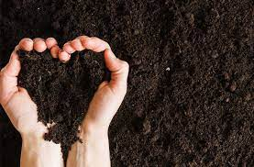  (picture of soil) | Identify the soil | For proper understanding
STEP 2 | Teaches the pupils definition of soil  Soil is the upper layer of the earth surface where plants grow and get materials to prepare their food. | Learn attentively | For better understanding
STEP 3 | Teaches pupils the types of soil  There are three types of soil. They include  - Clay soil  - Sandy soil  - Loamy soil | Listen carefully | For further understanding
SUMMARY | Summarises the lesson by emphasising on the main concept and writes note on the board | Listen and copy their notes | For onward study
EVALUATION | Asks pupils to  - Identify soil  - Define soil  - State types of soil | Respond to the teachers questions | To test the understanding of the lesson
CONCLUSION | Summarises, reacts and corrects the pupils | Answer to the teachers questions | To consolidate the lesson
HOME WORK | - What picture is this?  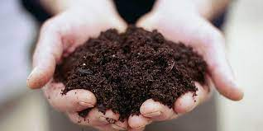  - What is soil?  - How many types of soil do we have and name them | Return home with task | Extending the lesson home


Approved as a working document.
Dep. Head Instructor (Academics)
12th January, 2024

