EMERALD ROYAL INTERNATIONAL SCHOOL, MPAPE ABUJA
LESSON PLAN AND NOTE FOR WEEK 4 ENDING FRIDAY, 2ND FEBRUARY, 2024
TERM: SECOND TERM
WEEK: WEEK 4
SUBJECT: MATHEMATICS
TOPIC: MONEY
SUB-TOPIC: CHANGING UNITS OF MONEY
DATE: MONDAY, 29TH AND TUESDAY, 30TH JANUARY, 2024
TIME: 08:10 – 08:45AM AND 09:25 – 09:55AM
DURATION: 40 MINUTES
PERIOD: 1ST AND 3RD
CLASS: GRADE 1
NUMBER IN CLASS: SIX
AVERAGE AGE: FIVE
SEX: MIXED
LEARNING OBJECTIVES: By the end of the lesson, the pupils should be able to
- Identify the value of the currency (coins and notes)
- Change and break currency (coins)
- Change and break currency (notes)
RATIONALE: for pupils to know how to change and break currency (coins and notes) into smaller bit.
PREVIOUS KNOWLEGDE: pupils learnt recognition of Nigeria currency coins and notes.
INSTRUCTIONAL MATERIALS:
- Real samples of money.
- pictorial charts of money.
REFERENCE MATERIALS:
- New general mathematics for primary schools Book 2 by J Aderohunmu, A Arigbabu etal 2014
- Smart Mathematics primary Pupils Book 2 Cambridge University Press Contributors Are D.A Afariogun, F.C Ona
- Lantern steps to Quantitative reasoning book 2 by Ore Olunloyo
LESSON DEVELOPMENT
STAGES/STEPS | TEACHER’S ACTIVITIES | PUPILS’ ACTIVITIES | LEARNING POINTS
INTRODUCTION | Display the currencies on a flat surface | Recognises the money | Arousing the pupils interest
PRESENTATION  STEP 1 | Leads the pupils to Identify the value of the currency (coins and notes)  5k and 10K  ₦1 and ₦2  ₦10 and ₦20  Etc | Identify money (coins and notes) | For proper understanding
STEP 2 | Teach pupils how to change and break the value of the currency (coins)  - 5k = 1k+1k+1k+1k+1k  - 10K = 2k+2k+2k+2k+2k  - ₦1 = 5k+5k  - ₦2 = ₦1+₦1  Etc | Learns attentively | For better understanding
STEP 3 | Teach pupils how to change and break the value of the currency (note)  - ₦5 = ₦1+₦1+₦1+₦1+₦1  - ₦10 = ₦2+₦2+₦2+₦2₦2 or  ₦5+₦5  ₦20 = ₦5+₦5+₦5+₦5 or ₦10+₦10  - ₦50 = ₦10+₦10+₦10+₦10+₦10 or  ₦20+₦20₦10  etc | Learns attentively | For further understanding
SUMMARY | Summarises the lesson by emphasising on the main concept and writes note on the board | Listen and copy their notes | For onward study
EVALUATION | Asks pupils to  1.Identify the value of the currency (coins and notes)  2.Change and break currency (coins)  3.Change and break currency (notes) | Respond to the teachers questions | To test the understanding of the lesson
CONCLUSION | Summarises, reacts and corrects the pupils | Answer to the teachers questions | To consolidate the lesson
HOME WORK | New general mathematics for primary schools  Workbook book 2  Page 26  Worksheet 19  Exercise 1 | Returns home with task | Extending the lesson home

LESSON PLAN AND NOTE FOR WEEK 4 ENDING FRIDAY, 2ND FEBRUARY, 2024
TERM: SECOND TERM
WEEK: WEEK 4
SUBJECT: MATHEMATICS
TOPIC: MONEY
SUB-TOPIC: SHOPPING WITH MONEY
DATE: WEDNESDAY, 31ST AND THURSDAY, 1ST FEBRUARY, 2024
TIME: 10:30 – 11:10AM
DURATION: 40 MINUTES
PERIOD: 5TH
CLASS: GRADE 1
NUMBER IN CLASS: SIX
AVERAGE AGE: FIVE
SEX: MIXED
LEARNING OBJECTIVES: By the end of the lesson, the pupils should be able to
- Identify the kobo on the coin
- Solve addition of coin
- Solve subtraction of coin
RATIONALE: for pupils to know how to shop -with money (kobo).
PREVIOUS KNOWLEGDE: pupils learnt about the change and break of the value of currency (coins and notes).
INSTRUCTIONAL MATERIALS:
- Real samples of money.
- pictorial charts of money
- Items to be sold.
REFERENCE MATERIALS:
- New general mathematics for primary schools Book 2 by J Aderohunmu, A Arigbabu etal 2014
- Smart Mathematics primary Pupils Book 2 Cambridge University Press Contributors Are D.A Afariogun, F.C Ona
- Lantern steps to Quantitative reasoning book 2 by Ore Olunloyo
LESSON DEVELOPMENT
STAGES/STEPS | TEACHER’S ACTIVITIES | PUPILS’ ACTIVITIES | LEARNING POINTS
INTRODUCTION | Display the currencies on a flat surface | Recognises the money | Arousing the pupils interest
PRESENTATION  STEP 1 | leads the pupils to Identify the kobo on each coins | Identify the kobo on the coins | For proper understanding
STEP 2 | Teach pupils to solve addition of coin. | Learns attentively | For better understanding
   | K & ₦ | TOTAL
  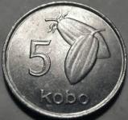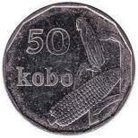 + | 55k
  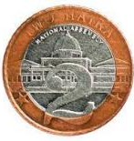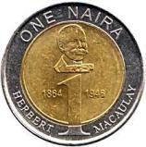+ | 3K
STEP 3 | Teach pupils to solve subtraction of coin. | Learns attentively | For further understanding
   | YOU PAY WITH | YOUR CHANGE
  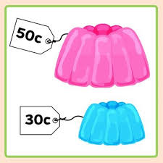 | 50K | 20K
   | ₦ 1 | 50K
SUMMARY | Summarises the lesson by emphasising on the main concept and writes note on the board | Listen and copy their notes | For onward study
EVALUATION | Asks pupils to  1.Identify the kobo on the coin  2.Solve addition of coin  3.Solve subtraction of coin | Respond to the teachers questions | To test the understanding of the lesson
CONCLUSION | Summarises, reacts and corrects the pupils | Answer to the teachers questions | To consolidate the lesson
HOME WORK | New general mathematics for primary schools  Workbook book 2  Page 27-28  Worksheet 19  Exercise 3-4 | Returns home with task | Extending the lesson home

LESSON PLAN AND NOTE FOR WEEK 4 ENDING FRIDAY, 2ND FEBRUARY, 2024
TERM: SECOND TERM
WEEK: WEEK 4
SUBJECT: MATHEMATICS
TOPIC: MONEY
SUB-TOPIC: RECOGNITION OF CURRENCY (COINS AND BANK NOTE)
DATE: FRIDAY, 2ND FEBRUARY, 2024
TIME: 09:20 – 09:55AM
DURATION: 40 MINUTES
PERIOD: 3RD
CLASS: GRADE 1
NUMBER IN CLASS: SIX
AVERAGE AGE: FIVE
SEX: MIXED
LEARNING OBJECTIVES: By the end of the lesson, the pupils should be able to
- Identify the naira on the note
- Solve addition of note
- Solve subtraction of note
RATIONALE: for pupils to know how to shop -with money (note).
PREVIOUS KNOWLEGDE: pupils learnt about shop with money (coins).
INSTRUCTIONAL MATERIALS:
- Real samples of money.
- pictorial charts of money
- Items to be sold.
REFERENCE MATERIALS:
- New general mathematics for primary schools Book 2 by J Aderohunmu, A Arigbabu etal 2014
- Smart Mathematics primary Pupils Book 2 Cambridge University Press Contributors Are D.A Afariogun, F.C Ona
- Lantern steps to Quantitative reasoning book 2 by Ore Olunloyo
LESSON DEVELOPMENT
STAGES/STEPS | TEACHER’S ACTIVITIES | PUPILS’ ACTIVITIES | LEARNING POINTS
INTRODUCTION | Display the currencies on a flat surface | Recognises the money | Arousing the pupils interest
PRESENTATION  STEP 1 | leads the pupils to Identify the naira on each note | Identify the naira on the note | For proper understanding
STEP 2 | Teach pupils to solve addition of note. | Learns attentively | For better understanding
   | ₦ | TOTAL
  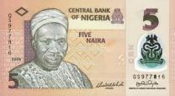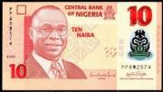+ | ₦ 15 |  | ₦ 15
  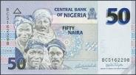+  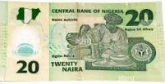 | ₦ 70 |  | ₦ 70
STEP 3 | Teach pupils to solve subtraction of note. | Learns attentively | For further understanding
   | YOU PAY WITH | YOUR CHANGE
  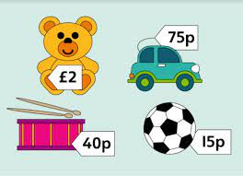 | ₦ 100 | ₦ 25
   | ₦ 20 | ₦ 5
SUMMARY | Summarises the lesson by emphasising on the main concept and writes note on the board | Listen and copy their notes | For onward study
EVALUATION | Asks pupils to  1.Identify the naira on the note  2.Solve addition of note  3.Solve subtraction of note | Respond to the teachers questions | To test the understanding of the lesson
CONCLUSION | Summarises, reacts and corrects the pupils | Answer to the teachers questions | To consolidate the lesson
HOME WORK | New general mathematics for primary schools  Workbook book 2  Page 27-28  Worksheet 19  Exercise 3-4 | Returns home with task | Extending the lesson home


Approved as a working document.
Dep. Head Instructor (Academics)
2nd February, 2024

