**EMERALD ROYAL INTERNATIONAL SCHOOL MPAPE, ABUJA.**

**LESSON PLAN AND NOTE FOR WEEK 8 PERIOD 1 ENDING 14/06/2024**

**TERM: THIRD**

**WEEK: 8TH**

**DATE: 10/06/2024**

**CLASS: NURSERY 2**

**SUBJECT: LETTER WORK**

**TOPIC: COMMON THINGS IN THE CLASSROOM**

**SUB-TOPIC: IDENTIFICATION OF THINGS IN THE CLASSROOM**

**PERIOD: 1ST PERIOD**

**TIME: 09: 30 - 10:10am**

**DURATION: 40 MINUTES.**

**NUMBER IN CLASS: 13**

**AVERAGE AGE: 5 YEARS.**

**SEX: MIXED.**

**SPECIFIC OBJECTIVES: BY THE END OF THE LESSON,THE PUPILS SHOULD BE**

**ABLE TO:**

**1. MENTION THINGS IN THE CLASSROOM**

**2. SPELL AND PRONOUNCE THINGS IN THE**

**CLASSROOM**

**RATIONALE: FOR PUPILS TO KNOW HOW TO SPELL THINGS IN**

**CLASSROOM**

**PREVIOU KNOWLEDGE: PUPILS HAVE BEEN MAKING USE OF THINGS IN THE**

**CLASSROOM**

**INSTRUCTIONAL MATERIALS: PENCILS,BOOKS, CHAIRS AND DESK**

**REFERENCE MATERIALS: THE NEW MASTERING ENGLISH FOR NURSERY**

**SCHOOLS BOOK 3 BY J .M OMOGBAI .**

**LESSON DEVELOPMENT**

|  |  |  |  |
| --- | --- | --- | --- |
| **STAGES/STEPS** | **TEACHER’S ACTIVITIES** | **PUPILS’ ACTIVITIES** | **LEARNING POINTS** |
| **INTRODUCTION** | **Teacher reviews the previous lesson on vowel digraphs to pupils.** | **Pupil listen attentively to the teacher.** | **To prepare pupils minds for the lesson ahead.** |
| **PRESENTATION**  **STEP 1** | **Teacher mentions the things in the classroom to pupils and asks them to repeat after her.** | **Pupils listen attentively to the teacher and repeat after her.** | **For proper understanding .** |
| **STEP 2** | **Teacher writes the words on things in the classroom on the board, spell and pronounce and also asks pupils to repeat after her.** | **Pupils pay attention to the teacher and repeat after her.** | **For better understanding of the lesson.** |
| **BOARD SUMMARY** | **Teacher writes the whole not of lesson on the board for pupils to copy.ie,**  **COMMON THINGS IN THE CLASSROOM**  **The following are things we can find the classroom:**  **1. Eraser**  **2. Ruler**  **3. Desk**  **4. Calculator**  **5. Chair**  **6. Books**  **7. Pencils**  **8. Scissors**  **9. Backpack**  **10. Pen**  **11. Crayon**  **12. Board**  **13. Sharpener**  **14. Clock**  **15. Paint**  **16. Paper**  **17. Waste bin**  **18. Paint brush**  **19. Pencil case**  **20. Calendar etc.** | **Pupils copy the note into their exercise books.** | **For onward study.** |
| **EVALUATION** | **Teacher evaluates the lesson by asking asking the following questions:**  **1. MENTION the things in the classroom.**  **2. Spell and pronounce the things in the classroom on the board one after another** | **Pupils listen to the teacher and answer the questions asked by her..** | **To assess pupils reading skills.** |
| **CONCLUTION** | **Teacher concludes the lesson by marking pupils books.** | **Pupils submit their books for marking.** | **For endorsement.** |
| **ASSIGNMENT** | **Answer the following questions:** | **Pupils do their assignment at home.** | **To encourage learning at home.** |

**LESSON PLAN AND NOTE FOR WEEK 8 PERIOD 2 ENDING 14/06/2024**

**TERM: THIRD**

**WEEK: 8TH**

**DATE: 11/06/2024**

**CLASS: NURSERY 2**

**SUBJECT: LETTER WORK**

**TOPIC: COMMON THINGS IN THE CLASSROOM**

**SUB-TOPIC: THINGS IN THE SCHOOL ENVIRONMENT**

**PERIOD: 2ND PERIOD**

**TIME: 08: 50 - 09:30am**

**DURATION: 40 MINUTES.**

**NUMBER IN CLASS: 13**

**AVERAGE AGE: 5 YEARS.**

**SEX: MIXED.**

**SPECIFIC OBJECTIVES: BY THE END OF THE LESSON,THE PUPILS SHOULD BE**

**ABLE TO:**

**1. MENTION THINGS IN SCHOOL ENVIRONMENT**

**2. SPELL AND PRONOUNCE THINGS IN SCHOOL**

**ENVIRONMENT**

**RATIONALE: FOR PUPILS TO KNOW THINGS IN SCHOOL**

**ENVIRONMENT**

**PREVIOU KNOWLEDGE: PUPILS HAVE LEARNT THINGS IN THE CLASSROOM**

**IN PREVIOUS LESSON**

**INSTRUCTIONAL MATERIALS: STAPLER, COMPUTER, AND TELEVISION**

**REFERENCE MATERIALS: GOOGLE.COM**

**LESSON DEVELOPMENT**

|  |  |  |  |
| --- | --- | --- | --- |
| **STAGES/STEPS** | **TEACHER’S ACTIVITIES** | **PUPILS’ ACTIVITIES** | **LEARNING POINTS** |
| **INTRODUCTION** | **Teacher introduces the lesson by taking pupils round the school environment.** | **Pupil walk together with the teacher round the school environment.** | **To prepare pupils minds for the lesson ahead.** |
| **PRESENTATION**  **STEP 1** | **Teacher mentions the things in the school environment to pupils and asks them to repeat after her.** | **Pupils listen attentively to the teacher and repeat after her.** | **For proper understanding .** |
| **STEP 2** | **Teacher writes the things in the school environment on the board, spell and pronounce and also asks pupils to repeat after her.** | **Pupils pay attention to the teacher and repeat after her.** | **For better understanding of the lesson.** |
| **BOARD SUMMARY** | **Teacher writes the whole not of lesson on the board for pupils to copy.ie,**  **Things in the school environment are:**  **1. School bus**  **2. Television**  **3. Waste bin**  **4. C C T V camera**  **5. Power bike**  **6. Slide**  **7. Swing**  **8. Computer**  **9. Stapler**  **10. Pins etc.** | **Pupils copy the note into their exercise books.** | **For onward study.** |
| **EVALUATION** | **Teacher evaluates the lesson by asking pupils the following questions:**  **1. Mention the things in the school environment.**  **2. Spell and PRONOUNCE the words on the board one after the other.** | **Pupils listen to the teacher and answer the questions asked by her.** | **To assess pupils reading skills.** |
| **CONCLUTION** | **Teacher concludes the lesson by marking pupils books.** | **Pupils submit their books for marking.** | **For endorsement.** |
| **ASSIGNMENT** | **Match the pictures below to the given words.** | **Pupils do their assignment at home.** | **To encourage learning at home.** |

**LESSON PLAN AND NOTE FOR WEEK 8 PERIOD 3 ENDING 14/06/2024**

**TERM: THIRD**

**WEEK: 8TH**

**DATE: 14/06/2024**

**CLASS: NURSERY 2**

**SUBJECT: LETTER WORK**

**TOPIC: COMMON THINGS IN THE CLASSROOM**

**SUB-TOPIC: MATCHING WORDS WITH IN THE CLASSROOM**

**PERIOD: 3RD PERIOD**

**TIME: 09: 30 - 10:10am**

**DURATION: 40 MINUTES.**

**NUMBER IN CLASS: 17**

**AVERAGE AGE: 5 YEARS.**

**SEX: MIXED.**

**SPECIFIC OBJECTIVES: BY THE END OF THE LESSON,THE PUPILS SHOULD BE ABLE TO:**

**1. MENTION THINGS IN THE CLASSROOM**

**AND IN THE SCHOOL ENVIRONMENT**

**2. MATCH THE THINGS IN THE CLASSROOM TO WORDS**

**RATIONALE: TO IMPROVE PUPILS EYE AND HAND COORDINATION**

**PREVIOU KNOWLEDGE: PUPILS HAVE LEARNT ABOUT THINGS IN THE SCHOOL**

**ENVIROMENT.**

**INSTRUCTIONAL MATERIALS: CHAIRS, PENCILS, AND RULER**

**REFERENCE MATERIALS: NEW MASTERING ENGLISH FOR NURSERY**

**SCHOOLS BOOK 3 BY J. M OMOGBAI**

**LESSON DEVELOPMENT**

|  |  |  |  |
| --- | --- | --- | --- |
| **STAGES/STEPS** | **TEACHER’S ACTIVITIES** | **PUPILS’ ACTIVITIES** | **LEARNING POINTS** |
| **INTRODUCTION** | **Teacher reviews the previous lesson on to pupils.** | **Pupil listen attentively to the teacher.** | **To prepare pupils minds for the lesson ahead.** |
| **PRESENTATION**  **STEP 1** | **Teacher mentions the things in the classroom and things in the school environment and then asks Pupils to repeat after her.** | **Pupils listen attentively to the teacher and repeat after her.** | **For proper understanding** |
| **STEP 2** | **Teacher guides pupils to read and match the things in the classroom.** | **Pupils rea and match the things in the classroom** | **For better understanding of the lesson.** |
| **BOARD SUMMARY** | **Teacher writes the whole not of lesson on the board for pupils to copy and match. As;**  **Things in the class and school environment are:**  **1. Books**  **2. Chairs**  **3. Desk**  **4. Pencils**  **5. Crayon**  **6. School bus**  **7. Swing**  **8. Slide**  **9. Television**  **10. Computer etc**  **Matching of words to objects in the classroom** | **Pupils copy the note into their exercise books.** | **For onward study.** |
| **EVALUATION** | **Teacher evaluates the lesson by asking pupils the following questions:**  **1. Mention the things in the classroom.**  **2. List the things in the school environment.** | **Pupils read the note on the board one after another.** | **To assess pupils reading skills.** |
| **CONCLUTION** | **Teacher concludes the lesson by marking pupils books.** | **Pupils submit their books for marking.** | **For endorsement.** |
| **ASSIGNMENT** | **Match the following sentences to the correct objects.** | **Pupils do their assignment at home.** | **To encourage learning at home.** |

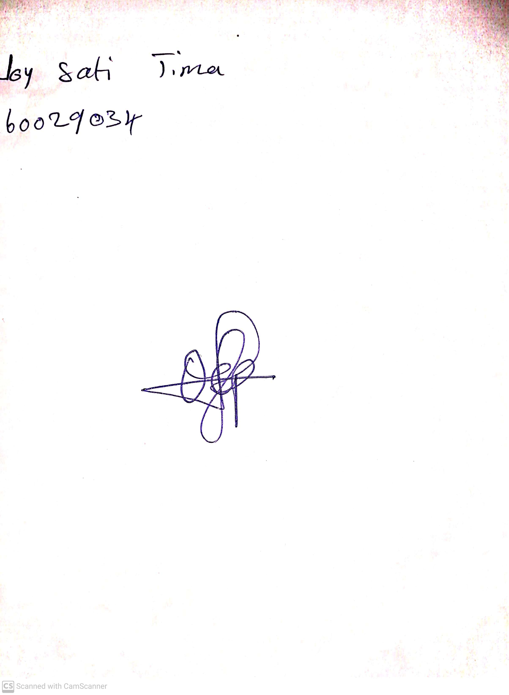

**7th June, 2024**

**Perpetual Ojoma**

**Stream Head Nursery**