**LESSON PLAN AND NOTE 1 FOR WEEK 3 ENDING 10/5/2024**

**Term 3rd term**

**Week 3rd week**

**Date 6/5/2024**

**Class Nursery one**

**Subject Letter work**

**Topic Coping words with letter Rr - Zz.**

**Sub-topic Naming three letter words with letter Rr - Zz.**

**Period 2nd period**

**Time 9:05 am**

**Duration 35 minutes**

**No in class 14**

**Average Age 3 years**

**Sex Mixed**

**Specific Objectives: By the end of the lesson the pupils should be able to;**

1. **Name three letter words that with Rr - Zz.**
2. **Trace three letter words that with Rr - Zz.**

**Rationale: To make sure the pupils mention and trace three letter words**

**with Rr - Zz.**

**Previous knowledge: The pupils can write three letter words with Mm-Qq.**

**Instructional Resources: Chart, board, marker, exercise books, pencils.**

**Reference Materials: Online Research,chart,board.**

**LESSON PRESENTATION**

|  |  |  |  |
| --- | --- | --- | --- |
| **Steps** | **Teacher’s Activities** | **Pupils’ Activities** | **Learning points** |
| **Introduction** | **The teacher introduces the topic (coping words with letter Rr - Zz.) to the pupils.** | **The pupils listen attentively to the teacher.** | **To arouse the interest of the pupils.** |
| **Step 1** | **The teacher starts by naming three letter words with Rr - Zz. for the pupils to repeat after ‘’rat’’, ‘’sun’’, “tap”, “van”, “win”, “yam”, “zip”.** | **The pupils repeat after the teacher the three letter words with Rr - Zz ‘’rat’’, ‘’sun’’, “tap”, “van”, “win”, “yam”, “zip”.** | **For proper understanding.** |
| **Step 2** | **The teacher guides the pupils in tracing three letter words with sound Rr - Zz.** | **The pupils trace the three letter words with Rr - Zz as the teacher guides them.** | **For better understanding.** |
| **Summary** | **The teacher summarizes the lesson by sounding three letter words with Rr - Zz : ‘’rat’’, ‘’sun’’, “tap”, “van”, “win”, “yam”, “zip”.** | **The pupils can sound three letter words with Rr - Zz : ‘’rat’’, ‘’sun’’, “tap”, “van”, “win”, “yam”, “zip”.** | **For onward study.** |
| **Evaluation** | **Question:**   1. **Mention the three letter word starting with Rr - Zz.** 2. **Trace words with Rr - Zz.** | **The pupils answer the question correctly.** | **To ascertain the pupils’ understanding.** |
| **Conclusion** | **The teacher summarizes, reacts & corrects the pupils.** | **The pupils answer to the teacher’s questions.** | **To consolidate the lesson.** |
| **Assignment** | **Question:**  **Mention the three letter word starting with Rr - Zz.**  **Trace words with Rr - Zz.** | **The pupils copy and do their homework at home.** | **To encourage learning while at home.** |

**LESSON PLAN AND NOTE 2 FOR WEEK 3 ENDING 10/5/2024**

**Term 3rd term**

**Week 3rd week**

**Date 8/5/2024**

**Class Nursery one**

**Subject Letter work**

**Topic Coping words with letter Rr - Zz.**

**Sub-topic Colouring objects & animals with Rr - Zz.**

**Period 2nd period**

**Time 9:32 am**

**Duration 35 minutes**

**No in class 14**

**Average Age 3 years**

**Sex Mixed**

**Specific Objectives: By the end of the lesson the pupils should be able to;**

1. **Identify three letter words &objects that start with Rr - Zz.**
2. **Colour three letter words &objects that start with Rr - Zz.**

**Rationale: To make the pupils identify &colour three letter words**

**with Rr - Zz.**

**Previous knowledge: The pupils have name &trace letter words starting with Rr - Zz.**

**Instructional Resources: Crayon, board, marker, exercise books, pencils.**

**Reference Materials: Online Research,marker,board.**

**LESSON PRESENTATION**

|  |  |  |  |
| --- | --- | --- | --- |
| **Steps** | **Teacher’s Activities** | **Pupils’ Activities** | **Learning points** |
| **Introduction** | **The teacher introduces the topic (coping words with letter Rr - Zz) to the pupils.** | **The pupils listen attentively to the teacher.** | **To arouse the interest of the pupils.** |
| **Step 1** | **The teacher draws objects that start with three letter words Rr - Zz for the pupils to identify.** | **The pupils participate to identify objects that start with Rr - Zz** | **For proper understanding.** |
| **Step 2** | **The teacher draws and guides the pupils to colour objects starting with sound Rr - Zz** | **The pupils colour the objects that start with letter Rr - Zz** | **For better understanding.** |
| **Summary** | **The teacher summarizes the lesson by identifying other objects with letter Rr - Zz** | **The pupils have knowledge of identifying and colouring objects with letter Rr - Zz** | **For onward study.** |
| **Evaluation** | **Question:**  **Identify the objects below with letter Rr - Zz**  **Colour the objects below with letter Rr - Zz** | **The pupils answer the question correctly.** | **To ascertain the pupils’ understanding.** |
| **Conclusion** | **The teacher summarizes, reacts & corrects the pupils.** | **The pupils answer to the teacher’s questions.** | **To consolidate the lesson.** |
| **Assignment** | **Question:**  **Identify the objects below with letter Rr - Zz**  **Colour the objects below with letter Rr - Zz** | **The pupils copy and do their homework at home.** | **To encourage learning while at home.** |

**LESSON PLAN AND NOTE 3 FOR WEEK 3 ENDING 10/5/2024**

**Term 3rd term**

**Week 3rd week**

**Date 10/5/2024**

**Class Nursery one**

**Subject Letter work**

**Topic Coping words with letter Rr - Zz.**

**Sub-topic Matching objects & animals with letter Rr - Zz on the cardboard**

**Period 2nd period**

**Time 9:43am**

**Duration 35 minutes**

**No in class 14**

**Average Age 3 years**

**Sex Mixed**

**Specific Objectives: By the end of the lesson the pupils should be able to;**

1. **Pick from a box a picture word with Rr - Zz & paste on the cardboard**
2. **Write three letter words with Rr - Zz.**

**Rationale: To make the pupils match & write three letter words with Rr - Zz**

**Previous knowledge: The pupils have identify&colour three letter words with Rr - Zz.**

**Instructional Resources: Cardboard , exercise books, pencils.**

**Reference Materials: Online Research,Cardboard.**

**LESSON PRESENTATION**

|  |  |  |  |
| --- | --- | --- | --- |
| **Steps** | **Teacher’s Activities** | **Pupils’ Activities** | **Learning points** |
| **Introduction** | **The teacher introduces the topic (coping words with letter Rr - Zz) to the pupils.** | **The pupils listen attentively to the teacher.** | **To arouse the interest of the pupils.** |
| **Step 1** | **The teacher present a box with picture words and assists the pupils using gum to paste on the cardboard the pictures starting with Rr - Zz.** | **The pupils participate actively in picking and pasting on the cardboard the word picture with letter Rr - Zz.** | **For proper understanding.** |
| **Step 2** | **The teacher guides the pupils to write three letter words with Rr - Zz inside their notebooks**  **r a t**  **s u n**  **t a p**  **v a n**  **w i n**  **y a m**  **z i p** | **The pupils write three letter words with Rr - Zz as the teacher guides them.** | **For better understanding.** |
| **Summary** | **The teacher summarizes the lesson by sounding random three letter words with Rr - Zz.** | **The pupils have knowledge of three letter words with Rr - Zz.** | **For onward study.** |
| **Evaluation** | **Question:**  **Pick and identify a picture word from the box?**  **Write the three letter words with Rr - Zz below**   |  | | --- | | **r a t** | |  | | **t a p** | |  | | **w i n** | |  | | **v a n** | |  | | **The pupils answer the question correctly.** | **To ascertain the pupils’ understanding.** |
| **Conclusion** | **The teacher summarizes, reacts & corrects the pupils.** | **The pupils answer to the teacher’s questions.** | **To consolidate the lesson.** |
| **Assignment** | **Write the three letter words “rat” & “zip”, “van”, “tap”.** | **The pupils copy and do their homework at home.** | **To ensure learning while at home.** |

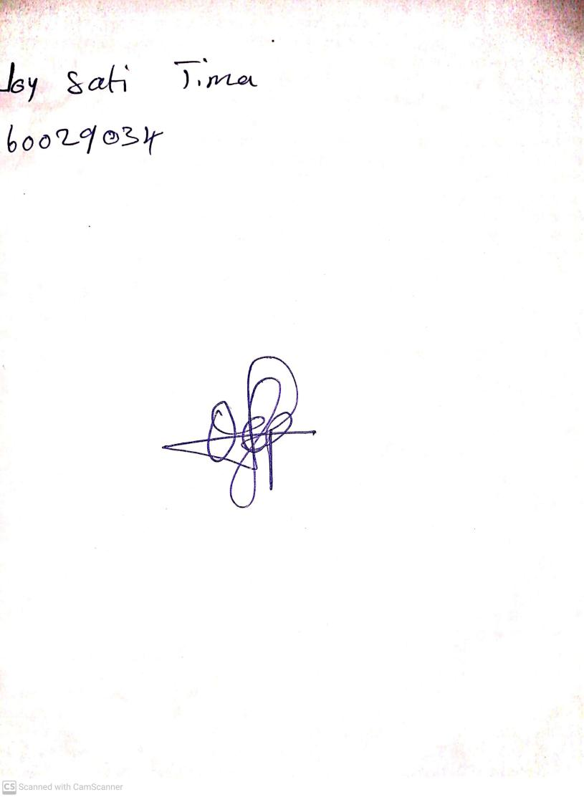

3rd May, 2024

Perpetual Ojoma Ocheja

Stream Head Nursery