**Lesson Plan/Note for Week 4 Ending 3/2/2023.**

**Term:** 2nd.

**Week:** 4.

**Date:** 30/1/2023**.**

**Class: SS 2**

**Subject:** Economics

**Topic:** price determination

**Sub-Topic:** Meaning of elasticity, Elasticity of Demand and types of elasticity of demand.

**Period:** second

**Time:** 8:50-9:30

**Duration:** 40 minutes

**Number in class:** 5 Students

**Average Age:** 14 Years.

**Sex**: mixed

**Specific objectives:** By the end of the lesson, the students should be able to:

(1) Define Elasticity

(11) explain elasticity of demand

(111) mention the types of elasticity of demand.

**Rationale:** To be able to differentiate between the changes in demand and supply as a result of changes in the price of commodity.

**Previous knowledge:** The students have seen changes in the price of goods in the market.

**Instructional Material**: A chart showing curve in price, inelastic, unitary and perfectly Elastic demand.

**Reference material:** Gbenga Babalola (2017) metropolitan economics for senior Secondary schools.

**LESSON DEVELOPMENT**

|  |  |  |  |
| --- | --- | --- | --- |
| **Stages/steps** | **Teacher's Activities** | **Students' Activities** | **Learning points** |
| **Introduction** | Review the previous lesson | Participate actively in the class discussion. | To arouse the students’ interest to learn. |
| **Step 1** | Defines elasticity as: The percentage change in dependent variable resulting from a percentage change in the value of an independent variable. | Listen carefully to the teacher and ask questions when necessary. | For better understanding of the lesson |
| **Step 11** | Guides the students to explain elasticity of demand | Participate in the class discussion | To encourage critical thinking |
| **Step 111** | Leads the students to mention the types of elasticity of demand. | Mention the types of elasticity of demand as : (1) price elasticity of demand. (2) inelastic demand (3) unitary elasticity of demand etc | To enhance their logical reasoning. |
| **Summary** | Summarises the lesson as:  **Elasticity**  Elasticity can be defined as the percentage change in a dependent variable resulting from a percentage change in the value of an independent variable. The concept of elasticity helps in decision making. Elasticity seek to measure the relationship existing between two variables. It measures the responsiveness of dependent variable to a change in the independent variable.  **Elasticity of demand**  Elasticity of demand measures the degree of responsiveness of quantity demanded of a commodity to changes in the price of the commodity. Income or prices of other commodities and so on. The measure of elasticity of demand are as varied as the determinants of demand. The most important of these are the price elasticity, income and cross-price elasticity of demand.  **(a) Price elasticity of demand:** This measures the responsiveness of the quantity demanded to changes in the price of commodity.    **(b) Inelastic demand:** A demand is said to be inelastic if a larger change in price leads to a little change in quantity demanded.    Note that a change in price results in only a small change in quantity demanded. In other words, the quantity demanded is not very responsive to changes in the price. Example like food and fuel.  **(c) unitary elasticity:** A demand is said to be unitary if a change in price leads to an equal change in quantity. In this case, the elasticity coefficient is equal to one. | Copy and submit their Note book for marking | For future reference |
| **Evaluation** | Evaluates the students as:  (1) Define Elasticity  (2) state the types of elasticity of demand.  (3) Describe elasticity of demand | Respond to the questions | Ascertaining the attainment of the stated objectives. |
| **Conclusion** | Rounds up the lesson by marking and correcting students work. | Check and do their correction | Consolidation of the lesson. |
| **Assignment** | Gives home work as:  (1) Explain cross-price elasticity of demand.  (2) What is income elasticity of demand? | Respond by doing the home work at home. | To ensure continuity of learning. |

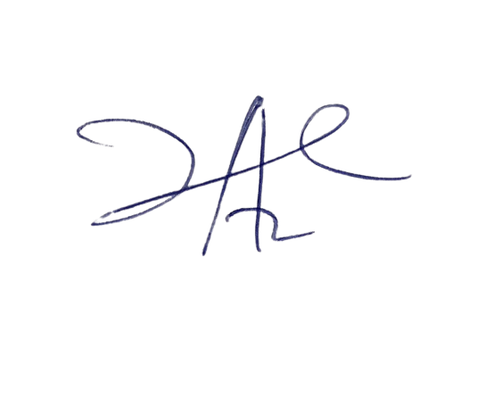

6/3/2023

Principal Head Instructor