**LESSON PLAN AND NOTE FOR WEEK 8 ENDING 3/11/2023**

**Term 1st term**

**Week 8th week.**

**Date 2nd November,2023**

**Class Nursery one**

**Subject Social Norms**

**Topic Social Studies**

**Sub-topic Meaning of social studies**

**Period 7th period**

**Time 1:55 pm**

**Duration 35 minutes**

**No in class 15**

**Average Age 3 years**

**Sex Mixed**

**Specific Objectives: By the end of the lesson the pupils should be able to:**

1. **Define social studies.**
2. **Types of social studies.**

**Rationale: To ensure the pupils define & list types of social studies.**

**Previous Knowledge: The pupils can lists and identify the objects at home.**

**Instructional Resources: Board,marker ,online research.**

**Reference Materials: Smart smart Civic Education by A.M Solu, T.Y Alabi, Nursery 2**

**LESSON PRESENTATION**

|  |  |  |  |
| --- | --- | --- | --- |
| **Steps** | **Teacher’s Activities** | **Pupils’ Activities** | **Learning Points** |
| **Introduction** | **The teacher introduces the lesson (Social studies) to the pupils.** | **The pupils listens attentiely to their teacher.** | **To arouse the pupils’ interest towards the lesson.** |
| **Step 1** | **The teacher defines social studies for the pupils as “the study of man and his environment”** | **The pupils actively repeats after their teacher the meaning of social studies.** | **For proper understanding.** |
| **Step 2** | **The teacher mentions to the pupils the types of social studies which include:**  **PHYSICAL ENVIRONMENT**  **SOCIAL ENVIRONMENT** | **The pupils pays attention to the teacher and repeats after the teacher the types of social studies.** | **For better understanding.** |
| **Summary** | **The teacher summarizes the lesson by listing the examples of physical environment which include:**  **LAND**  **RIVER ETC** | **The pupils actively repeats after their teacher.** | **For onward study.** |
| **Evaluation** | **The teacher asks the pupils to:**   1. **Define social studies?** 2. **Mention the types of social studies?** | **The pupils answer the questions accordingly.** | **To ascertain the pupils’ understanding.** |
| **Conclusion** | **The teacher summarizes,reacts,and corrects the pupils.** | **The teacher gives answers to the teacher’s question.** | **To consolidate the lesson.** |
| **Assignment** | 1. **What is social studies?** 2. **What are the 2 types of social studies?** | **The pupils copy and do their home-work at home.** | **To encourage learning while at home.** |

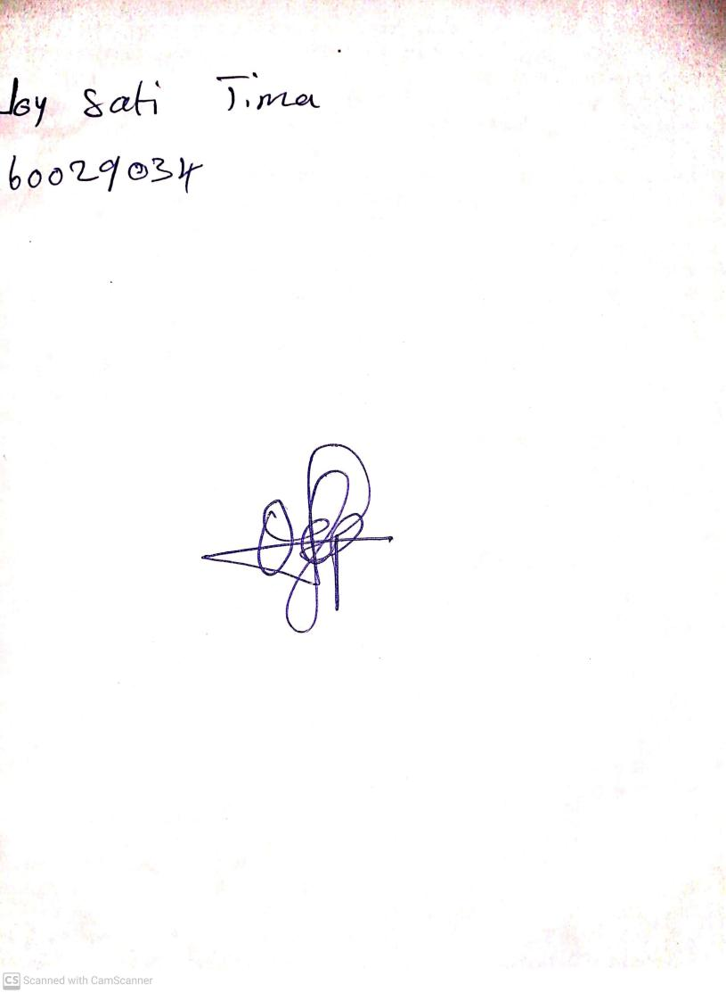

20th August, 2023

Perpetual Ojoma Ocheja

Stream Head Nursery