EMERALD ROYAL INTERNATIONAL SCHOOL

MPAPE, ABUJA.

LESSON PLAN AND NOTE FOR WEEK 6 ENDING 19TH OCTOBER,2023

TERM: First term.

WEEK: Six

SUBJECT: Nature studies.

TOPIC: Uses of Sense organs.

SUB-TOPIC: Functions of the sense organs. Example . Nose, tongue and skin.

DATE: 15/10/2023

DURATION: 40 minutes

TIME: 08:50-09:30

PERIOD: 3rd

CLASS: Pre-nursery

NUMBER OF PUPILS: 11

AVERAGE AGE: 2 years

SEX: Mixed

SPECIFIC OBJECTIVES: By the end of the lesson, the pupils should be able to:-

I Identify nose, tongue and skin on a chart as a sense organs.

2. State the functions of nose , tongue and skin as a sense organs.

RATIONALE: For Pupils to mention the Uses of their sense organs.

PREVIOUS KNOWLEDGE: Pupils have been taught the functions of eye and ear in their previous lesson .

INSTRUCTIONAL MATERIALS: Charts, video clips.

REFERENCE: Showers kiddies books Elementary science book nursery 1 by Showers kiddies books.

LESSON DEVELOPMENT

|  |  |  |  |
| --- | --- | --- | --- |
| Stages/steps | Teacher's activities | Pupils' activities | Learning points |
| Introduction | Teacher introduces the lesson by singing a nursery rhymes:-  Oh be careful little nose what you smell  What you smell------------------------------ | Pupils sing the song along with the teacher. | To arouse the interest of the pupils. |
| Presentation  Step 1 | Teacher shows the pupils a chart that has the sense organs on it and the teacher also asks the pupils to identify the following sense organs:-  --- Nose  --- Tongue  --- Skin | Pupils point at the chart and identify the nose,tongue and skin as a sense organs. | For better understanding of the lesson. |
| Step 2 | Teacher tells the pupils the functions of the noses, tongue and skin as thus:-   1. The nose is the sense organ smell. 2. The tongue is the sense organ taste. 3. The skin is the sense organ of feel.   The teacher also asks the pupils to repeat after her. | Pupils listen to the teacher and repeat after the teacher. | For better understanding of the lesson. |
| Summary | Teacher summarizes the lesson by going over the lesson again for more understanding of the lesson by identifying the sense organs again in the body and the uses of some of them.  Tongue is for taste.  Skin is for feel.  Nose is for smell. | Pupils listen attentively to the teacher as she is going over the lesson again. | To ensure better understanding. |
| Evaluation | Teacher asks the Pupils to :-   1. Identify the nose, skin and tongue. 2. State the functions of the above mentioned sense organs | Pupils answer the teacher's questions correctly. | To ascertain the level of pupils understanding of the lesson. |
| Conclusion | Teacher concludes the lesson by correcting pupils who was unable to identify. | Pupils take note of the corrections. | For onwards learning. |
| Assignment | Teacher asks the pupils to answer the these questions at home.  I taste with my--------------(eyes, tongue)  I smell with my------------(nose,ear)  I feel with -----------(hand, skin) | Pupils do the assignment at home. | To encourage Learning at home. |

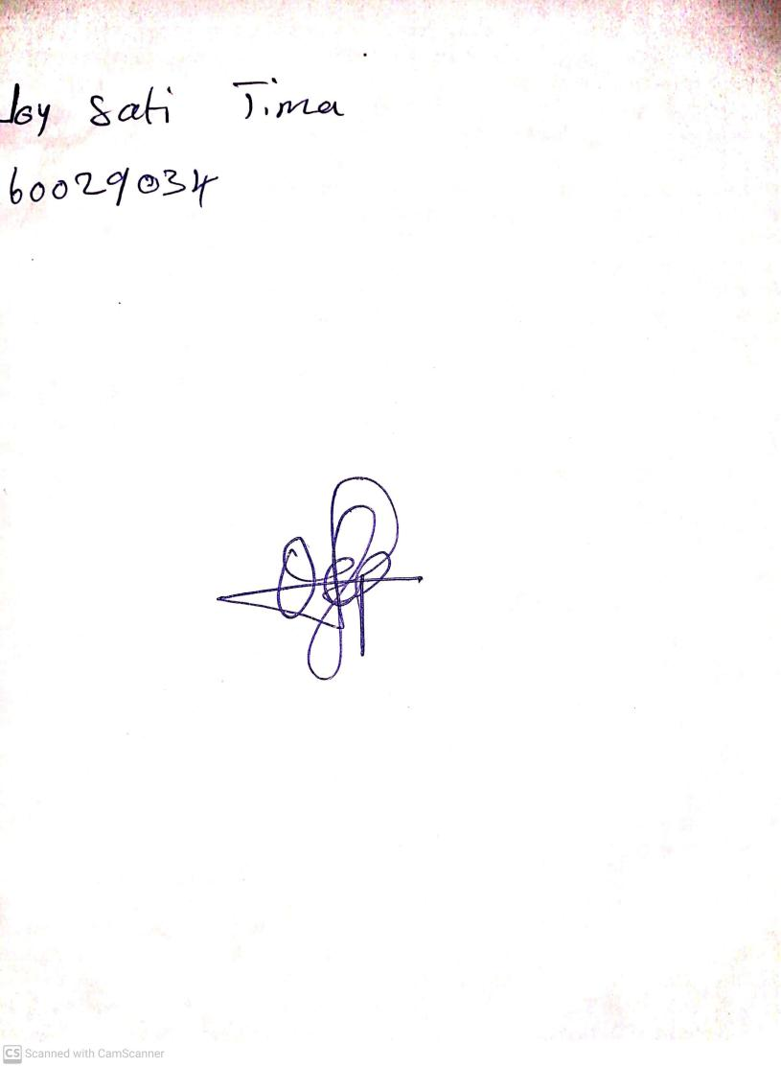

20th August, 2023

Perpetual Ojoma Ocheja

Stream Head Nursery