**EMERALD ROYAL INTERNATIONAL SCHOOL MPAPE, ABUJA**

**LESSON PLAN AND NOTE FOR WEEK 7 PERIOD 1 ENDING 23/02/2024**

**TERM: 2nd**

**WEEK: 7**

**DATE: 19/02/2024**

**CLASS: Nursery 2**

**SUBJECT: Number work**

**TOPIC: Multiplication table 3**

**SUB—TOPIC: Recitation and solving exercises on Multiplication table 3 from 1—4**

**PERIOD: 3rd**

**TIME: 08:50 —09:30am**

**DURATION: 40 minutes**

**NUMBER IN CLASS: 13**

**AVERAGE AGE: 5 years**

**SEX: Mixed**

**LEARNING OBJECTIVES: By the end of the lesson, the Pupils should be able to:**

**1. Recite multiplication table 3 from 1—4.**

**2. Solve exercises on Multiplication table 3 from 1—4.**

**RATIONALE: For pupils to know how to recite multiplication table 3**

**PREVIOUS KNOWLEDGE: Pupils have learnt multiplication table 2 in previous Lesson.**

**INSTRUCTIONAL MATERIALS: A chat of multiplication table 3.**

**REFERENCE MATERIALS: My choice of mathematics stage 3.**

**LESSON DEVELOPMENT**

|  |  |  |  |
| --- | --- | --- | --- |
| **Steps** | **Teacher's activities** | **Pupils' activities** | **Learning point** |
| **Introduction** | **Teacher introduces the lesson by asking pupils to all stand and recite multiplication table 2.** | **Pupils all stand and recite multiplication table 2** | **To arouse pupils interest for the lesson ahead.** |
| **Presentation step 1** | **Teacher presents the lesson by writing multiplication table 3 on the board from 1—4 and then read and asks Pupils to repeat after her. That is ;**  **MULTIPLICATION TABLE 3 FROM 1—4**  **3 × 1= 3**  **3 × 2 = 6**  **3 × 3 = 9**  **3 × 4 =12** | **Pupils listen and repeat after the teacher.** | **For proper understanding.** |
| **Step 2** | **Teacher solve the table on the board. As;**  **1). 3**  **× 1**  **__________**  **3**  **__________**  **2). 3**  **× 2**  **__________**  **6**  **__________**  **3). 3**  **× 3**  **___________**  **9**  **____________**  **4). 3**  **× 4**  **____________**  **12**  **____________** | **Pupils pay attention to the teacher** | **For better understanding.** |
| **Board summary** | **Teacher evaluates the lesson by going through the lesson on the board over again and then prepare pupils books for them to copy the note on the board into their books.** | **Pupils listen very attentively to the teacher and copy the note into their exercise books.** | **To create platform for slow learners and to build Pupils writing skills.** |
| **Evaluation** | **Teacher evaluates the lesson by asking pupils to recite multiplication table 3 from 1—4.** | **Pupils recite multiplication table 3 from 1—4.** | **To assess Pupils level of understanding** |
| **Conclusion** | **Teacher concludes the lesson by marking pupils books.** | **Pupils submit their books for marking.** | **For endorsement.** |
| **Assignment ( home work)** | **Recite and write multiplication table 3 from 1— 8.** | **Pupils do their assignment at home.** | **To encourage learning at home.** |

**LESSON NOTE/ PLAN FOR WEEK 7 PERIOD 2 ENDING 23/02/2024**

**TERM: 2nd**

**WEEK: 7th**

**DATE: 22/02/2024**

**CLASS: Nursery 2**

**SUBJECT: Number work**

**TOPIC: Multiplication table 3**

**SUB—TOPIC: Recitation of multiplication table 3 from 5—8**

**PERIOD: 2nd**

**TIME: 08:50—09:30am**

**DURATION: 40 minutes**

**NUMBER IN CLASS: 13**

**AVERAGE AGE: 5**

**SEX: Mixed**

**LEARNING OBJECTIVES: By the end of the lesson, the Pupils should be able to:**

**1. Recite multiplication table 3 from 5—8.**

**2. Solve exercises on Multiplication table 3from 5—8.**

**RATIONALE: For pupils to know multiplication table 3**

**PREVIOUS KNOWLEDGE: Pupils learnt multiplication table 3 from 1—4 in previous Lesson.**

**INSTRUCTIONAL MATERIALS: A chart of multiplication table 3.**

**REFERENCE MATERIALS: My choice of Mathematics stage 3.**

**LESSON DEVELOPMENT**

|  |  |  |  |
| --- | --- | --- | --- |
| **Steps** | **Teacher's activities** | **Pupils' activities** | **Learning point** |
| **Introduction** | **Teacher introduces the lesson the lesson by asking pupils to recite multiplication table 3 from 1—4** | **Pupils recite multiplication table 3 from 1—4** | **To prepare pupils minds for the lesson ahead.** |
| **Presentation step 1** | **Teacher presents the lesson by writing multiplication table 3 on the board from 5—8, read and asks Pupils to repeat after her. That is;**  **MULTIPLICATION TABLE 3 FROM 5—8**  **3 × 5 = 15**  **3 × 6 = 18**  **3 × 7 = 21**  **3 × 8 = 24** | **Pupils listen to the teacher and repeat after her.** | **To improve Pupils speaking ability.** |
| **Step 2** | **Teacher solves the table on the board. As;**  **1). 3 × 5 = 15**  **3**  **× 5**  **___________**  **1 5**  **___________**  **2). 3 × 6 = 18**  **3**  **× 6**  **___________**  **1 8**  **___________**  **3). 3 × 7 = 21**  **3**  **× 7**  **_____________**  **2 1**  **_____________**  **4). 3 × 8 = 24**  **3**  **× 8**  **____________**  **24**  **_____________** | **Pupils pay attention to the teacher.** | **For better understanding.** |
| **Board summary** | **Teacher prepares pupils books for them to copy the note on the board into their books.** | **Pupils copy the note into their exercise books.** | **For onward study.** |
| **Evaluation** | **Teacher evaluates the lesson by asking pupils to all stand and recite multiplication table 3 from 1—8** | **Pupils all stand and recite multiplication table 3 from 1—8 .** | **To assess Pupils level of understanding.** |
| **Conclusion** | **Teacher concludes the lesson by marking pupils books.** | **Pupils submit their books on the teacher's table for marking.** | **For endorsement.** |
| **Assignment (home work)** | **Recite and write multiplication table 3 from 1—8** | **Pupils do their assignment at home.** | **To encourage learning at home.** |

**LESSON NOTE AND PLAN FOR WEEK 7 PERIOD 3 ENDING 23/02/2024**

**TERM: 2nd**

**WEEK: 7th**

**DATE: 19/02/2024**

**CLASS: Nursery 2**

**SUBJECT: Number work**

**TOPIC: Multiplication table 3**

**SUB—TOPIC: Multiplication table 3 from 9—12**

**PERIOD: 3rd**

**TIME: 08:10—08:50am**

**DURATION: 40 minutes**

**NUMBER IN CLASS: 13**

**AVERAGE AGE: 5**

**SEX: Mixed**

**LEARNING OBJECTIVES: By the end of the lesson, the Pupils should be able to:**

**1. Recite multiplication table 3 from 9 —12.**

**2. Write the table from 1—12**

**RATIONALE: For pupils to be conversant with multiplication table 3**

**PREVIOUS KNOWLEDGE: Pupils have learnt multiplication table 3 from 1—8**

**INSTRUCTIONAL MATERIALS: A chart of multiplication table 3**

**REFERENCE MATERIALS: My choice of Mathematics stage 3.**

**LESSON DEVELOPMENT**

|  |  |  |  |
| --- | --- | --- | --- |
| **Steps** | **Teacher's activities** | **Pupils' activities** | **Learning point** |
| **Introduction** | **Teacher introduces the lesson by reviewing the previous lesson.** | **Pupils pay attention to the teacher.** | **To arouse pupils interest for the lesson ahead.** |
| **Presentation step 1** | **Teacher presents the lesson by reciting multiplication table 3 from 9 —12 and then asks pupils to repeat after her.** | **Pupils listen and repeat after the teacher.** | **To improve Pupils speaking ability.** |
| **Step 2** | **Teacher writes the table on the board for pupils to identify and recites.** | **Pupils identify the table and recite. That is;**  **3 × 9 = 27**  **3 × 10 = 30**  **3 × 11 = 33**  **3 × 12 = 36** | **To enhance Pupils participation in class.** |
| **Board summary** | **Teacher summarizes the lesson by writing multiplication table 3 on the board for pupils to copy the note into their books. That is;**  **3 × 1= 3**  **3 × 2 =6**  **3 × 3 =9**  **3 × 4 =12**  **3 × 5 =15**  **3 × 6 =18**  **3 × 7 =21**  **3 × 8 =24**  **3 × 9 =27**  **3 × 10 =30**  **3 × 11 = 33**  **3 × 12 = 36** | **Pupils copy the note into their exercise books.** | **For onward study.** |
| **Evaluation** | **Teacher evaluates the lesson by asking pupils to all stand and recite multiplication table 3 from 1—12** | **Pupils all stand and recite the table on the board.** | **To assess Pupils level of understanding.** |
| **Conclusion** | **Teacher concludes the lesson by marking pupils books.** | **Pupils submit their books for marking.** | **For endorsement.** |
| **Assignment** | **Recite and write multiplication table 3** | **Pupils do their assignment at home.** | **To encourage learning at home.** |

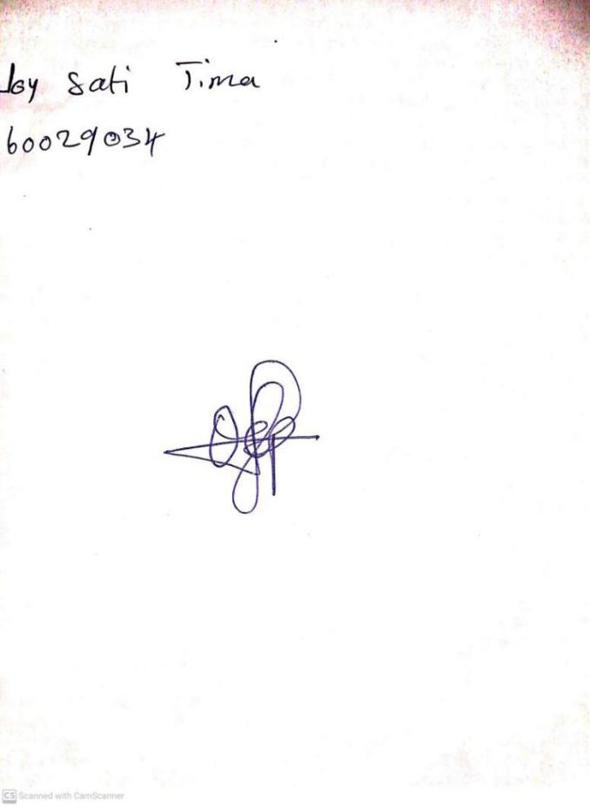

**16TH FEBRUARY, 2024**

**Perpetual Ojoma Ocheja**

**Stream Head Nursery**