**LESSON PLAN AND NOTE FOR WEEK 10 ENDING 7/7/2023**

**Term 3rd term**

**Week 10th week**

**Date 7th July,2023**

**Class Nursery one**

**Subject Nature studies**

**Topic Simple machines in the school.**

**Sub-Topic Name simple machines in the school.**

**Period 2nd period**

**Time 9:05 am**

**Duration 35 minutes**

**No in class 18**

**Average Age 3 years**

**Sex Mixed.**

**Specific Objectives: By the end of the lesson, the pupils should know how to:**

1. **Name the simple machines in the school**
2. **Identify the simple machines in the school**
3. **List the uses of simple machine in the school**

**Rationale: To help the pupils know the simple machines in the school.**

**Previous Knowledge: The pupils have knowledge of simple machine in the school.**

**Instructional Resources: Online Research,Chart.**

**Reference Materials: Online Research, Elementary Science by Showers Kiddies.**

**LESSON PRESENTATION**

|  |  |  |  |
| --- | --- | --- | --- |
| **Steps** | **Teacher’s Activities** | **Pupils’ Activities** | **Learning Points** |
| **Introduction** | **The teacher introduces the topic (Simple Machines ) by showing the pupils pictures of different simple machines.** | **The pupils participates in seeing the simple machines on the chart.** | **To arouse the interest of the pupils.** |
| **Step 1** | **The teacher starts the lesson by naming the simple machines in the school e.g**  **Duster**  **Stapler**  **Sharpner**  **Eraser**  **Marker Board etc.** | **The pupils listen attentively to the teacher and repeats after the teacher the simple machines in the school.** | **For proper understanding.** |
| **Step 2** | **The teacher leads the pupils to identify the simple machines in the school on the chart.** | **The pupils identify the simple machines found in the school in the chart.** | **For better understanding.** |
| **Step 3** | **The teacher name the uses of simple machines in the home for the pupils**  **Duster is used for cleaning what is written on white marker board.**  **Sharpener is used for sharpening pencils.**  **Eraser is used for cleaning mistakes in our books.** | **The pupils mention uses of simple machines in the school with the teacher.** | **For further understanding.** |
| **Summary** | **The teacher summarizes the lesson by listing more simple machines that can be found in the school.** | **The pupils lists with the teacher the simple machines in the school.** | **For onward study.** |
| **Evaluation** | **Question:**  **Name three simple machines in the school?**  **Is duster a simple machine found in the school?**  **What is the use of Eraser?** | **The pupils answer the question correctly.** | **To ascertain the pupils’ understanding.** |
| **Conclusion** | **The teacher summarizes, reacts, and corrects the pupils.** | **The pupils gives answers to the teacher’s question.** | **To consolidate the lesson.** |
| **Assignment** | **Question:**  **Mention two simple machines found in the school?.** | **The pupils copy and do their homework at home.** | **To encourage learning while at home.** |

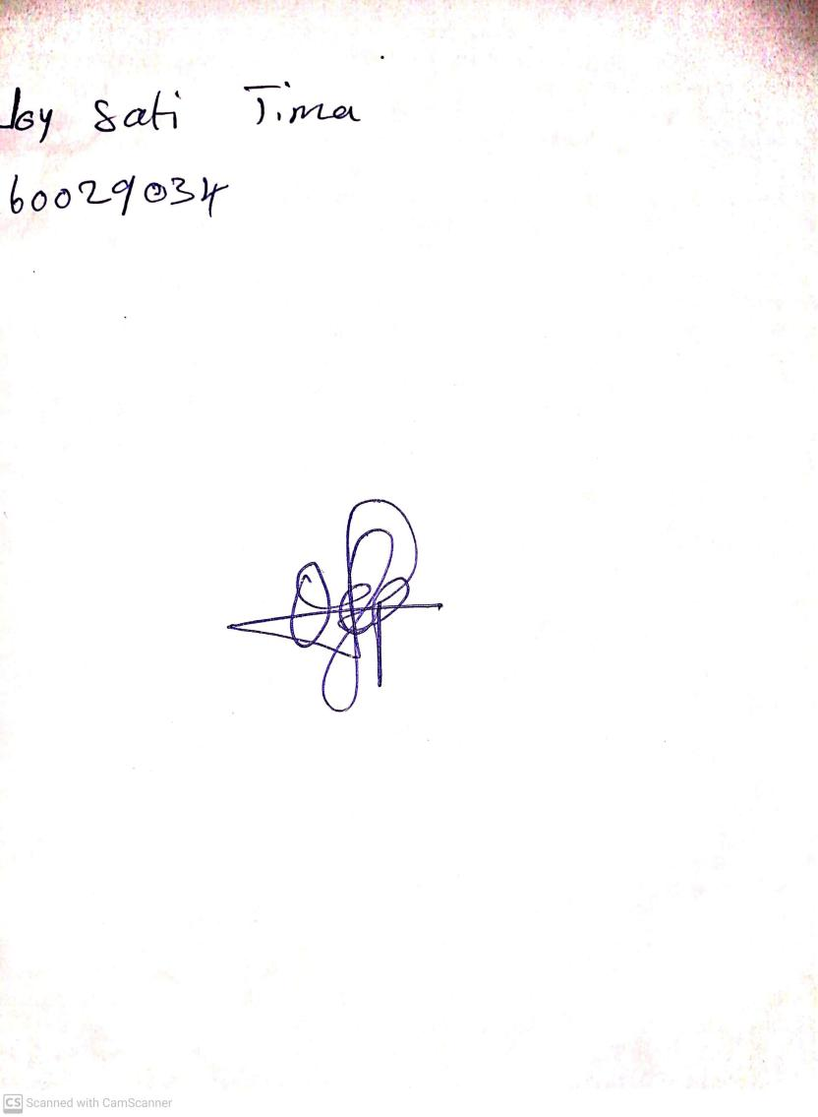

30th April, 2023

Perpetual Ojoma

Stream Head Nursery