LESSON PLAN AND NOTE FOR WEEK 1 ENDING 15/09/2023

TERM: 1st

WEEK: 1st

DATE: 11/09/2023

CLASS: Nursery 2

SUBJECT: Nature studies

TOPIC: First aid

SUB—TOPIC: Meaning of first aid and first aid kit.

PERIOD: 4th

TIME: 10:40—11:20am

DURATION: 40 minutes

NUMBER IN CLASS: 14

AVERAGE AGE: 5 years

SEX: Mixed

LEARNING OBJECTIVES: By the end of the lesson, the pupils should be able to:

1. Explain the meaning of first aid.

2. Identify a first aid kit.

RATIONALE: For pupils to know about first aid.

PREVIOUS KNOWLEDGE: Pupils have under go first aid treatment in one way or the other.

INSTRUCTIONAL MATERIALS: First aid kit.

REFERENCE MATERIALS: Basic science and technology for Nursery schools book 3 by OPEMIPO DADA.

LESSON DEVELOPMENT

|  |  |  |  |
| --- | --- | --- | --- |
| Steps | Teacher's activities | Pupils' activities | Learning point |
| Introduction | Teacher introduces the lesson by asking pupils the following question:   1. Have you ever been injured? 2. Did you receive first aid? | Pupils answer the question asked by the teacher. | To prepare pupils minds for the lesson ahead. |
| Presentation step 1 | Teacher explains the meaning of first aid to pupils and then asks them to repeat after her. | Pupils listen to the teacher and repeat after her. | To improve pupils listening and speaking ability. |
| Step 2 | Teacher draws the diagram of a first aid kit on the board for pupils to identify and then explain to pupils what the kit is use for. And also asks pupils to repeat after her. | Pupils pay attention to the teacher and repeat after the teacher. | To enhance pupils participation in the class. |
| Board summary | Teacher writes the whole note of lesson on the board for pupils to copy into their books. That is;  First aid:  First aid is the first treatment that is given to an injured or accident person before he or she is taken to the hospital.  First aid kit:  A first aid kit is a box, bag or pack that holds supplies used to treat minor injuries including cuts, scrampes, burns, bruises, and sprains.    Diagram of a first aid kit. | Pupils copy the note into their exercise books. | To build pupils writing ability. |
| Evaluation | Teacher evaluates the lesson by asking pupils the following questions;  1.What is first aid?  2. What is a first aid kit and it used? | Pupils answer the questions asked by the teacher. | To assess pupils level of understanding. |
| Conclusion | Teacher concludes the lesson by marking pupils books. | Pupils submit their books for marking. | For endorsement. |
| Assignment | 1.Mention ten (10) items in first aid kit.  2. State the uses of the first aid items. | Pupils do their assignment at home. | To encourage learning at home. |

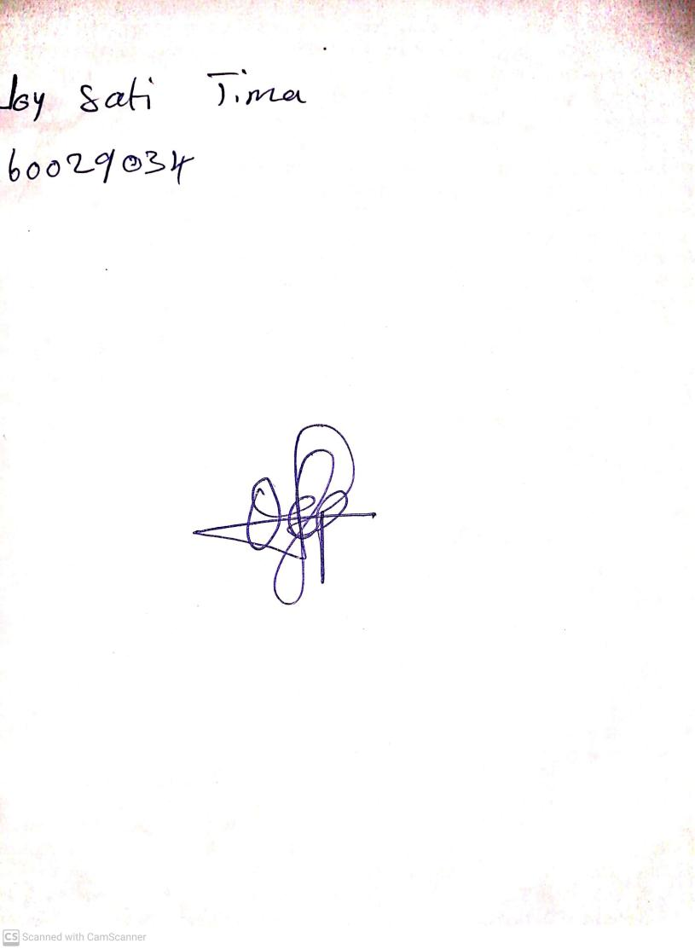

27th August, 2023

Perpetual Ojoma Ocheja

Stream Head Nursery