**EMERALD ROYAL INTERNATIONAL SCHOOL MPAPE, ABUJA.**

**LESSON PLAN AND NOTE FOR WEEK 6 ENDING 31/05/2024**

**TERM: 3rd**

**WEEK: 6th**

**DATE: 27/05/2024**

**CLASS: Nursery 2**

**SUBJECT: Social norms**

**TOPIC: Love and care for orphaned and vulnerable children.**

**SUB—TOPIC: Meaning of orphaned and vulnerable children.**

**PERIOD: 2nd period after long break**

**TIME: 11:20—12: 00pm**

**DURATION: 40 minutes**

**NUMBER IN CLASS: 13**

**AVERAGE AGE: 5 years**

**SEX: Mixed**

**LEARNING OBJECTIVES: By the end of the lesson, the Pupils should be able to:**

**1. Explain the meaning of orphaned**

**2. Define vulnerable children**

**3. State the ways of caring for orphaned and vulnerable children.**

**RATIONALE: For pupils to learn how to give-away.**

**PREVIOUS KNOWLEDGE: Pupils have learnt about children with special needs.**

**INSTRUCTIONAL MATERIALS: Pictures of orphaned and vulnerable children in the system.**

**REFERENCE MATERIALS: Stage 3 Social habit for nursery classes.**

**LESSON DEVELOPMENT**

|  |  |  |  |
| --- | --- | --- | --- |
| **Steps** | **Teacher's activities** | **Pupils' activities** | **Learning point** |
| **Introduction** | **Teacher reviews the previous lesson.** | **Pupils pay attention to the teacher.** | **To prepare pupils minds for the lesson ahead.** |
| **Presentation step 1** | **Teacher explains the meaning of orphaned to pupils and then asks them to repeat after her.** | **Pupils pay attention to the teacher and repeat after her.** | **For proper understanding.** |
| **Step 2** | **Teacher defines the word vulnerable children to pupils and also asks them to repeat after her.** | **Pupils listen to the teacher and repeat after her.** | **For better understanding.** |
| **Step 3** | **Teacher States the various ways in which we can care for the orphaned and the vulnerable children to pupils and also asks them to repeat after her.** | **Pupils listen attentively to the teacher and also repeat after her.** | **To enhance Pupils listening and speaking ability.** |
| **Board summary** | **Teacher summarizes the lesson by writing the whole note of lesson on the board for pupils to copy into their books. That is;**  **LOVE AND CARE FOR ORPHANED AND VULNERABLE CHILDRENCHILDREN**  **Orphaned children: simply means a child deprived by death of one or usually both parents. Or a child without a parent or guardian.**  **Vulnerable children: this is one who has been identified as being at greater risk of experiencing physical or emotional harm.**  **Ways of caring for orphaned and vulnerable children are:**  **1. Give them what they need, like food or clean water and clothes.**  **2. Support their education.**  **3. Provide them with a safe place to stay.**  **4. Sponsor them.**  **5. Educate them by giving them some courses.**  **6. Give away hi our children's old toys etc.** | **Pupils copy the note into their books.** | **For onward study.** |
| **Evaluation** | **Teacher evaluates the lesson by asking pupils the following questions:**  **1. Who are orphans?**  **2. How do we care for orphaned children?**  **Define vulnerable children.** | **Pupils answer the questions asked by the teacher.** | **To assess pupils level of understanding.** |
| **Conclusion** | **Teacher concludes the lesson by marking pupils books.** | **Pupils submit their books for marking..** | **For endorsement.** |
| **Assignment** | **Answer the following questions:**  **1. What is the meaning of HIV?**  **2. What is AID?**  **3. Mention 3 ways we can contact HIV/AIDS.** | **Pupils do their assignment at home.** | **To encourage learning at home.** |

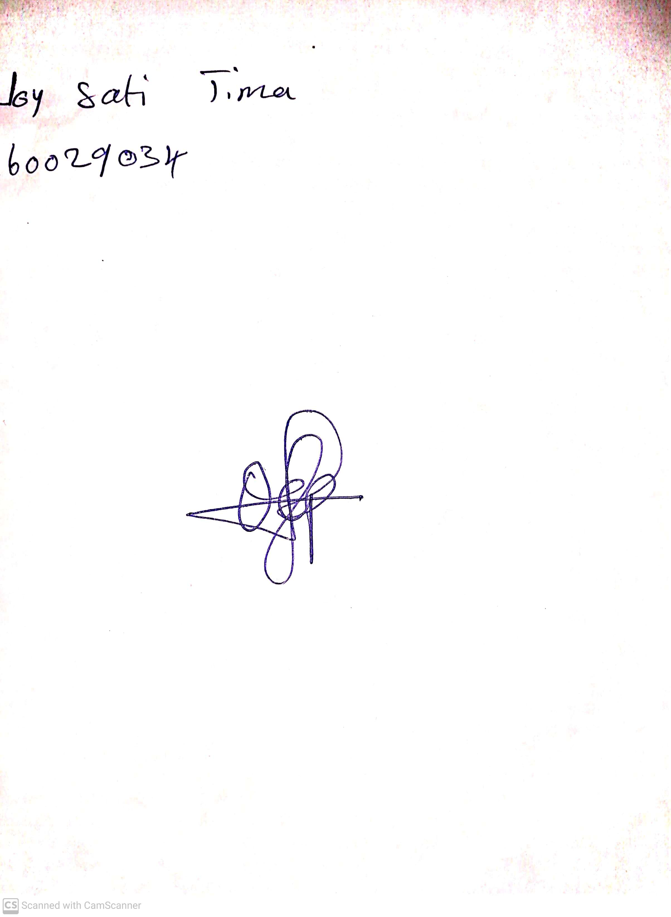

**24th May, 2024**

**Perpetual Ojoma Ocheja**

**Stream Head Nursery**