**EMERALD ROYAL INTERNATIONAL SCHOOL, MPAPE ABUJA**

**LESSON PLAN AND NOTE FOR WEEK 1 ENDING FRIDAY, 12TH JANUARY, 2024**

**TERM:** FIRST TERM

**WEEK:** WEEK 1

**SUBJECT:** SOCIAL STUDIES

**TOPIC:** SOCIAL AND HEALTH ISSUES

**SUB-TOPIC:** REASONS FOR TAKING SUBSTANCES INTO THE BODY

**DATE:** TUESDAY, 9TH ANDWEDNESDAY, 10TH JANUARY, 2024

**TIME:** 11:50 – 12:30PM AND 01:20 – 02:00PM

**DURATION:** 40 MINUTES

**PERIOD:** 6TH AND 8TH

**CLASS:** NURSERY 3

**NUMBER IN CLASS:** TWELVE

**AVERAGE AGE:** FIVE

**SEX:** MIXED

**LEARNING OBJECTIVES:** By the end of the lesson, the pupils should be able to:

1. Give the meaning of substance.
2. State the reasons for taking substance into the body.

**RATIONALE:** for pupils to learn the meaning and reasons for taking substance into the body.

**PREVIOUS KNOWLEGDE:** pupils eat and drinks.

**INSTRUCTIONAL MATERIALS:**

1. charts.
2. Textbooks

**REFERENCE MATERIALS:**

1. Social Studies for primary schools book 1 by Olufemi J. Olugasa, Olusola H. Bamidele, Felix K. Alonge, Julius O. Onwuka

**LESSON DEVELOPMENT**

|  |  |  |  |
| --- | --- | --- | --- |
| **STAGES/STEPS** | **TEACHER’S ACTIVITIES** | **PUPILS’ ACTIVITIES** | **LEARNING POINTS** |
| **INTRODUCTION** | The teacher introduces the lesson by asking pupils what they eat before coming to school. | Respond to the teacher | To arouse the pupils’ interest. |
| **PRESENTATION**  **STEP 1** | Teaches and explain the meaning of substances  **Meaning of substances**  Substances are things we take into our body. They are food, water, drinks, drugs, fruits, milk etc. We can eat and drink these substance. | Listen attentively and learn. | Meaning of substance. |
| **STEP 2** | Teaches pupils the reasons for taking substance into the body.  **Reasons for taking substance into the body.**  There are various reasons why we take substance into the body. These include:   1. To stay alive. 2. To prevent hunger. 3. To prevent thirst. 4. For our enjoyment. 5. Out of curiosity (to know whether it is good or bad).   6.To imitate other people or friends.  7. Because of availability and less cost.  8.To know how the thing taste. | Listen attentively and learn. | Reasons for taking substance into the body. |
| **SUMMARY** | Summarises the lesson by emphasising on the main concept and writes note on the board | Listen and copy their notes | For onward study |
| **EVALUATION** | Asks pupils to:   1. Define substance. 2. State the reasons for taking substance into the body. | Respond to the teacher’s question. | To test the pupils understanding on the lesson. |
| **CONCLUSION** | Summarizes, corrects and mark pupils’ notebooks | Submit their notebooks for marking. | Clarifying the concept. |
| **HOME WORK** | 1. Mention five (5) reasons for taking substance into the body. | Cope and return with task. | Extending lesson home. |

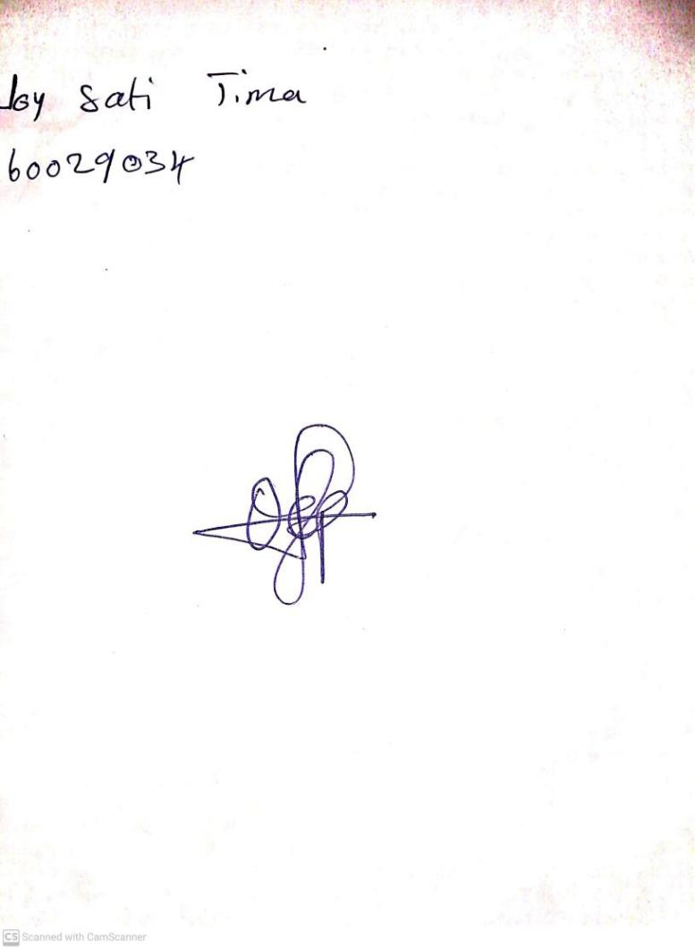

12TH January, 2024

Perpetual Ojoma Ocheja

Stream Head Nursery