**EMERALD ROYAL INTERNATIONAL SCHOOL**

**MPAPE, ABUJA.**

**LESSON PLAN AND NOTE FOR WEEK 1 PERIOD 1 ENDING 13/09/2024**

**TERM: FIRST**

**WEEK: 1ST**

**DATE: 09/09/2024**

**CLASS: NURSERY 2**

**SUBJECT: LITERACY**

**TOPIC: REVISION**

**SUB-TOPIC: REVISION ON LETTER Aa-Zz**

**PERIOD: 1ST PERIOD**

**TIME: 08: 50 - 09:30am**

**DURATION: 40 MINUTES.**

**NUMBER IN CLASS: 14**

**AVERAGE AGE: 5 YEARS.**

**SEX: MIXED.**

**SPECIFIC OBJECTIVES: BY THE END OF THE LESSON,THE PUPILS SHOULD BE ABLE TO:**

**1. RECITE LETTER Aa - Zz ORALLY**

**2. IDENTIFY LETTER Aa - Zz ON FLASH CARDS**

**RATIONALE: FOR PUPILS TO REVIEW THE PREVIOUS CLASS WORK.**

**PREVIOU KNOWLEDGE: PUPILS HAVE LEARNT ABOUT THE TOPIC IN PREVIOUS CLASS.**

**INSTRUCTIONAL MATERIALS: CHART OF LETTERS Aa - Zz**

**REFERENCE MATERIALS: MASTERING ENGLISH FOR NURSERY SCHOOLS BOOK 2 BY J . M OMOGBAI .**

**LESSON DEVELOPMENT**

|  |  |  |  |
| --- | --- | --- | --- |
| **STAGES/STEPS** | **TEACHER’S ACTIVITIES** | **PUPILS’ ACTIVITIES** | **LEARNING POINTS** |
| **INTRODUCTION** | **Teacher introduces the lesson by singing new nursery rhymes to pupils.** | **Pupils sing the rhymes along with the teacher.** | **To arouse pupils interest for the lesson ahead.** |
| **PRESENTATION**  **STEP 1** | **Teacher recites letter Aa - Zz to pupils and asks them to repeat after her.** | **Pupils listen attentively to the teacher and repeat after her.** | **For proper understanding .** |
| **STEP 2** | **Teacher displays letter Aa - Zz on flash cards, identify to pupils and also asks them to repeat after her.** | **Pupils pay attention to the teacher and repeat after her.** | **For better understanding of the lesson.** |
| **BOARD SUMMARY** | **Teacher writes the whole not of lesson on the board for pupils to copy. That is:**  **Letter Aa - Zz:**  **Aa Bb Cc Dd Ee Ff Gg Hh Ii Jj Kk Ll Mm Nn Oo Pp Qq Rr Ss Tt Uu Vv Ww Xx Yy Zz** | **Pupils copy the note into their exercise books.** | **For onward study.** |
| **EVALUATION** | **Teacher evaluates the lesson by:**   1. **Recite letter Aa–Zz.** 2. **Identify letter Aa–Zz on flash cards.** | **Pupils listen to the teacher and read the note on the board one after another.** | **To assess pupils reading skills.** |
| **CONCLUTION** | **Teacher concludes the lesson by marking pupils books.** | **Pupils submit their books for marking.** | **For endorsement.** |
| **ASSIGNMENT** | **Answer the following questions:**  **Fill in the missing letters**  **Aa ----- Cc ----- Ee -----**  **Gg Hh ----- Jj ----- Ll ---- Nn ----- Pp ----- Rr ---- Tt Uu Vv ------ Xx ------ Zz** | **Pupils do their assignment at home.** | **To encourage learning at home.** |

**LESSON PLAN AND NOTE FOR WEEK 1 PERIOD 2 ENDING 13/09/2024**

**TERM: FIRST**

**WEEK: 1ST**

**DATE: 10/09/2024**

**CLASS: NURSERY 2**

**SUBJECT: LITERACY**

**TOPIC: REVISION**

**SUB-TOPIC: REVITION ON 2 LETTER WORDS**

**PERIOD : 2ND PERIOD**

**TIME: 08: 50 - 09:30am**

**DURATION: 40 MINUTES.**

**NUMBER IN CLASS: 14**

**AVERAGE AGE: 5 YEARS.**

**SEX: MIXED.**

**SPECIFIC OBJECTIVES: BY THE END OF THE LESSON,THE PUPILS SHOULD BE ABLE TO:**

1. **IDENTIFY 2 LETTER WORDS.**
2. **SPELL AND PRONOUNCE 2 LETTER WORDS.**

**RATIONALE: FOR PUPILS TO REVIEW THE PREVIOUS CLASS WORK.**

**PREVIOU KNOWLEDGE: PUPILS HAVE LEARNT ABOUT THE TOPIC IN PREVIOUS CLASS.**

**INSTRUCTIONAL MATERIALS: CHART OF TWO LETTER WORDS.**

**REFERENCE MATERIALS: MASTERING ENGLISH FOR NURSERY SCHOOLS BOOK 3 BY J.M OMOGBAI .**

**LESSON DEVELOPMENT**

|  |  |  |  |
| --- | --- | --- | --- |
| **STAGES/STEPS** | **TEACHER’S ACTIVITIES** | **PUPILS’ ACTIVITIES** | **LEARNING POINTS** |
| **INTRODUCTION** | **Teacher introduces the lesson by asking pupils to all stand and recite the alphabets Aa - Zz.** | **Pupils all stand and recite the alphabets Aa -Zz.** | **To arouse pupils interest for the lesson ahead.** |
| **PRESENTATION**  **STEP 1** | **Teacher writes two letter words on the board, identify to pupils and then asks them to repeat after her.** | **Pupils listen attentively to the teacher and repeat after her.** | **For proper understanding .** |
| **STEP 2** | **Teacher guides pupils on how to spell and pronounce the two letter words on the board and also asks them to repeat after her.** | **Pupils pay attention to the teacher and repeat after her.** | **For better understanding of the lesson.** |
| **BOARD SUMMARY** | **Teacher writes the whole not of lesson on the board for pupils to copy. That is;**  **Two letter words**  **Two letter words are:**  **a + m = am**  **a + s = as**  **a + n = an**  **a + t = at**  **i + t = it**  **i + f = if**  **i + s = is**  **i + n = in**  **m + y = my**  **b + y = by**  **o + f = of**  **0 + n = on**  **o + r = or**  **o + x = ox**  **b + e = be**  **h + e = he**  **m + e = me**  **w + e = we**  **t + o = to**  **g + o = go**  **n + o = no**  **s + o = so**  **d + o = do**  **l + o = lo**  **u + p = up**  **u + s = us** | **Pupils copy the note into their exercise books.** | **For onward study.** |
| **EVALUATION** | **Teacher evaluates the lesson by asking the following questions:**   1. **Mention two letter words.** 2. **Spell and pronounced two letter words.** | **Pupils listen to the teacher and read the note on the board one after another.** | **To assess pupils reading skills.** |
| **CONCLUTION** | **Teacher concludes the lesson by marking pupils books.** | **Pupils submit their books for marking.** | **For endorsement.** |
| **ASSIGNMENT** | **Spell and write 20 two letter words.** | **Pupils do their assignment at home.** | **To encourage learning at home.** |

**LESSON PLAN AND NOTE FOR WEEK 1 PERIOD 3 ENDING 13/09/2024**

**TERM: FIRST**

**WEEK: 1ST**

**DATE: 13/09/2024**

**CLASS: NURSERY 2**

**SUBJECT: LITERACY**

**TOPIC: REVISION OF TWO LETTER WORDS**

**SUB-TOPIC: SIMPLE SENTENCES ON TWO LETTER WORDS.**

**PERIOD: 3RD PERIOD**

**TIME: 08: 50 - 09:30am**

**DURATION: 40 MINUTES.**

**NUMBER IN CLASS: 14**

**AVERAGE AGE: 5 YEARS.**

**SEX: MIXED.**

**SPECIFIC OBJECTIVES: BY THE END OF THE LESSON,THE PUPILS SHOULD BE ABLE TO:**

1. **IDENTIFY TWO LETTER WORDS**
2. **MAKE SIMPLE SENTENCES ON TWO LETTER WORDS**

**RATIONALE: FOR PUPILS TO REVEW THE THE PREVIOUS TERM WORK.**

**PREVIOU KNOWLEDGE: PUPILS HAVE LEARNT ABOUT THE TOPIC IN PREVIOUS CLASS.**

**REFERENCE MATERIALS: MASTERING ENGLISH FORNURSERY SCHOOLS BOOK 3 BY J.M OMOGBAI .**

**LESSON DEVELOPMENT**

|  |  |  |  |
| --- | --- | --- | --- |
| **STAGES/STEPS** | **TEACHER’S ACTIVITIES** | **PUPILS’ ACTIVITIES** | **LEARNING POINTS** |
| **INTRODUCTION** | **Teacher introduces the lesson by singing new nursery rhymes to pupils.** | **Pupils sing the rhymes along with the teacher.** | **To arouse pupils interest for the lesson ahead.** |
| **PRESENTATION**  **STEP 1** | **Teacher writes two letter words on the board for pupils to identify.** | **Pupils listen attentively to the board and identify .** | **For proper understanding .** |
| **STEP 2** | **Teacher also makes simple sentences with two letter words on the board, read and also asks them to repeat after her.** | **Pupils pay attention to the teacher and repeat after her.** | **For better understanding of the lesson.** |
| **BOARD SUMMARY** | **Teacher writes the whole not of lesson on the board for pupils to copy.ie,**  **Simple sentences on two letter words:**  **Simple sentences on two letter words are:**  **Go on. Go up**  **Go in or on.**  **I am up. Up I go.**  **I am on. On I go.**  **I go on. I go in.**  **If I go on. I go up.**  **He is to go up.**  **I am to go in.** | **Pupils copy the note into their exercise books.** | **For onward study.** |
| **EVALUATION** | **Teacher evaluates the lesson by:**   1. **Identify and pronounce the two letter words.** 2. **Make simple sentences with two letter words.** | **Pupils listen to the teacher and read the note on the board one after another.** | **To assess pupils reading skills.** |
| **CONCLUTION** | **Teacher concludes the lesson by marking pupils books.** | **Pupils submit their books for marking.** | **For endorsement.** |
| **ASSIGNMENT** | **Read the following:**  **I am to go up.**  **He is to go up.**  **Ox,go up. Ox, go in.**  **Go on ox,go on.**  **It is to go up.**  **It is to go on.**  **I go up. He is up.**  **Is he to go in?**  **No,he is to go up.**  **So,it is up.**  **No, it is in.** | **Pupils do their assignment at home.** | **To encourage learning at home.** |

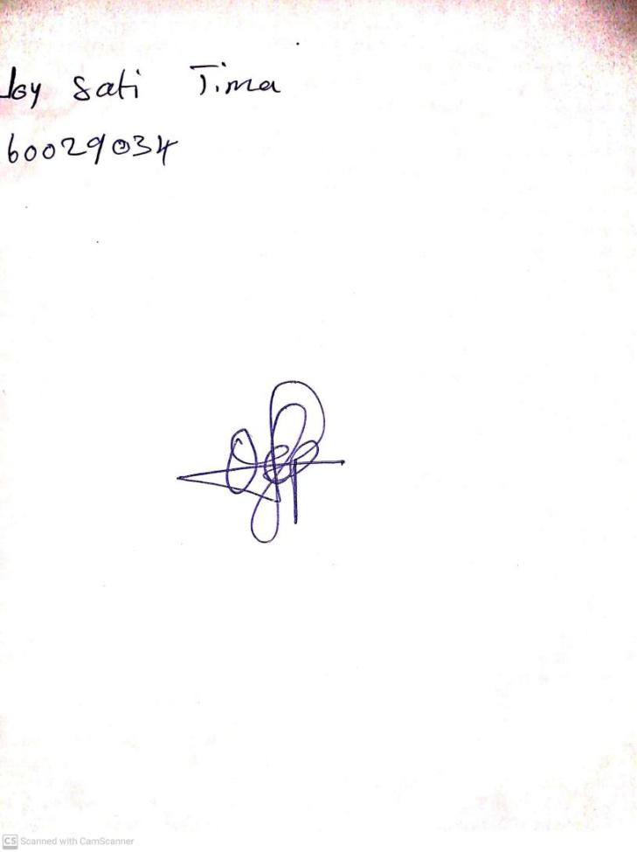

**13th September, 2024**

**Perpetual Ojoma Ocheja**

**Stream Head Nursery**