**EMERALD ROYAL INTERNATIONAL SCHOOL, MPAPE ABUJA**

**LESSON PLAN AND NOTE FOR WEEK 7 ENDING FRIDAY, 23RD FEBRUARY, 2024**

**TERM:** FIRST TERM

**WEEK:** WEEK 7

**SUBJECT:** BASIC SCIENCE

**TOPIC:** ROAD MARKINGS

**SUB-TOPIC:** MEANING OF ROAD MARKING

**DATE:** TUESDAY, 2OTH AND WEDNESDAY, 21ST FEBRUARY, 2024

**TIME:** 08:45 – 09:25AM AND 09:25 – 09:55AM

**DURATION:** 40 MINUTES

**PERIOD:** 2ND AND 3RD

**CLASS:** NURSERY 3

**NUMBER IN CLASS:** TWELVE

**AVERAGE AGE:** FIVE

**SEX:** MIXED

**LEARNING OBJECTIVES:** By the end of the lesson, the pupils should be able to:

1. Give the meaning of road markings.
2. List the road marks.

**RATIONALE:** for pupils to learn the meaning of road marking.

**PREVIOUS KNOWLEGDE:** pupils have learnt road signs and their colours.

**INSTRUCTIONAL MATERIALS:**

1. Flash cards.
2. Road chart.

**REFERENCE MATERIALS:**

Smart Basic Science and Technology book 1 by D. I. Bika, Cambridge University Press

**LESSON DEVELOPMENT**

|  |  |  |  |
| --- | --- | --- | --- |
| **STAGES/STEPS** | **TEACHER’S ACTIVITIES** | **PUPILS’ ACTIVITIES** | **LEARNING POINTS** |
| **INTRODUCTION** | Review previous knowledge | Respond to the teacher | To arouse the pupils’ interest. |
| **PRESENTATION**  **STEP 1** | Teaches and explain the meaning of soil.  **Meaning of road markings**  Road markings are those marks on the road to keep us safe, by guiding us on how to use the road. | Give the meaning of road markings. | Meaning of road markings. |
| **STEP 2** | Teaches and explain the examples of road markings.  **Examples of road markings**   1. Centre lines   Screenshot_20240319-142504  The centre lines are at the centre of the road to separate the motorist travelling in opposite direction.   1. Edge lines   Screenshot_20240319-142616  The edge lines are solid lines near the edge of the road. It may be crossed only by motorist moving from the side of the road. | List the examples of road markings | Examples of road markings. |
| **SUMMARY** | Summarises the lesson by emphasising on the main concept and writes note on the board | Listen and copy their notes | For onward study |
| **EVALUATION** | Asks pupils to:   1. Define road markings. 2. Mention the examples of road marks. | Respond to the teacher’s question. | To test the pupils understanding on the lesson. |
| **CONCLUSION** | Summarizes, corrects and mark pupils’ notebooks | Submit their notebooks for marking. | Clarifying the concept. |
| **HOME WORK** | 1. Define road markings. 2. List the examples of road markings. | Cope and return with task. | Extending lesson home. |

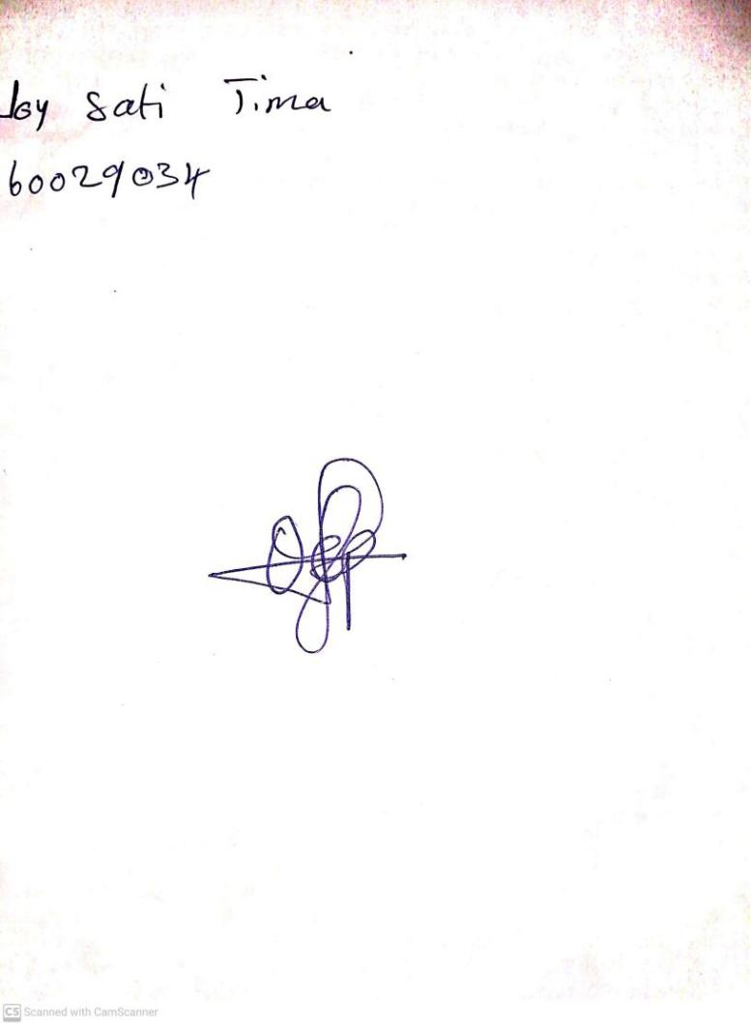

16TH FEBRUARY, 2024

Perpetual Ojoma Ocheja

Stream Head Nursery