**EMERALD ROYAL INTERNATIONAL SCHOOL**

**MPAPE, ABUJA.**

**LESSON PLAN AND NOTE FOR WEEK 1 PERIOD 1 ENDING 26/04/2024**

**TERM: THIRD**

**WEEK: 1ST**

**DATE: 22/04/2024**

**CLASS: NURSERY 2**

**SUBJECT: LETTER WORK**

**TOPIC: REVISION OF DIGRAPHS AND TRIGRAPHS BLENDS. SUB-TOPIC: TRIGRAPHS BLENDS.**

**PERIOD: 1ST PERIOD**

**TIME: 08: 50 - 09:30am**

**DURATION: 40 MINUTES.**

**NUMBER IN CLASS: 13**

**AVERAGE AGE: 5 YEARS.**

**SEX: MIXED.**

**SPECIFIC OBJECTIVES: BY THE END OF THE LESSON,THE PUPILS SHOULD BE**

**ABLE TO:**

**1. EXPLAIN THE MEANING OF CONSONANT**

**TRIGRAPHS.**

**2. MENTION THE EXAMPLES OF CONSONANT DIGRAPHS**

**RATIONALE: FOR PUPILS TO REVEW THE THE PREVIOUS TERM WORK.**

**PREVIOU KNOWLEDGE: PUPILS HAVE LEARNT ABOUT THE TOPIC IN PREVIOUS**

**TERMS**

**INSTRUCTIONAL MATERIALS: CHART OF CONSONANTS TRIGRAPHS WORDS.**

**REFERENCE MATERIALS: GOOGLE.COM .**

**LESSON DEVELOPMENT**

|  |  |  |  |
| --- | --- | --- | --- |
| **STAGES/STEPS** | **TEACHER’S ACTIVITIES** | **PUPILS’ ACTIVITIES** | **LEARNING POINTS** |
| **INTRODUCTION** | **Teacher introduces the lesson by singing new nursery rhymes to pupils.** | **Pupils sing the rhymes along with the teacher.** | **To arouse pupils interest for the lesson ahead.** |
| **PRESENTATION**  **STEP 1** | **Teacher explains the meaning of consonant trigraph to pupils and asks them to repeat after her.** | **Pupils listen attentively to the teacher and repeat after her.** | **For proper understanding .** |
| **STEP 2** | **Teacher mentions the examples of consonant trigraph to pupils and also asks them to repeat after her.** | **Pupils pay attention to the teacher and repeat after her.** | **For better understanding of the lesson.** |
| **BOARD SUMMARY** | **Teacher writes the whole not of lesson on the board for pupils to copy.ie,**  **CONSONANT TRIAGRAHS: are three (3) consonant letters that make single sound when blended together.**  **EXAMPLES :**   1. **”scr” as in** 2. **Screw** 3. **Scrub** 4. **Scribble** 5. **Script** 6. **Street etc.** 7. **“shr” as in** 8. **Shrimp** 9. **Shrine** 10. **Shrink** 11. **Shroud** 12. **Shrew etc.**   **(c) “sch” as in**  **1. schooL**  **2. scholar**  **3 . scheme**  **4. schedule**  **5. scholarship etc.** | **Pupils copy the note into their exercise books.** | **For onward study.** |
| **EVALUATION** | **Teacher asks the following questions;**  **1. What are consonant digraphs?**  **2. Mention the examples of consonant digraphs.** | **Pupils listen to the teacher and answer the questions asked by the teacher.** | **To assess pupils reading skills.** |
| **CONCLUTION** | **Teacher concludes the lesson by marking pupils books.**  **:** | **Pupils submit their books for marking.** | **For endorsement.** |
| **ASSIGNMENT** | **Answer the following questions:**   1. **what is consonant digraph?** 2. **Explain some examples of consonant digraphs.** 3. **Define consonant trigraph.** 4. **Mention the examples of consonant trigraph that you know.** | **Pupils do their assignment at home.** | **To encourage learning at home.** |

**LESSON PLAN AND NOTE FOR WEEK 1 PERIOD 2 ENDING 26/04/2024**

**TERM: THIRD**

**WEEK: 1ST**

**DATE: 23/04/2024**

**CLASS: NURSERY 2**

**SUBJECT: LETTER WORK**

**TOPIC: REVISION OF DIGRAPHS AND TRIGRAPHS BLENDS. SUB-TOPIC: TRIGRAPHS BLENDS.**

**PERIOD : 2ND PERIOD**

**TIME: 08: 50 - 09:30am**

**DURATION: 40 MINUTES.**

**NUMBER IN CLASS: 13**

**AVERAGE AGE: 5 YEARS.**

**SEX: MIXED.**

**SPECIFIC OBJECTIVES: BY THE END OF THE LESSON,THE PUPILS SHOULD BE**

**ABLE TO:**

**1.MAKE WORDS WITH CONSONANT TRIGRAPHS “TCH”**

**2.MENTION WORDS WITH CONSONANT TRIGRAPHS “THR”**

**RATIONALE: FOR PUPILS TO REVIEW THE THE PREVIOUS TERM WORK.**

**PREVIOU KNOWLEDGE: PUPILS HAVE LEARNT ABOUT THE TOPIC IN PREVIOUS**

**TERM.**

**INSTRUCTIONAL MATERIALS: CHART OF CONSONANTS TRIGRAPHS WORDS.**

**REFERENCE MATERIALS: GOOGLE.COM .**

**LESSON DEVELOPMENT**

|  |  |  |  |
| --- | --- | --- | --- |
| **STAGES/STEPS** | **TEACHER’S ACTIVITIES** | **PUPILS’ ACTIVITIES** | **LEARNING POINTS** |
| **INTRODUCTION** | **Teacher introduces the lesson by asking pupils the following questions:**   1. **What are consonant trigraph?** 2. **Mention words with consonants trigraph “sch”** | **Pupils answer the questions asked by the teacher.** | **To arouse pupils interest for the lesson ahead.** |
| **PRESENTATION**  **STEP 1** | **Teacher makes words with consonant trigraph “tch” to pupils and then asks them to repeat after her.** | **Pupils listen attentively to the teacher and repeat after her.** | **For proper understanding .** |
| **STEP 2** | **Teacher mentions the examples of words with consonant trigraph “thr” to pupils and also asks them to repeat after her.** | **Pupils pay attention to the teacher and repeat after her.** | **For better understanding of the lesson.** |
| **BOARD SUMMARY** | **Teacher writes the whole not of lesson on the board for pupils to copy.ie,**  **CONSONANT TRIAGRAHS “TCH”:are ;**  **EXAMPLES :**  **”tch” as in**  **1.hatch**  **2.catch**  **3.batch**  **4. fetch etc.**  **“thr” as in**  **1.throne**  **2.three**  **3.throat**  **4.threw etc.** | **Pupils copy the note into their exercise books.** | **For onward study.** |
| **EVALUATION** | **1. Mention words with consonant trigraphs "tch"**  **2. List consonant trigraphs "thr" words.** | **Pupils listen to the teacher and read the note on the board one after another.** | **To assess pupils reading skills.** |
| **CONCLUTION** | **Teacher concludes the lesson by marking pupils books.**  **:** | **Pupils submit their books for marking.** | **For endorsement.** |
| **ASSIGNMENT** | **Make words with the following consonant trigraphs**   1. **”tch”**   **2 .”sch”**   1. **”shr”**   **4. “thr”** | **Pupils do their assignment at home.** | **To encourage learning at home.** |

**LESSON PLAN AND NOTE FOR WEEK 1 PERIOD 3 ENDING 26/04/2024**

**TERM: THIRD**

**WEEK: 1ST**

**DATE: 26/04/2024**

**CLASS: NRSERY 2**

**SUBJECT: LETTER WORK**

**TOPIC: REVISION OF DIGRAPHS AND TRIGRAPHS BLENDS. SUB-TOPIC: DIGRAPHS AND TRIGRAPHS BLENDS.**

**PERIOD: 3RD PERIOD**

**TIME: 08: 50 - 09:30am**

**DURATION: 40 MINUTES.**

**NUMBER IN CLASS: 17**

**AVERAGE AGE: 5 YEARS.**

**SEX: MIXED.**

**SPECIFIC OBJECTIVES: BY THE END OF THE LESSON,THE PUPILS SHOULD BE**

**ABLE TO:**

**1. MAKE WORDS WITH CONSONANT DIGRAPHS**

**"TH" AND "WH".**

**2. MENTION WORDS WITH CONSONANT**

**TRIGRAPHS " STR" AND "TCH".**

**RATIONALE: FOR PUPILS TO REVEW THE THE PREVIOUS TERM WORK.**

**PREVIOU KNOWLEDGE: PUPILS HAVE LEARNT ABOUT THE TOPIC IN PREVIOUS TERM.**

**REFERENCE MATERIALS: GOOGLE.COM .**

**LESSON DEVELOPMENT**

|  |  |  |  |
| --- | --- | --- | --- |
| **STAGES/STEPS** | **TEACHER’S ACTIVITIES** | **PUPILS’ ACTIVITIES** | **LEARNING POINTS** |
| **INTRODUCTION** | **Teacher introduces the lesson by singing new nursery rhymes to pupils.** | **Pupils sing the rhymes along with the teacher.** | **To arouse pupils interest for the lesson ahead.** |
| **PRESENTATION**  **STEP 1** | **Teacher makes words with consonant digraph “th” and “wh” to pupils and asks them to repeat after her.** | **Pupils listen attentively to the teacher and repeat after her.** | **For proper understanding .** |
| **STEP 2** | **Teacher also mention words with consonant trigraph”str” and “tch” to pupils and also asks them to repeat after her.** | **Pupils pay attention to the teacher and repeat after her.** | **For better understanding of the lesson.** |
| **BOARD SUMMARY** | **Teacher writes the whole not of lesson on the board for pupils to copy.ie,**  **CONSONANT DIAGRAPHS “TH” ARE :**   1. **Then** 2. **Shirt** 3. **Bruch** 4. **Wash** 5. **She etc.**   **C0NSONANT DIGRAPHS “WH” ARE:**   1. **Wheel** 2. **What** 3. **When** 4. **Which** 5. **Where etc.**   **CONSONANT TRIGRAPH “STR” ARE:**   1. **Straw** 2. **Street** 3. **Strong** 4. **Stray** 5. **Strawberry etc.**   **TRIGRAPHS “TCH” ARE:**   1. **match** 2. **watch** 3. **batch** 4. **switch** 5. **Catch etc.** | **Pupils copy the note into their exercise books.** | **For onward study.** |
| **EVALUATION** | **Teacher asks the following questions;**  **1. Mention words with consonant digraphs "th"**  **2. State words with consonant trigraphs "tch"**  **3. Outline Consonant digraphs "'wh" and Consonant trigraphs "str" words.** | **Pupils listen to the teacher and read the note on the board one after another.** | **To assess pupils reading skills.** |
| **CONCLUTION** | **Teacher concludes the lesson by marking pupils books.** | **Pupils submit their books for marking.** | **For endorsement.** |
| **ASSIGNMENT** | **Answer the following questions:**   1. **what is vowel digraphs?** 2. **Make words with vowel “ee”, “ea”, “oo”.** | **Pupils do their assignment at home.** | **To encourage learning at home.** |

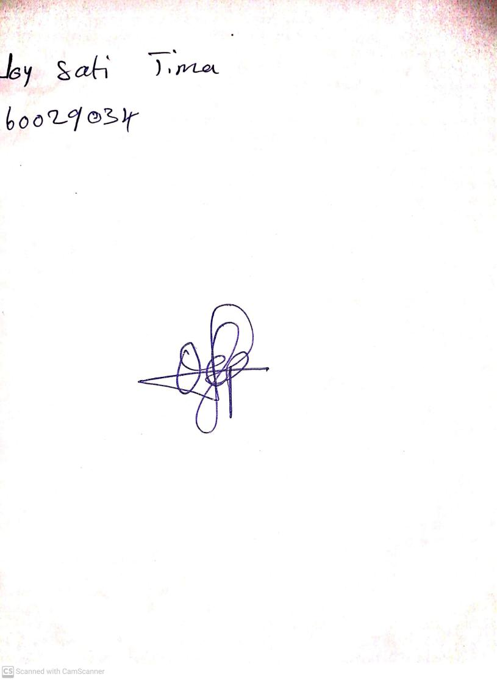

**19th April, 2024**

**Perpetual Ojoma Ocheja**

**Stream Head Nursery**