EMERALD ROYAL INTERNATIONAL SCHOOL

MPAPE, ABUJA.

LESSON PLAN AND NOTE 1 FOR WEEK 4 ENDING 17TH MAY, 2024.

SUBJECT: Letter work

TOPIC: Matching letters Kk - Oo with picture word .

SUB-TOPIC: identification of letters kk-Oo

DATE: 13/5/2024.

DURATION: 40 minutes.

TIME: 08:50--09:30.

PERIOD: 2nd

CLASS: Pre-nursery

NUMBER OF PUPILS: 11

AVERAGE AGE: 2 YEARS

SEX: Mixed.

SPECIFIC OBJECTIVES: By the end of the lesson, the pupils should be able to:-

1. Identify letters Kk-Oo
2. Match the upper case with the lower case.

RATIONALE: For pupils to know letters and their sounds.

PREVIOUS KNOWLEDGE: Pupils have been learning the lower case.

INSTRUCTIONAL MATERIALS: Flash cards, board, and phonics song.

REFERENCE:Mastering English for nursery schools book 1 by J.M.Omogbai.

LESSON DEVELOPMENT

|  |  |  |  |
| --- | --- | --- | --- |
| STAGES/STEPS | TEACHER’S ACTIVITIES | PUPILS’ ACTIVITIES | LEARNING POINTS |
| INTRODUCTION | Teacher introduces the lesson by singing a jolly phonics song for the pupils. | Pupils sing along with the teacher. | To arouse the interest of the pupils for the lesson. |
| PRESENTATION  STEP 1 | Teacher scattered the flash cards of upper and lower case on the table and asks the pupils the upper case and the lower case of each letters. | Pupils identify the upper and lower case of each letters on the table. | For better understanding of the lesson . |
| STEP2 | Teacher prepares the pupils books for them to match the upper case with lower case .  K o  L n  M l  N m  O k | Pupils match the upper case with the lower-case.  K o .  L n  M l  N m  O k | To improve pupils locomotive skills. |
| SUMMARY | Teacher summarizes the lesson by going over the lesson again for more understanding | Pupils listen very attentively to the teacher | For more understanding of the lesson. |
| EVALUATION | Teacher calls out the pupils one after another to identify the upper and the lower case of letter Kk-Oo. | Pupils answer the teacher’s questions. | To assess the level of pupils understanding of the lesson. |
| CONCLUSION | Teacher marks the pupils books and make corrections where necessary. | Pupils submit their books for marking and corrections . | For onwards study. |
| ASSIGNMENT | Read and match upper case and lower case of letter Kk-Oo | Pupils do their Home work at home. | To ensure learning takes place at home. |

LESSON PLAN AND NOTE 2 FOR WEEK 4 ENDING 17TH MAY, 2024.

SUBJECT: Letter work

TOPIC: Matching letter Kk-Oo with picture word .

SUB-TOPIC: identification of letters Kk-Oo and matching letters with the pictures.

DATE: 15/5/2024.

DURATION: 40 minutes.

TIME: 08:50--09:30.

PERIOD: 2nd

CLASS: Pre-nursery

NUMBER OF PUPILS: 11

AVERAGE AGE: 2 YEARS

SEX: Mixed.

SPECIFIC OBJECTIVES: By the end of the lesson, the pupils should be able to:-

1. Identify letter Kk-Oo.
2. Match the upper case with the picture word.

RATIONALE: For pupils to know letters and their sounds.

PREVIOUS KNOWLEDGE: Pupils have been learning the lower case.

INSTRUCTIONAL MATERIALS: Flash cards, board, and phonics song.

REFERENCE:Mastering English for nursery schools book 1 by J.M.Omogbai.

LESSON DEVELOPMENT

|  |  |  |  |
| --- | --- | --- | --- |
| STAGES/STEPS | TEACHER’S ACTIVITIES | PUPILS’ ACTIVITIES | LEARNING POINTS |
| INTRODUCTION | Teacher introduces the lesson by singing a jolly phonics song for the pupils. | Pupils sing along with the teacher. | To arouse the interest of the pupils for the lesson. |
| PRESENTATION  STEP 1 | Teacher scattered the flash cards of upper and lower case on the table and asks the pupils the upper case and the lower case of each letters. | Pupils identify the upper and lower case of each letters on the table. | For better understanding of the lesson . |
| STEP2 | Teacher prepares the pupils books for them to match the upper case with the picture words.  Kk as in cdownload (11)    Ll as in download (12)    Mm as in download (13)    Nn as in download (17)    Oo as in cae4d6ac6be77486f8fcf62c550a1ff02 | Pupils match the upper case with the picture words.  Kk as in download (11)  Ll as in download (12)  Mm as in download (13)  Nn as in download (17)  Oo as in ae4d6ac6be77486f8fcf62c550a1ff02ae4d6ac6be77486f8fcf62c550a1ff02  . | To improve pupils locomotive skills. |
| SUMMARY | Teacher summarizes the lesson by going over the lesson again for more understanding | Pupils listen very attentively to the teacher | For more understanding of the lesson. |
| EVALUATION | Teacher calls out the pupils one after another to:-  1. identify the upper and the lower case of letter Kk-Oo.   1. match the letters with the pictures.   kK as in download (11)  Ll as in download (12)  Mm as in download (13)  Nn as in download (17)  Oo as in  ae4d6ac6be77486f8fcf62c550a1ff02ae4d6ac6be77486f8fcf62c550a1ff02 | Pupils answer the teacher’s questions. | To assess the level of pupils understanding of the lesson. |
| CONCLUSION | Teacher marks the pupils books and make corrections where necessary. | Pupils submit their books for marking and corrections . | For onwards study. |
| ASSIGNMENT | Read and match upper case with the picture words in the text books. | Pupils do their Home work at home. | To ensure learning takes place at home. |

LESSON PLAN AND NOTE 3 FOR WEEK 4 ENDING 17TH MAY, 2024.

SUBJECT: Letter work

TOPIC: Matching letter Kk-Oo with picture word .

SUB-TOPIC: identification of letters Kk-Oo and writing letters.

DATE: 17/5/2024.

DURATION: 40 minutes.

TIME: 08:50--09:30.

PERIOD: 2nd

CLASS: Pre-nursery

NUMBER OF PUPILS: 11

AVERAGE AGE: 2 YEARS

SEX: Mixed.

SPECIFIC OBJECTIVES: By the end of the lesson, the pupils should be able to:-

1. Identify letter Kk-Oo
2. Copy letters Kk-Oo

RATIONALE: For pupils to know letters and their sounds.

PREVIOUS KNOWLEDGE: Pupils have been learning the lower case.

INSTRUCTIONAL MATERIALS: Flash cards, board, and phonics song.

REFERENCE:Mastering English for nursery schools book 1 by J.M.Omogbai.

LESSON DEVELOPMENT

|  |  |  |  |
| --- | --- | --- | --- |
| STAGES/STEPS | TEACHER’S ACTIVITIES | PUPILS’ ACTIVITIES | LEARNING POINTS |
| INTRODUCTION | Teacher introduces the lesson by singing a nursery rhyme for the pupils. | Pupils sing along with the teacher. | To arouse the interest of the pupils for the lesson. |
| PRESENTATION  STEP 1 | Teacher writes the upper case and lower case of letter Kk-Oo on the board for pupils to identify.  Kk Ll Mm Nn Oo. | Pupils points at the letters on the chalk board and identify them by reading them one after another. | For proper recognition of letters. |
| STEP2 | Teacher prepares the pupils books for them to re-write letter Kk-Oo  .  Kk Ll Mm NnOo | Pupils re-write Cc-Ff in the books.  Kk Ll Mm Nn Oo  .  Kk Ll Mm Nn Oo  Kk Ll Mm Nn Oo | To improve pupils locomotive skills. |
| SUMMARY | Teacher summarizes the lesson by asking the pupils to sing the phonics song for letters Cc-Ff with the teacher. | Pupils sing the phonics song for letters Cc-Ff with the teacher. | For more understanding of the lesson. |
| EVALUATION | Teacher calls out the pupils one after another to:-  1. identify the upper and lower case on the flash card.  2.Re-write letter Kk-Oo | Pupils answer the teacher’s questions. | To assess the level of pupils understanding of the lesson. |
| CONCLUSION | Teacher marks the pupils books and make corrections where necessary. | Pupils submit their books for marking and corrections . | For onwards study. |
| ASSIGNMENT | Read and match upper case with the picture words in the text books. | Pupils do their Home work at home. | To ensure learning takes place at home. |

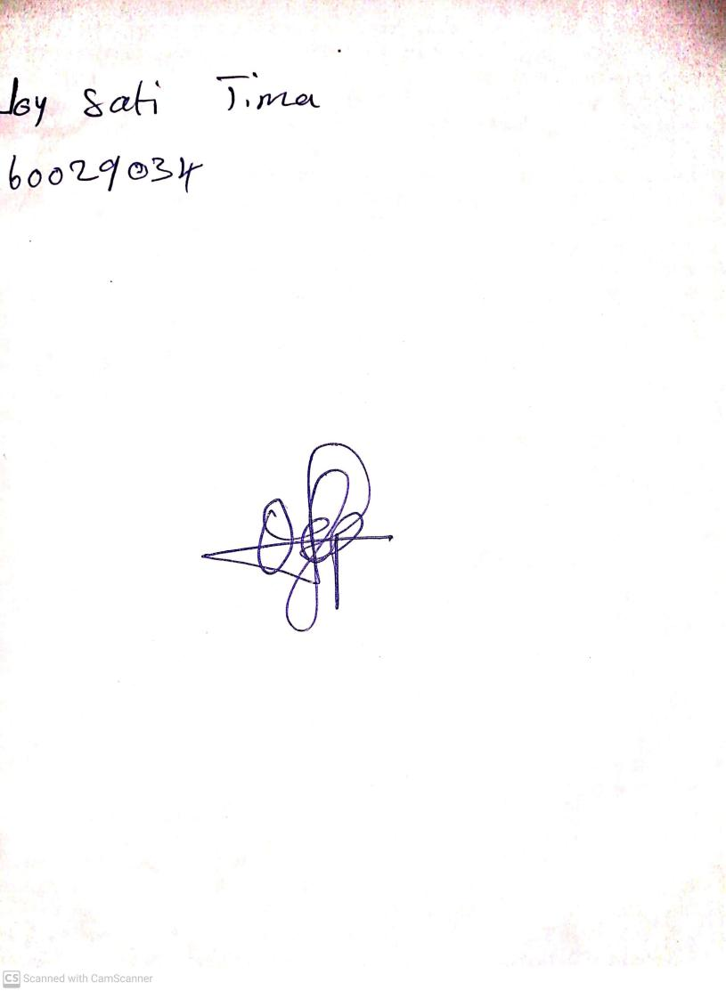

**10th May, 2024**

**Perpetual Ojoma Ocheja**

**Stream Head Nursery**