**EMERALD ROYAL INTERNATIONAL SCHOOL**

**MPAPE, ABUJA.**

**LESSON PLAN AND NOTE FOR WEEK 1 PERIOD 1 ENDING 05/05/2023**

TERM: THIRD

WEEK: 1ST

DATE: 01/05/2023

CLASS: NURSERY 2

SUBJECT: LETTER WORK

TOPIC: REVISION OF DIGRAPHS AND TRIGRAPHS BLENDS. SUB-TOPIC: TRIGRAPHS BLENDS.

PERIOD: 1ST PERIOD

TIME: 08: 50 - 09:30am

DURATION: 40 MINUTES.

NUMBER IN CLASS: 17

AVERAGE AGE: 5 YEARS.

SEX: MIXED.

SPECIFIC OBJECTIVES: BY THE END OF THE LESSON,THE PUPILS SHOULD BE

ABLE TO:

1. EXPLAIN THE MEANING OF CONSONANT

TRIGRAPHS.

2. MENTION THE EXAMPLES OF CONSONANT DIGRAPHS

RATIONALE: FOR PUPILS TO REVEW THE THE PREVIOUS TERM WORK.

PREVIOU KNOWLEDGE: PUPILS HAVE LEARNT ABOUT THE TOPIC IN PREVIOUS

TERMS

INSTRUCTIONAL MATERIALS: CHART OF CONSONANTS TRIGRAPHS WORDS.

REFERENCE MATERIALS: GOOGLE.COM .

**LESSON DEVELOPMENT**

|  |  |  |  |
| --- | --- | --- | --- |
| STAGES/STEPS | TEACHER’S ACTIVITIES | PUPILS’ ACTIVITIES | LEARNING POINTS |
| INTRODUCTION | Teacher introduces the lesson by singing new nursery rhymes to pupils. | Pupils sing the rhymes along with the teacher. | To arouse pupils interest for the lesson ahead. |
| PRESENTATION  STEP 1 | Teacher explains the meaning of consonant trigraph to pupils and asks them to repeat after her. | Pupils listen attentively to the teacher and repeat after her. | For proper understanding . |
| STEP 2 | Teacher mentions the examples of consonant trigraph to pupils and also asks them to repeat after her. | Pupils pay attention to the teacher and repeat after her. | For better understanding of the lesson. |
| BOARD SUMMARY | Teacher writes the whole not of lesson on the board for pupils to copy.ie,  CONSONANT TRIAGRAHS:are three (3) consonant letters that make single sound when blended together.  EXAMPLES :   1. ”scr” as in 2. Screw 3. Scrub 4. Scribble 5. Script 6. Street etc. 7. “shr” as in 8. Shrimp 9. Shrine 10. Shrink 11. Shroud 12. Shrew etc.   (c) “sch” as in  1. schooL  2. scholar  3 .scheme  4. schedule  5. scholarship etc. | Pupils copy the note into their exercise books. | For onward study. |
| EVALUATION | Teacher asks the following questions;  1. What are consonant digraphs?  2. Mention the examples of consonant digraphs. | Pupils listen to the teacher and answer the questions asked by the teacher. | To assess pupils reading skills. |
| CONCLUTION | Teacher concludes the lesson by marking pupils books.  : | Pupils submit their books for marking. | For endorsement. |
| ASSIGNMENT | Answer the following questions:   1. what is consonant digraph? 2. Explain some examples of consonant digraphs. 3. Define consonant trigraph. 4. Mention the examples of consonant trigraph that you know. | Pupils do their assignment at home. | To encourage learning at home. |

**LESSON PLAN AND NOTE FOR WEEK 1 PERIOD 2 ENDING 05/05/2023**

TERM: THIRD

WEEK: 1ST

DATE: 04/05/2023

CLASS: NURSERY 2

SUBJECT: LETTER WORK

TOPIC: REVISION OF DIGRAPHS AND TRIGRAPHS BLENDS. SUB-TOPIC: TRIGRAPHS BLENDS.

PERIOD : 2ND PERIOD

TIME: 08: 50 - 09:30am

DURATION: 40 MINUTES.

NUMBER IN CLASS: 17

AVERAGE AGE: 5 YEARS.

SEX: MIXED.

SPECIFIC OBJECTIVES: BY THE END OF THE LESSON,THE PUPILS SHOULD BE

ABLE TO:

1.MAKE WORDS WITH CONSONANT TRIGRAPHS “TCH”

2.MENTION WORDS WITH CONSONANT TRIGRAPHS “THR” .

RATIONALE: FOR PUPILS TO REVIEW THE THE PREVIOUS TERM WORK.

PREVIOU KNOWLEDGE: PUPILS HAVE LEARNT ABOUT THE TOPIC IN PREVIOUS

TERM.

INSTRUCTIONAL MATERIALS: CHART OF CONSONANTS TRIGRAPHS WORDS.

REFERENCE MATERIALS: GOOGLE.COM .

**LESSON DEVELOPMENT**

|  |  |  |  |
| --- | --- | --- | --- |
| STAGES/STEPS | TEACHER’S ACTIVITIES | PUPILS’ ACTIVITIES | LEARNING POINTS |
| INTRODUCTION | Teacher introduces the lesson by asking pupils the following questions:   1. What are consonant trigraph? 2. Mention words with consonants trigraph “sch” | Pupils answer the questions asked by the teacher. | To arouse pupils interest for the lesson ahead. |
| PRESENTATION  STEP 1 | Teacher makes words with consonant trigraph “tch” to pupils and then asks them to repeat after her. | Pupils listen attentively to the teacher and repeat after her. | For proper understanding . |
| STEP 2 | Teacher mentions the examples of words with consonant trigraph “thr” to pupils and also asks them to repeat after her. | Pupils pay attention to the teacher and repeat after her. | For better understanding of the lesson. |
| BOARD SUMMARY | Teacher writes the whole not of lesson on the board for pupils to copy.ie,  CONSONANT TRIAGRAHS “TCH”:are ;  EXAMPLES :  ”tch” as in  1.hatch  2.catch  3.batch  4. fetch etc.  “thr” as in  1.throne  2.three  3.throat  4.threw etc. | Pupils copy the note into their exercise books. | For onward study. |
| EVALUATION | 1. Mention words with consonant trigraphs "tch"  2. List consonant trigraphs "thr" words. | Pupils listen to the teacher and read the note on the board one after another. | To assess pupils reading skills. |
| CONCLUTION | Teacher concludes the lesson by marking pupils books.  : | Pupils submit their books for marking. | For endorsement. |
| ASSIGNMENT | Make words with the following consonant trigraphs   1. ”tch”   2 .”sch”   1. ”shr”   4. “thr” | Pupils do their assignment at home. | To encourage learning at home. |

**LESSON PLAN AND NOTE FOR WEEK 1 PERIOD 3 ENDING 05/05/2023**

TERM: THIRD

WEEK: 1ST

DATE: 05/05/2023

CLASS: NRSERY 2

SUBJECT: LETTER WORK

TOPIC: REVISION OF DIGRAPHS AND TRIGRAPHS BLENDS. SUB-TOPIC: DIGRAPHS AND TRIGRAPHS BLENDS.

PERIOD: 3RD PERIOD

TIME: 08: 50 - 09:30am

DURATION: 40 MINUTES.

NUMBER IN CLASS: 17

AVERAGE AGE: 5 YEARS.

SEX: MIXED.

SPECIFIC OBJECTIVES: BY THE END OF THE LESSON,THE PUPILS SHOULD BE

ABLE TO:

1. MAKE WORDS WITH CONSONANT DIGRAPHS

"TH" AND "WH".

2. MENTION WORDS WITH CONSONANT

TRIGRAPHS " STR" AND "TCH".

RATIONALE: FOR PUPILS TO REVEW THE THE PREVIOUS TERM WORK.

PREVIOU KNOWLEDGE: PUPILS HAVE LEARNT ABOUT THE TOPIC IN PREVIOUS TERM.

S.

REFERENCE MATERIALS: GOOGLE.COM .

**LESSON DEVELOPMENT**

|  |  |  |  |
| --- | --- | --- | --- |
| STAGES/STEPS | TEACHER’S ACTIVITIES | PUPILS’ ACTIVITIES | LEARNING POINTS |
| INTRODUCTION | Teacher introduces the lesson by singing new nursery rhymes to pupils. | Pupils sing the rhymes along with the teacher. | To arouse pupils interest for the lesson ahead. |
| PRESENTATION  STEP 1 | Teacher makes words with consonant digraph “th” and “wh” to pupils and asks them to repeat after her. | Pupils listen attentively to the teacher and repeat after her. | For proper understanding . |
| STEP 2 | Teacher also mention words with consonant trigraph”str” and “tch” to pupils and also asks them to repeat after her. | Pupils pay attention to the teacher and repeat after her. | For better understanding of the lesson. |
| BOARD SUMMARY | Teacher writes the whole not of lesson on the board for pupils to copy.ie,  CONSONANT DIAGRAPHS “TH” ARE :   1. Then 2. Shirt 3. Bruch 4. Wash 5. She etc.   C0NSONANT DIGRAPHS “WH” ARE:   1. Wheel 2. What 3. When 4. Which 5. Where etc.   CONSONANT TRIGRAPH “STR” ARE:   1. Straw 2. Street 3. Strong 4. Stray 5. Strawberry etc.   TRIGRAPHS “TCH” ARE:   1. match 2. watch 3. batch 4. switch 5. Catch etc. | Pupils copy the note into their exercise books. | For onward study. |
| EVALUATION | Teacher asks the following questions;  1. Mention words with consonant digraphs "th"  2. State words with consonant trigraphs "tch"  3. Outline Consonant digraphs "'wh" and Consonant trigraphs "str" words. | Pupils listen to the teacher and read the note on the board one after another. | To assess pupils reading skills. |
| CONCLUTION | Teacher concludes the lesson by marking pupils books. | Pupils submit their books for marking. | For endorsement. |
| ASSIGNMENT | Answer the following questions:   1. what is vowel digraphs? 2. Make words with vowel “ee”, “ea”, “oo”. | Pupils do their assignment at home. | To encourage learning at home. |

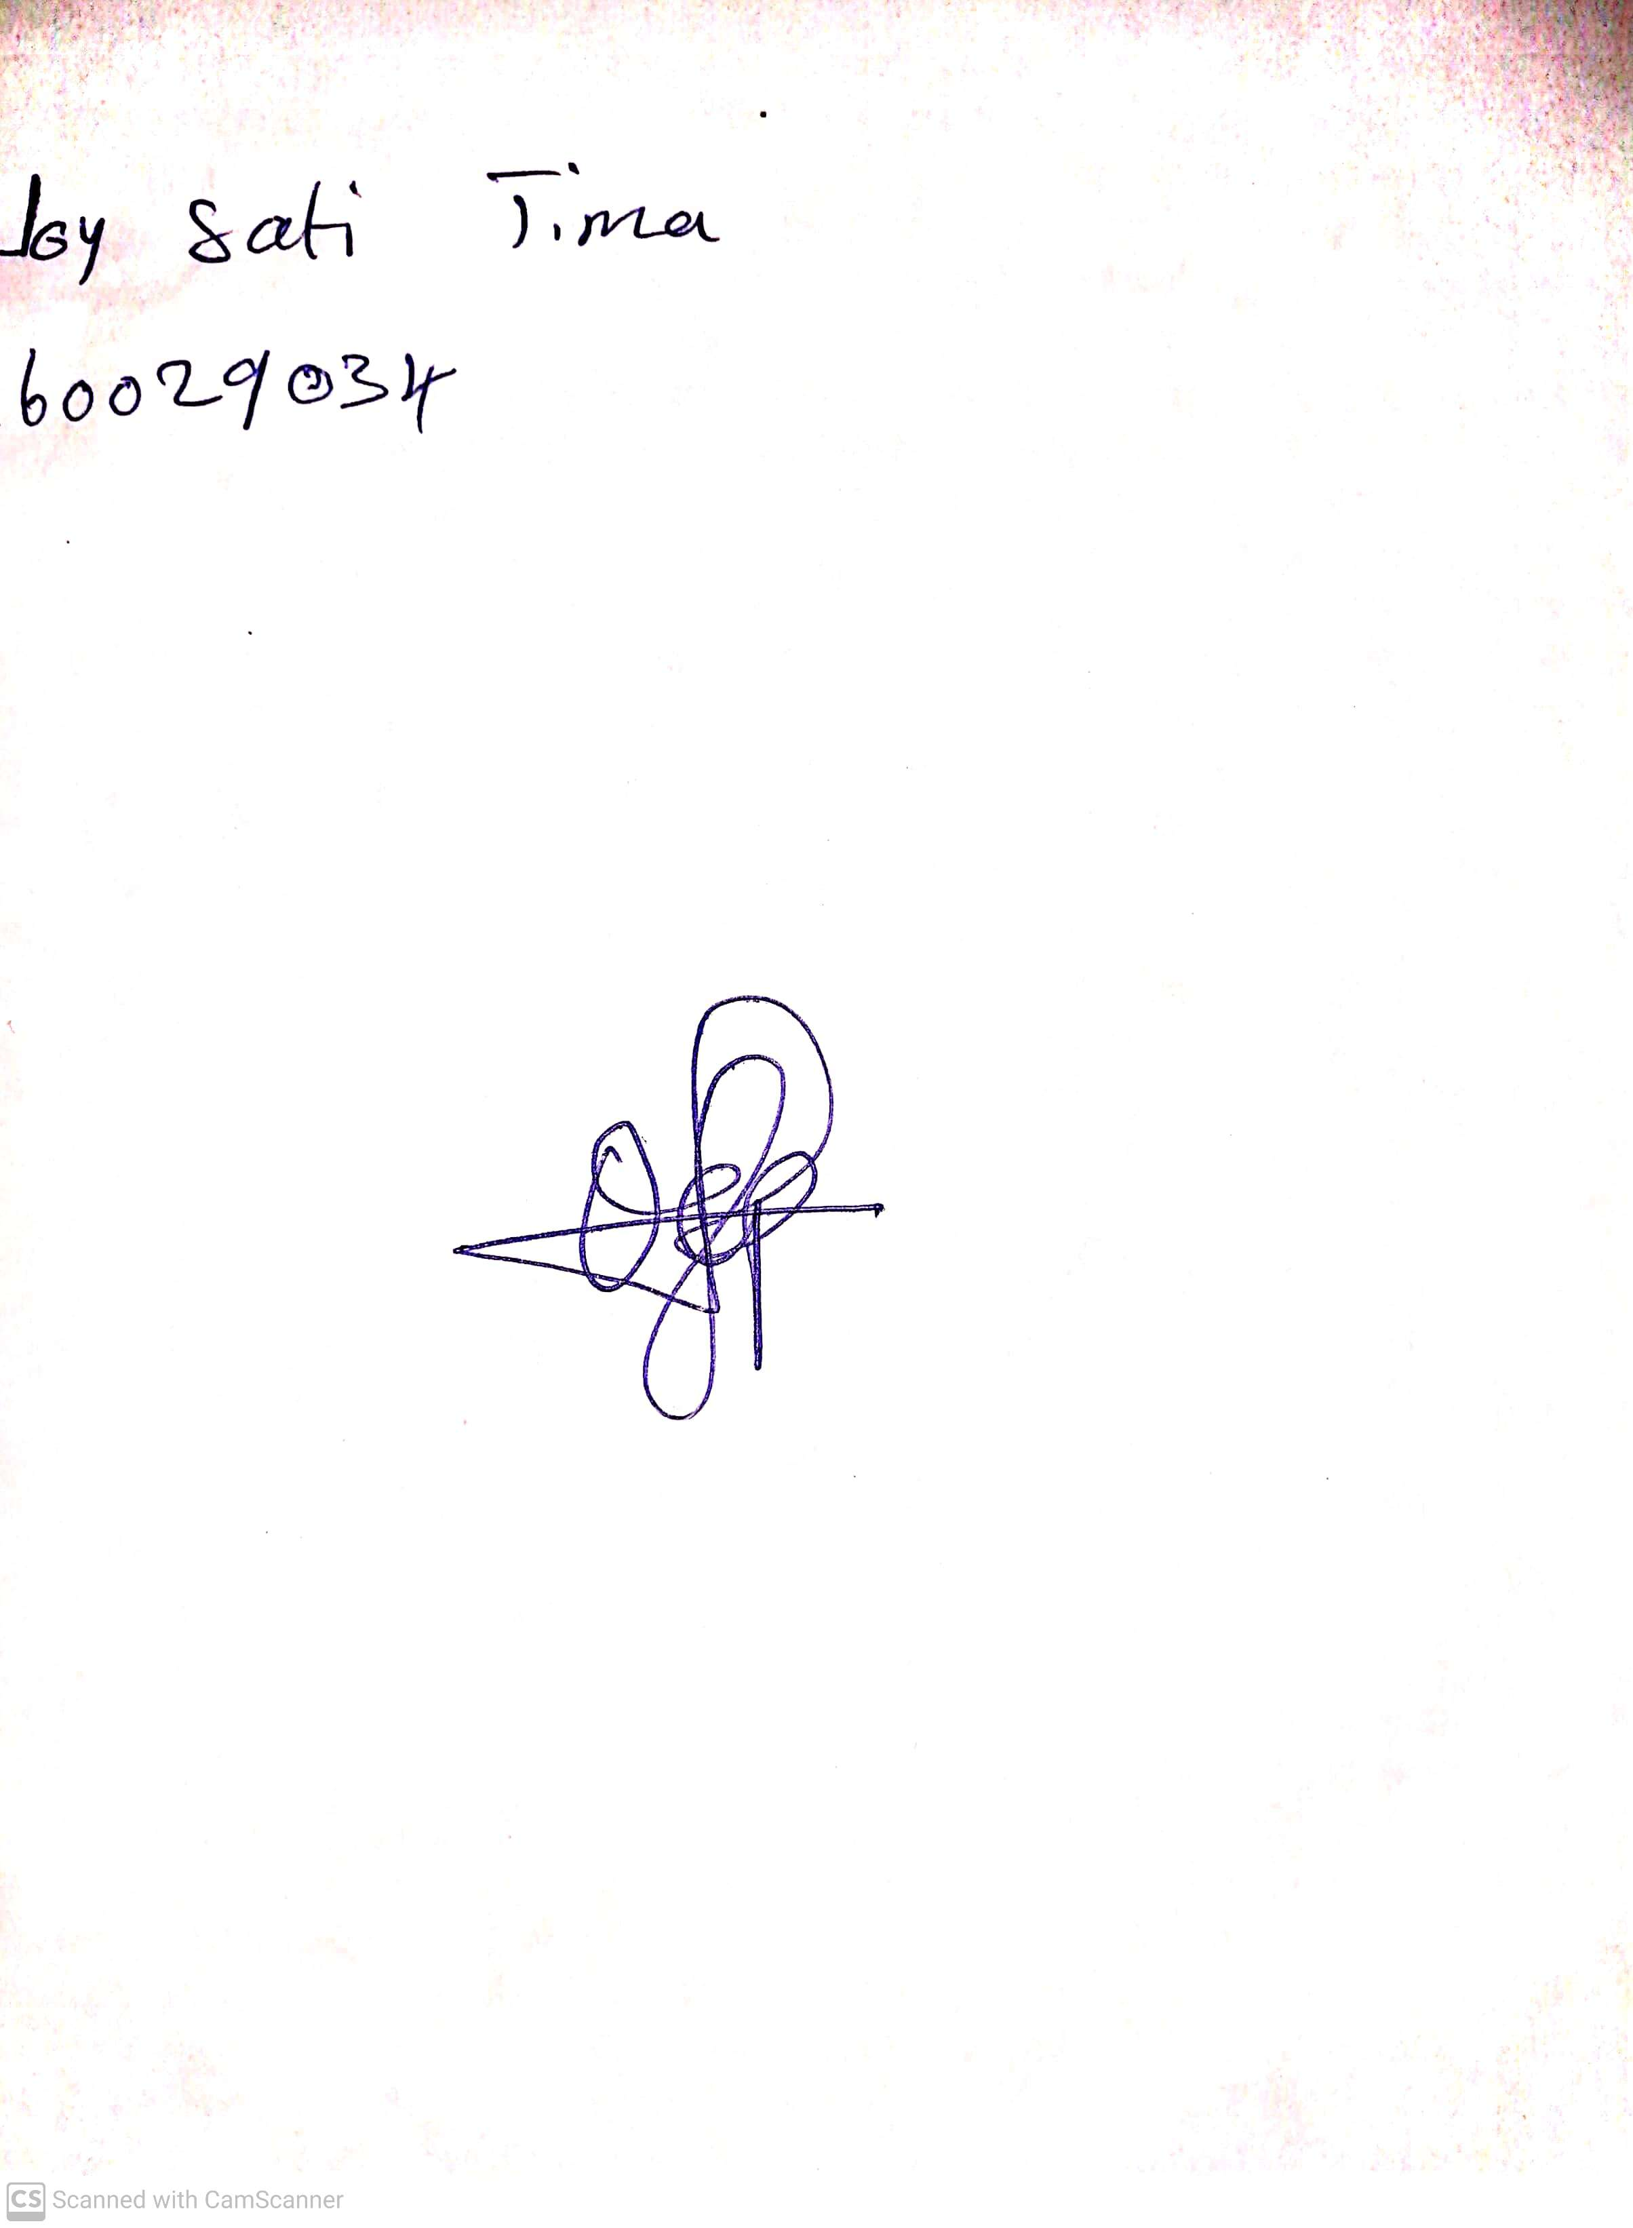

14th May, 2023

Perpetual Ojoma

Stream Head Nursery