**LESSON PLAN AND NOTE 1 FOR WEEK 6 ENDING 31/5/2024**

**Term 3rd term**

**Week 6TH week**

**Date 27/5/2024**

**Class Nursery one**

**Subject Number work**

**Topic Even numbers**

**Sub-topic Meaning of Even numbers.**

**Period 2nd period**

**Time 9:05 am**

**Duration 35 minutes**

**No in class 14**

**Average Age 3 years**

**Sex Mixed**

**Specific Objectives: By the end of the lesson the pupils should be able to;**

1. **Explain Even numbers.**
2. **List the examples of Even numbers**

**Rationale: To make sure the pupils explain Even numbers.**

**Previous knowledge: The pupils can fill in missing odd numbers.**

**Instructional Resources: Chart, board, marker, exercise books, pencils.**

**Reference Materials: Online Research,chart,board.**

**LESSON PRESENTATION**

|  |  |  |  |
| --- | --- | --- | --- |
| **Steps** | **Teacher’s Activities** | **Pupils’ Activities** | **Learning Points** |
| **Introduction** | **The teacher introduces the topic [Even numbers] to the pupils.** | **The pupils listens to the teacher.** | **To arouse the pupils’ interest towards the lesson.** |
| **Step 1** | **The teacher defines even numbers as “numbers that can be divided by two (2) without a reminder”.** | **The pupils individually repeats after the teacher.** | **For proper understanding.** |
| **Step 2** | **The teacher lists the examples of even numbers on the board e.g**  **2 4 6 8**  **10 12 14 16**  **18 20.** | **The pupils repeats after the teacher.** | **For better understanding.** |
| **Summary** | **The teacher summarizes the lesson by defining even numbers to the pupils.** | **The pupils understands the lesson.** | **For onward study.** |
| **Conclusion** | **The teacher summarizes, reacts, and corrects the pupils.** | **The pupils gives answers to the teacher’s question.** | **To consolidate the lesson.** |
| **Evaluation** | **Question:**  **What are even numbers?**  **List (3) even numbers you know?.** | **The pupils answer the question accordingly** | **To ascertain the pupils’ understanding.** |
| **Assignment** | **Question:**  **What are even numbers?**  **Write only even numbers from 1-10.** | **The pupils copy and do their homework at home.** | **To encourage learning while at home.** |

**LESSON PLAN AND NOTE 2 FOR WEEK 6 ENDING 31/5/2024**

**Term 3rd term**

**Week 6th week**

**Date 29/5/2024**

**Class Nursery one**

**Subject Number work**

**Topic Even numbers**

**Sub-topic Identification of even numbers.**

**Period 2nd period**

**Time 9:35 am**

**Duration 35 minutes**

**No in class 14**

**Average Age 3 years**

**Sex Mixed**

**Specific Objectives: By the end of the lesson the pupils should be able to;**

1. **Identify even numbers**
2. **Match even numbers.**

**Rationale: To make sure the pupils identify and match even numbers Previous knowledge: The pupils can define and list even numbers.**

**Instructional Resources: Chart, board, marker, exercise books, pencils.**

**Reference Materials: Online Research,chart,board.**

**LESSON PRESENTATION**

|  |  |  |  |
| --- | --- | --- | --- |
| **Steps** | **Teacher’s Activities** | **Pupils’ Activities** | **Learning Points** |
| **Introduction** | **The teacher introduces the topic [Even numbers] to the pupils.** | **The pupils repeats after the teacher.** | **To arouse the pupils’ interest towards the lesson.** |
| **Step 1** | **The teacher leads the pupils to identify even numbers**  **2 4 6 8 10 12 14 16 18 20.** | **The pupils individually identify even numbers**  **2 4 6 8 10 12 14 16 18 20.** | **For proper understanding.** |
| **Step 2** | **The teacher leads the pupils to match even numbers**  **2 12**  **8 10**  **10 6**  **6 4**  **4 8**  **12 2** | **The pupils match even numbers.**  **2 12**  **8 4**  **10 6**  **6 10**  **4 8**  **12 2** | **For better understanding.** |
| **Summary** | **The teacher summarizes the lesson by identifying random even numbers for the pupils.**  **32 20 10 14.** | **The pupils can identify even numbers.** | **For onward study.** |
| **Conclusion** | **The teacher summarizes, reacts, and corrects the pupils.** | **The pupils gives answers to the teacher’s question.** | **To consolidate the lesson.** |
| **Evaluation** | **Question:**  **Identify even numbers**  **2 4 6 8 10 12 14 16 18 20.**  **List the even number in numbers 1-10.** | **The pupils answer the question accordingly** | **To ascertain the pupils’ understanding.** |
| **Assignment** | **Question:**  **Identify even numbers**  **2 4 6 8 10 12 14 16 18 20.**  **Match the following even numbers below?**  **14 12**  **94 76**  **52 38**  **38 52**  **76 94**  **12 14** | **The pupils copy and do their homework at home.** | **To encourage learning while at home.** |

**LESSON PLAN AND NOTE 3 FOR WEEK 6 ENDING 31/5/2024**

**Term 3rd term**

**Week 6th week**

**Date 31/5/2024**

**Class Nursery one**

**Subject Number work**

**Topic Even numbers**

**Sub-topic Fill in the missing even numbers**

**Period 2nd period**

**Time 9:50 am**

**Duration 35 minutes**

**No in class 14**

**Average Age 3 years**

**Sex Mixed**

**Specific Objectives: By the end of the lesson the pupils should be able to;**

1. **Fill in the missing even numbers accordingly.**
2. **Underline even numbers.**

**Rationale: To make sure the pupils fill in & underline even numbers**

**previous knowledge: The pupils can identify and match even numbers**

**Instructional Resources: Crayons, exercise books, pencils.**

**Reference Materials: Online Research,chart,board.**

**LESSON PRESENTATION**

|  |  |  |  |
| --- | --- | --- | --- |
| **Steps** | **Teacher’s Activities** | **Pupils’ Activities** | **Learning Points** |
| **Introduction** | **The teacher introduces the topic [Even numbers] to the pupils.** | **The pupils listens to the teacher.** | **To arouse the pupils’ interest towards the lesson.** |
| **Step 1** | **The teacher writes missing even numbers on the board for the pupils to identify & fill in the missing numbers e.g**  **1------ 3 -----5 ----7----9**  **------.** | **The pupils fill in the missing even numbers from the board**  **1 2 3 4 5 6**  **7 8 9 10** | **For proper understanding.** |
| **Step 2** | **The teacher writes down random numbers for the pupils to underline the even numbers inside their notebooks.**  **15 16 17 18**  **19 20 21 22**  **23 24 25 26** | **The pupils underline the even numbers inside their notebook**  **15 16 17 18**  **19 20 21 22**  **23 24 25 26** | **For better understanding.** |
| **Summary** | **The teacher summarizes the lesson by defining even numbers to the pupils.** | **The pupils understands even numbers.** | **For onward study.** |
| **Conclusion** | **The teacher summarizes, reacts, and corrects the pupils.** | **The pupils gives answers to the teacher’s question.** | **To consolidate the lesson.** |
| **Evaluation** | **Question:**  **Fill in the missing numbers below**  **3 -----5 ----7----9**  **------.**  **Underline the even numbers below?**  **15 16 17 18**  **19 20 21 22**  **23 24 25 26** | **The pupils answer the question accordingly** | **To ascertain the pupils’ understanding.** |
| **Assignment** | **Question:**  **Fill in the missing even numbers below?**  **------ 41 -----43 ----45----47------.**  **Underline the even numbers below?**  **15 16 17 18**  **19 20 21 22**  **23 24 25 26** | **The pupils copy and do their homework at home.** | **To encourage learning while at home.** |

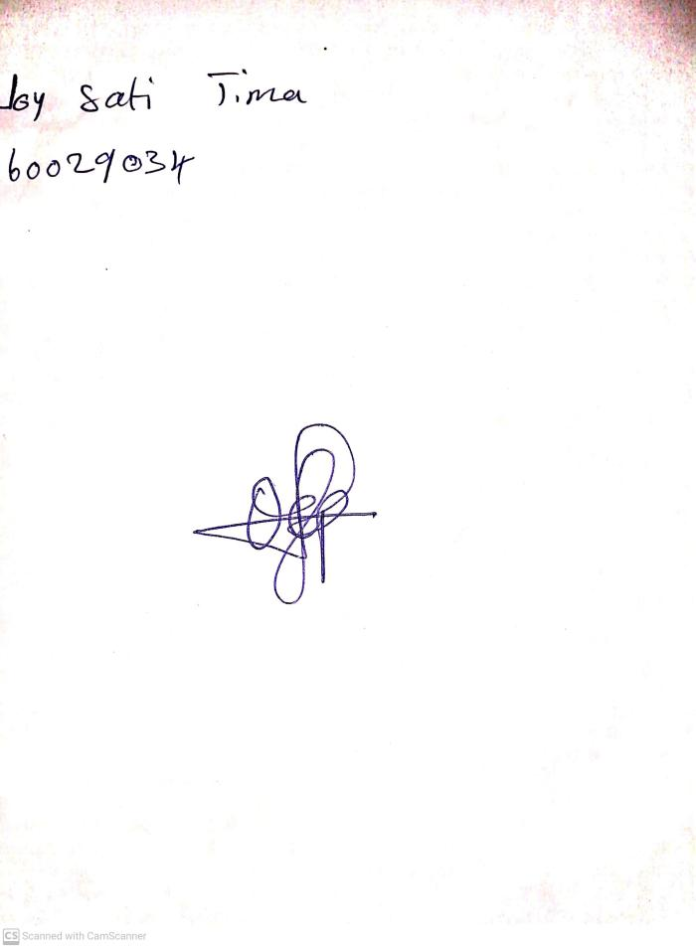

24th May, 2024

Perpetual Ojoma Ocheja

Stream Head Nursery