**EMERALD ROYAL INTERNATIONAL SCHOOL**

**MPAPE, ABUJA.**

**LESSON PLAN AND NOTE FOR WEEK 8 ENDING 14/06/2024**

**TERM: THIRD**

**WEEK: 8TH**

**DATE: 10/06/2024**

**CLASS: NURSERY 2**

**SUBJECT: SOCIAL NORMS**

**TOPIC: MY COUNTRY 2 .**

**SUB-TOPIC: COAT OF ARMS AND HER CHARACTERS**

**PERIOD: 2ND PERIOD AFTER LONG BREAK**

**TIME: 11: 20- 12: 00PM**

**DURATION: 40 MINUTES.**

**NUMBER IN CLASS: 13**

**AVERAGE AGE: 5 YEARS.**

**SEX: MIXED.**

**SPECIFIC OBJECTIVES: BY THE END OF THE LESSON,THE PUPILS SHOULD BE**

**ABLE TO:**

1. **EXPLAIN WHAT COAT OF ARMS STANDS FOR.**
2. **STATE THE VARIOUS CHARACTERS IN NIGERIA COAT OF ARMS AND WHAT THEY STAND FOR.**

**RATIONALE: FOR PUPILS TO KNOW ABOUT NIGERIA COAT OF ARM.**

**PREVIOU KNOWLEDGE: PUPILS HAVE LEARNT HOW TO RESITE NATIONAL ANTHEM,PLEDGE AND IMORTACE OF NATIONAL PLEDGE**

**IN PREVIOUS TERM**

**INSTRUCTIONAL MATERIALS: PICTURE OF NIGERIA COAT OF ARM.**

**REFERENCE MATERIALS: GOOGLE.COM**

**LESSON DEVELOPMENT**

|  |  |  |  |
| --- | --- | --- | --- |
| **STAGES/STEPS** | **TEACHER’S ACTIVITIES** | **PUPILS’ ACTIVITIES** | **LEARNING POINTS** |
| **INTRODUCTION** | **Teacher shows the pupils the picture of Nigeria coat of arm and then asks if they have seen it before?.** | **Pupils pay attention to the teacher and answer the question asked by her.** | **To prepare pupils minds for the lesson ahead.** |
| **PRESENTATION**  **STEP 1** | **Teacher explain to pupils what coat of arms stands for and then asks them to repeat after her.** | **Pupils listen attentively to the teacher and repeat after her.** | **For proper understanding .** |
| **STEP 2** | **Teacher states the characters in Nigeria coat of arm and what there stands for to pupils and also asks them to repeat after her.** | **Pupils pay attention to the teacher and repeat after her.** | **For better understanding.** |
| **BOARD SUMMARY** | **Teacher summarizes the lesson by writing the whole note of lesson on the board for pupils to copy into their books. Ie,**  **MY COUNTRY 2**  **A coat of arms is a symbol that represents a specific family or person.**  **The coat of arms of Nigeria consists of a black shield with a wavy white pall, symbolizing the meeting of the Niger and Benue Rivers at Lokoja.**  **CHARACTERS IN NIGERIA COAT OF ARM**   1. **Black shield: represents Nigeria’s fertile soil.** 2. **Two supporting horses: represents dignity.** 3. **Red eagle: is for the strength of the Nation.** 4. **“Y” shape: represents the rivers** | **Pupils copy the note into their exercise books.** | **For onward study.** |
| **EVALUATION** | **Teacher evaluates the lesson by asking the following questions;**   1. **What does coat of arm stands for?** 2. **Mention the characters in Nigeria coat of arm and what there stands for.** | **Pupils answer the questions ask by the teacher.** | **To assess pupils level of understanding.** |
| **CONCLUTION** | **Teacher concludes the lesson by marking pupils books.** | **Pupils submit their books for marking.** | **For endorsement.** |
| **ASSIGNMENT** | 1. **List out 10 electrical appliances in your home.** 2. **Mention 10 non electrical home appliances.** | **Pupils do their assignment at home.** | **To encourage learning at home.** |

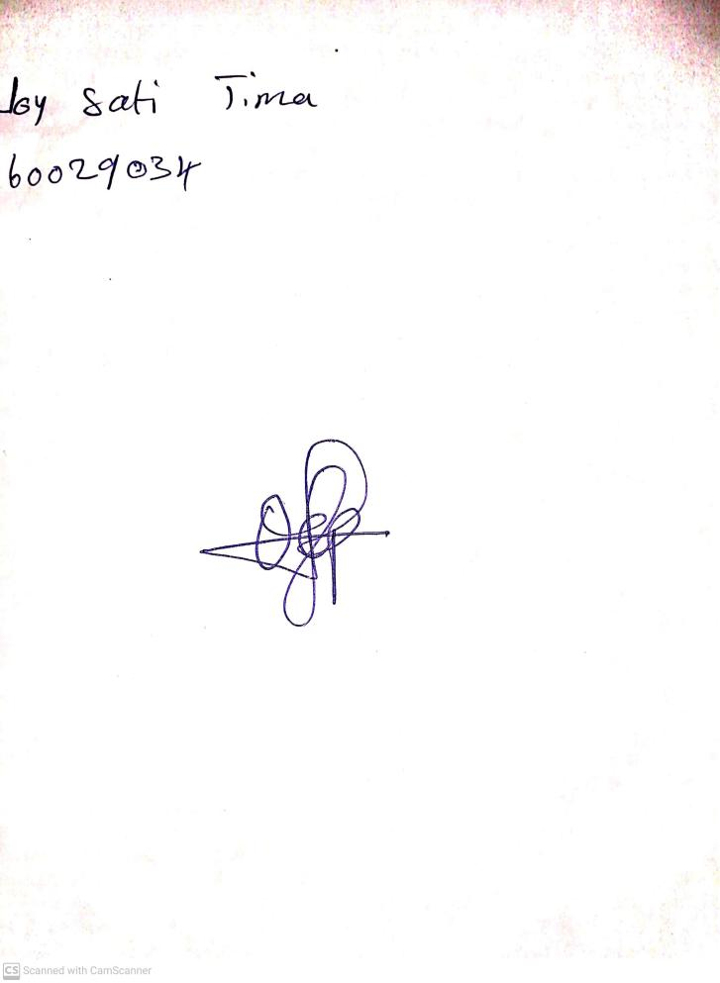

**7th June, 2024**

**Perpetual Ojoma Ocheja**

**Stream Head Nursery**