LESSON PLAN / NOTE FOR WEEK 9 ENDING 10/03/2023

TERM: 2nd

WEEK: 9th

DATE: 06/03/2023

CLASS: Nursery 2

SUBJECT: Letter work

TOPIC: Consonant digraphs 2

SUB—TOPIC: Words with consonant digraphs‘ th’ and ‘wh’

PERIOD: 1st

TIME: 09:30–10:10am

DURATION: 40 minutes

NUMBER IN CLASS: 14

AVERAGE AGE: 5 years

SEX: Mixed

LEARNING OBJECTIVES: By the end of the lesson, the Pupils should be able to:

1. Generate words with consonant digraphs ‘th’

2. Make words with consonant digraphs ‘wh’

RATIONALE: For Pupils to know words with consonant digraphs th and wh.

PREVIOUS KNOWLEDGE: Pupils have learnt consonant digraphs ck,ph, sh and ch in previous lesson.

INSTRUCTIONAL MATERIALS: A chart of words with initial ‘th’and ‘wh’

REFERENCE MATERIALS: Google. com

LESSON DEVELOPMENT

|  |  |  |  |
| --- | --- | --- | --- |
| Steps | Teacher's activities | Pupils' activities | Learning point |
| Introduction | Teacher introduces the lesson by reviewing the previous lesson. | Pupils pay attention to the teacher. | To arouse pupils interest for the lesson ahead. |
| Presentation Step 2 | Teacher generates words with consonant digraphs ‘th’and then ask Pupils to repeat after her. | Pupils listen to the teacher and repeat after her. | For proper understanding. |
| Step 2 | Teacher makes words with consonant digraphs ‘wh’and also ask Pupils to repeat after her. | Pupils pay attention to the teacher and also repeat after her. | For better understanding. |
| Board summary | Teacher writes the whole note of lesson on the board for pupils to copy into their books. That is;  CONSONANT DIGRAPHS ‘TH’ARE:  1. Then  2. Think  3. Thank  4. Thumb  5. Thursday  6. Thunder  7. Month etc  CONSONANT DIGRAPHS ‘WH’ ARE:  1. Wheel  2. What  3. When  4. Which  5. Where  6. Whister  7. Whisper etc. | Pupils copy the note into their exercise books. | For onward study |
| Evaluation | Teacher evaluates the lesson by asking pupils to read the words on the board one after another. | Pupils go to the board one after another and read. | To assess Pupils reading ability. |
| Conclusion | Teacher concludes the lesson by marking pupils books. | Pupils submit their books for marking. | For endorsement. |
| Assignment | Generate 10 words with consonant digraphs‘wr’ | Pupils do their assignment at home. | To encourage learning at home. |

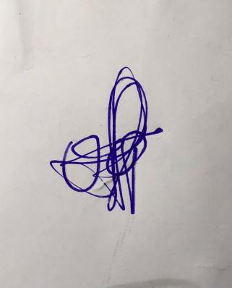

**29th March, 2023**

**Perpetual Ojoma Ocheja**

**Stream Head Nursery**