**LESSON PLAN AND NOTE FOR WEEK 9 ENDING 08/03/2024**

**Term 2nd term**

**Week 9th week**

**Date 6th March,2024**

**Class Nursery one**

**Subject Nature studies**

**Topic Rainbow**

**Sub-topic Meaning of Rainbow and rhyming the colour of a rainbow**

**Period 2nd period**

**Time 9:05 am**

**Duration 35 minutes**

**No in class 15**

**Average Age 3 years**

**Sex Mixed.**

**Specific Objectives: By the end of the lesson, the pupils should know how to:**

1. **Define Rainbow**
2. **Mention the colour of a rainbow.**

**Rationale: To help the pupils have vital knowledge of rainbow.**

**Previous Knowledge: The pupils have knowledge of Weather.**

**Instructional Resources: Online Research,Chart.**

**Reference Materials: Online Research, Elementary Science by Showers Kiddies.**

**LESSON PRESENTATION**

|  |  |  |  |
| --- | --- | --- | --- |
| **Steps** | **Teacher’s Activities** | **Pupils’ Activities** | **Learning Points** |
| **Introduction** | **The teacher introduces the topic (rainbow) by showing the pupils pictures of a rainbow.** | **The pupils could identify a beautiful rainbow.** | **To arouse the interest of the pupils.** |
| **Step 1** | **The teacher starts the lesson by teaching the pupils the meaning of rainbow as “a kind of curved coloured lines in the sky.** | **The pupils listen attentively to the teacher and repeats after the teacher the meaning of Rainbow.** | **For proper understanding.** |
| **Step 2** | **The teacher mention the seven colour of a rainbow with a rhyme for the pupils.** | **The pupils listens to the teacher and rhyme with fun the seven co-lours of a rainbow.** | **For better understanding.** |
| **Summary** | **The teacher summarizes the lesson by defining Rainbow.** | **The pupils knows the definition of a rainbow.** | **For onward study.** |
| **Evaluation** | **Question:**   1. **Define Rainbow?** 2. **Rhyme the seven co-lours in a rainbow.** | **The pupils answer the question correctly.** | **To ascertain the pupils’ understanding.** |
| **Conclusion** | **The teacher summarizes, reacts, and corrects the pupils.** | **The pupils gives answers to the teacher’s question.** | **To consolidate the lesson.** |
| **Assignment** | **Question:**   1. **Define Rainbow?** 2. **Rhyme the seven co-lours in a rainbow.** 3. **Draw a beautiful rainbow with the co-lours of a rainbow?** | **The pupils copy and do their homework at home.** | **To encourage learning while at home.** |

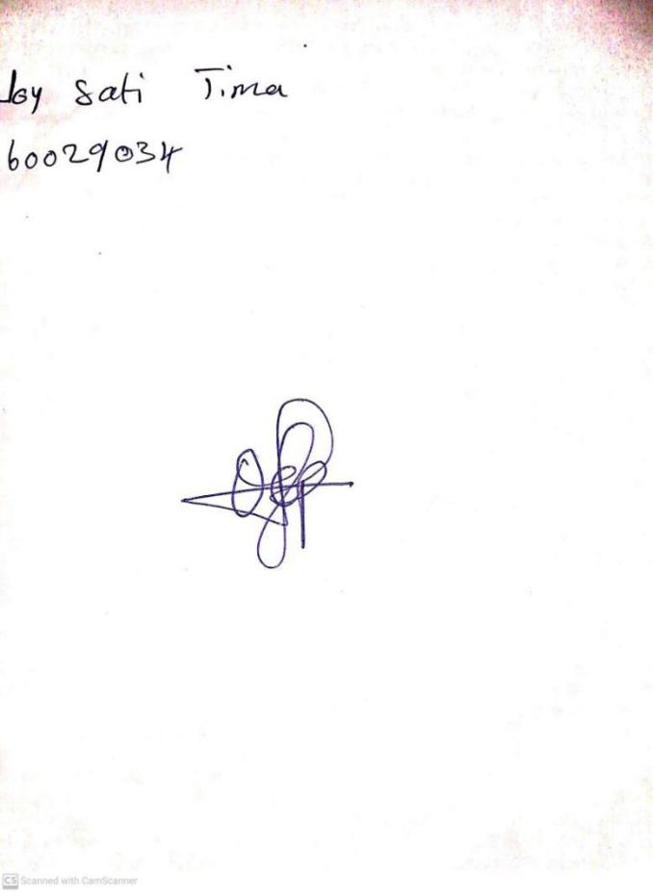

1ST March, 2024

Perpetual Ojoma Ocheja

Stream Head Nursery