**LESSON PLAN/NOTE FOR WEEK 6 ENDING 09/06/2023**

**Term**: 3rd

**Week**: 6

**Date**: 05/06/2023

**Class**: SS 1

**Subject**: Civic Education

**Topic**: Orderliness

**Sub-Topic**: Examples of orderliness

**Period**: 3rd

**Time**: 09:30-10:10

**Duration**: 40 Minutes

**Number in class:** 8 students

**Average Age:** 14 years

**Sex**: mixed

**Specific objectives**: By the end of the lesson, the students should be able to:

(1) State the Examples of orderliness

(11) Explain the examples of orderliness

**Rationale**: For the students to be able to follow due process in handling issues and obeying rules and regulations in the society.

**Previous knowledge:** The students have been following issues accordingly in the school.

**Instructional material:** A chart showing people listening to a speaker addressing them.

**Reference material**: Gbenga Babalola (2017) Essential civic Education for senior secondary schools.

**LESSON DEVELOPMENT**

|  |  |  |  |
| --- | --- | --- | --- |
| **Stages/Steps** | **Teacher's Activities** | **Students' Activities** | **Learning points** |
| **Introduction** | Review the previous lesson | Participate actively in the class discussion | To arouse the students interest to learn |
| **Step** **1** | States the examples of orderliness as:  (1) Listening skills (2) driving skills etc. | Listen carefully to the teacher | For better understanding of the lesson. |
| **Step 11** | Guides the students to explain the examples of orderliness | Respond to the class activity | To encourage critical thinking. |
| **Board summary** | Summarizes the lesson as:  **Examples of orderliness in the society**.  (1) Listening skills: we listen to gain information, to make decisions and for enjoyment. Good listening habits help to avoid misunderstanding, Embarrassment and mistakes. There is need for us to be attentive to others while they talk. Orderliness involves paying attention while others talk.  (2) Driving skills: There is a need to acquire driving skills before driving. It is important to go through the normal driving school process prescribed by the authority concerned before making any attempt to drive. That is where we will be thought the necessary driving skills. We can demonstrate orderliness in driving by observing the traffic light, obeying traffic warden instruction and obeying the traffic rules and regulations. | Copy and submit the note book for marking. | For future reference. |
| **Evaluation** | Evaluates the students as:  (1) State 2 examples of orderliness in the society  (2) Explain 2 examples of orderliness in the society | Respond to the questions | Ascertaining the attainment of the stated objectives |
| **Conclusion** | Rounds up the lesson by marking and correcting students work. | Check and do their correction | Consolidation of the lesson. |
| **Assignment** | Gives home work as:  (1) write short Note on the following:  (a) listening skills (b) driving skills (c) obeying traffic rules and regulations | Respond by doing the home work at home | To ensure continuity of learning |

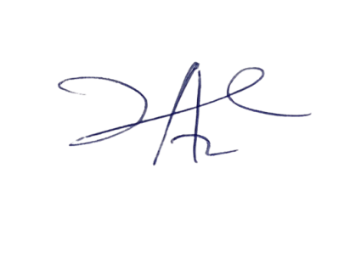

2/6/2023

Principal Head Instuctor