**EMERALD ROYAL INT’L SCHOOL**

**LESSON PLAN/NOTE FOR WEEK 2 ENDING: 12TH MAY, 2023**

|  |  |
| --- | --- |
| **Term** | 3rd |
| **Week** | 2 |
| **Class** | SS2 |
| **Date** | 08/05/2023 |
| **Subject** | Data Processing |
| **Topic** | Graphic packages |
| **Sub-Topic** | Examples of Graphic Packages |
| **Period** | 5th |
| **Time** | 10:50 – 11:20 |
| **Duration** | 30minutes |
| **Number in class** | 5 |
| **Average age** | 15years |
| **Sex** | Mixed |
| **Specific Objectives** | By the end of the lesson, students should be able to:   1. List the examples of graphic packages |
| **Rationale** | To enable students know the components of graphic packages |
| **Previous knowledge** | Students have been taught graphic packages in their previous lesson |
| **Instructional material** | Computer set, charts and pictures |
| **Reference** | Data Processing for Senior Secondary Education (SS1 – 3) by Hiit Plc |

|  |  |  |  |
| --- | --- | --- | --- |
| **STEPS** | **TEACHER’S ACTIVITIES** | **STUDENTS’ ACTIVITIES** | **LEARNING POINTS** |
| Introduction | The teacher introduces the lesson by asking the students to explain what they understand graphic packages | Students participate in the class discussion. | To arouse the students interest for the lesson. |
| Step I | *Teacher states the examples of graphic packages as follows:*  The common graphics packages are:   1. Ms- Paint 2. CorelDraw 3. Instant Artist 4. Print Artist 5. Harvard Graphic 6. Logic Graphic 7. CorelDream 8. Logo Graphic 9. Auto CAD 10. Photo Shop | Students pay attention | To keep them focused |
| Summary | *Teacher summarizes the lesson thus:*  Others examples of graphic software packages are: Adobe InDesign, QuarkXPress, Adobe Illustrator, Macromedia Freehand, Corel Photo-Paint and Jasc Paint Shop Pro. | Students pay attention and copy the note into their exercise books. | For reference purpose |
| Evaluation | The teacher evaluates the lesson by asking the students to explain the components of graphic packages. | Students answer the question orally | To ascertain the students level of understanding of the lesson |
| Conclusion | The teacher corrects the students where necessary. | Students take note of the correction(s) made. | To ensure proper understanding of the lesson |
| Assignment | The teacher gives the following assignment:   1. Conduct a research and get a list of the five (5) most common Graphic Packages used today. | Students copy the assignment in their exercise books | To encourage studying at a home. |

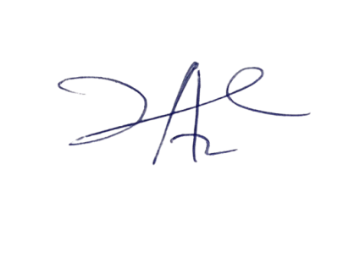

25/5/2023

Principal Head Instuctor