LESSON PLAN/NOTE FOR WEEK 3 ENDING 19/05/2023

TERM: 3rd

WEEK: 3

DATE: 16/05/2023

CLASS: Nursery 2

SUBJECT: Nature studies

TOPIC: Water: uses.

SUB—TOPIC: Meaning of water and it's uses.

PERIOD: 3rd

TIME: 09:30—10:10am

DURATION: 40 minutes

NUMBER IN CLASS: 14

AVERAGE AGE: 5 years

SEX: Mixed

LEARNING OBJECTIVES: By the end of the lesson, the pupils should be able to:

1. Define water.

2. Mention the uses of water .

RATIONALE: For Pupils to know the uses of water.

PREVIOUS KNOWLEDGE: Pupils have using for different purposes.

INSTRUCTIONAL MATERIALS: Pictures in Pupils textbooks.

REFERENCE MATERIALS: Basic science and technology for Nursery schools book 3 by OPEMIPO DADA.

LESSON LESSON DEVELOPMENT

|  |  |  |  |
| --- | --- | --- | --- |
| Steps | Teacher's activities | Pupils' activities | Learning point |
| Introduction | Teacher introduces the lesson by asking pupils the following questions:  1. How many of you bath before coming to school today?  2. If you know you brush your teeth this morning hands up. | Pupils answer the question asked by the teacher. | To prepare pupils minds for the lesson ahead. |
| Presentation step 1 | Teacher defines water and asks Pupils to repeat after her. | Pupils listen to the teacher and repeat after her. | For proper understanding. |
| Step 2 | Teacher mentions the uses of water to pupils and also asks them to repeat after her. | Pupils pay attention to the teacher and repeat after her. | For better understanding. |
| Board summary | Teacher writes the whole note of lesson on the board for pupils to copy into their books.  WATER  Water is a liquid substance that is colourless, odourless and tasteless.  Water has many uses.  The most important use of water is for drinking.  Human beings, plants and animals needs water to stay alive.  USES OF WATER  1. Drinking  2. Brushing of teeth  3. Washing dirty plates  4. Cooking  5. Cleaning  6. Washing dirty clothes  7. Watering plants  8. Washing fruits and vegetables  9. Building houses  10. Bathing  11. Animals need water to drink | Pupils copy the note into their exercise books. | For onward study. |
| Evaluation | Teacher evaluates the lesson by asking pupils the following questions;  1. Water is water?  2. Mention the uses of water. | Pupils answer the questions ask by the teacher. | To assess pupils level of understanding. |
| Conclusion | Teacher concludes the lesson by marking pupils books. | Pupils submit their books for marking. | For endorsement. |
| Assignment | Activity 17 page 60. Basic science textbook. | Pupils do their assignment at home. | To encourage learning at home. |

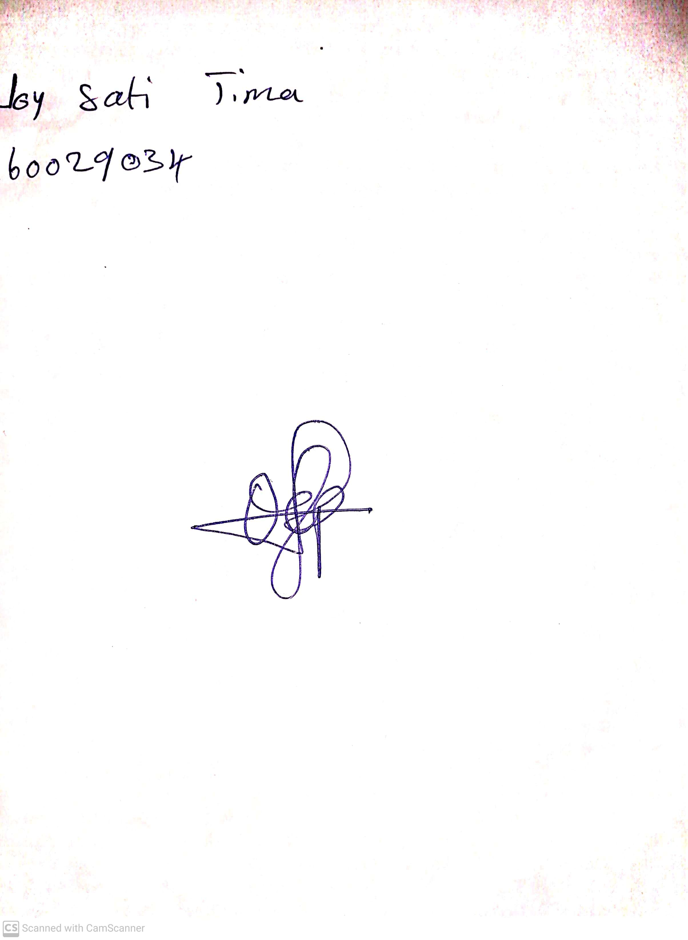

28TH APRIL, 2023

Perpetual Ojoma

Stream Head Nursery